FAST RISING MELODIC RAPPER KEVO MUNEY & MULTI-PLATINUM KEVIN GATES BLESS US WITH “AMEN”, OUT TODAY

LISTEN HERE: https://KevoMuney.lnk.to/Amen

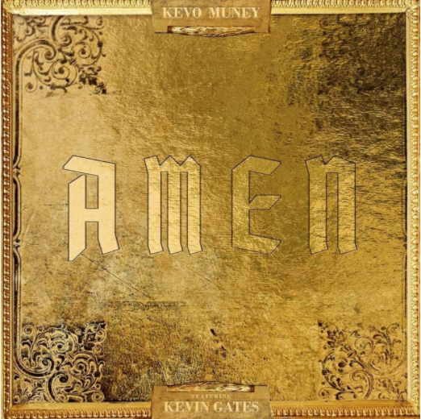

Soulful melodic rapper label mates Kevo Muney and Kevin Gates have combined forces on “Amen,” out today via Atlantic Records. Listen HERE. On the release, Kevin Gates says, “Yes Lord...Amen!” The single follows Kevo Muney’s “4 A.M. Remix” featuring fellow Memphis rapper Jucee Froot and Kevin Gates’ most recent single, “Difficult.”

20-year-old Atlantic Records rapper Kevo Muney fulfilled his vow to “bring soul back to rap” in December with the release of his mixtape, BABY G.O.A.T. The tape also sparked a viral moment online for its radical cover art, which had both DJ Akademiks and WorldStarHipHop suggesting it was “the best mixtape cover art of the year.” Most recently, mixtape track “4 A.M.” received a refresh from fellow Atlantic Records rapper Jucee Froot, who added her fearless bars on the “4 A.M. Remix.” Kevo Muney has earned acclaim and radio play in his native Memphis as well as early co-signs from heavyweights like Chief Keef, Kevin Gates, Gunna, Tay Keith, BlocBoy JB, and others, with Memphis hip-hop legend Don Trip declaring him “a breath of fresh air.” Before Baby G.O.A.T., Kevo released Who Am I: Reloaded, whose tracks have accumulated over 20 million views on YouTube.

Despite his legal challenges and incarceration circumstances over the past three years, the Baton Rouge-raised Multi-platinum recording artist Kevin Gates hasn’t stopped delivering heavy-hitting music to his fans. He recently released “Difficult” and “Grandmotha Grave,” and the video for “Still Hold Up,” a dark reflection of the artist’s life experiences, which has now accumulated over 4.7 MILLION views on YouTube. Gates’ recent string of new music follows last year’s critically acclaimed, RIAA-certified gold blockbuster LP, I’M HIM, available via Bread Winners Association HERE. Featured tracks “Facts” and “Walls Talking” are RIAA-certified Gold and the album proved a sensation, arriving at #1 on both Billboard’s “Top R&B/Hip-Hop Albums” and “Digital Albums” charts while also debuting among the top 5 on the overall SoundScan/Billboard 200 – Gates’ fourth top 10 debut thus far. I’M HIM marked Gates’ first official album release in more than three years, following 2016’s now-classic debut, ISLAH. The six-track project – which includes such acclaimed singles as “Really Really” and “2 Phones” – affirmed Kevin Gates as one of hip-hop’s greatest new stars, second only to Drake as the best-selling hip-hop artist of 2016.

CONNECT WITH KEVO MUNEY
INSTAGRAM | YOUTUBE | TWITTER | FACEBOOK | PRESS SITE

CONNECT WITH KEVIN GATES
WEBSITE | INSTAGRAM | TWITTER | YOUTUBE | OFFICIAL BWA

Kevo Muney Press contact: Corey.brewer@atlanticrecords.com
Kevin Gates press contact: Sydney.Margetson@atlanticrecords.com

