FOR IMMEDIATE RELEASE
OCTOBER 1, 2020

KIIARA ANNOUNCES HIGHLY-ANTICIPATED DEBUT ALBUM lil kiiwi OUT OCTOBER 9 - PRE-ORDER NOW HERE

MULTI-PLATINUM PRINCESS OF CHOP POP’S FULL-LENGTH PROJECT WILL INCLUDE
“SO SICK” FEATURING BLACKBEAR, 3X PLATINUM SMASH SINGLE “GOLD” AND MORE

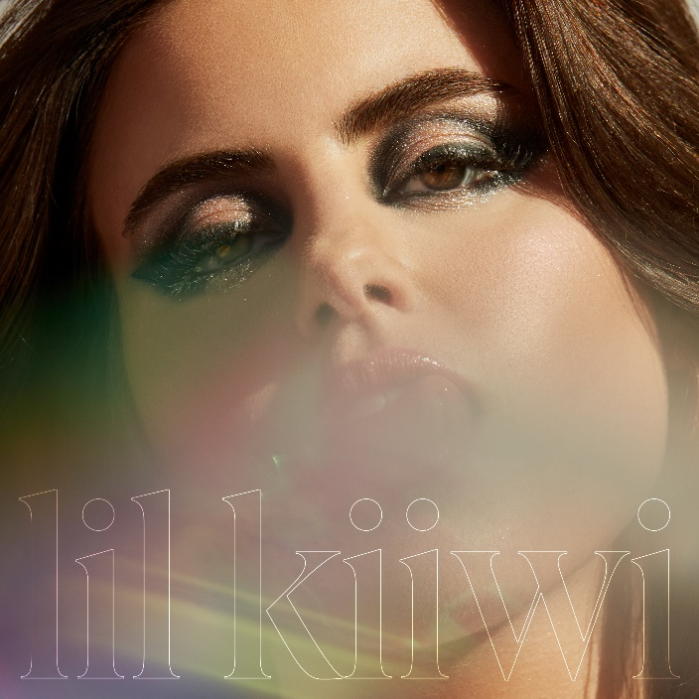
DOWNLOAD ARTWORK HERE

Atlantic Records recording artist Kiiara has announced her debut album, lil kiiwi, will be released Friday, October 9 – pre-order/pre-save it now HERE. lil kiiwi boasts high-profile collaborations with acclaimed artists such as blackbear, on the standout track “So Sick,” DeathbyRomy, PVRIS and more – see full tracklisting below. Fans who pre-order the album will receive instant downloads of recently released tracks “Numb (feat. DeathbyRomy and PVRIS),” “I Still Do” and “Never Let You” as well as Kiiara’s hit singles “Whippin (Feat. Felix Snow),” “Feels” and the 3x Platinum smash hit “Gold.”

“I made a lot of mistakes and thru the process of making this album I learned from a lot of those mistakes,” Kiiara shared. “I learned not to take love for granted, I learned to love, I learned not to push away the people who genuinely care about me. I took all the defeats I’ve faced over these past few years and put what I learned together like a puzzle. I picked myself up off the ground with the help of my family, friends, my team, and strangers who quickly became really important people in my life who I now look to for advice, all while I didn’t see the light in anything. Lil kiiwi is who I was early in my career. Lil kiiwi is a savage who, no matter how hard I try to control and hide, will always be a part of me”

Kiiara’s recent releases have increased the widespread anticipation for her debut album, with Billboard labeling “I Still Do” as “a tight, melodic first taste” and LADYGUNN predicting the album to be “one for the top charts.” The album title was teased in the “I Still Do” official video which introduced Lil Kiiwi, representing Kiiara in the earlier chapter of her career. In the video, flashbacks of Lil Kiiwi are intertwined with Kiiara’s present life, embodying the idea that while Kiiara is more composed and authentic today, she will always have a Lil Kiiwi side to her.

“I Still Do” was met with widespread critical acclaim upon release, with Refinery 29 encouraging readers to “dance out your feelings to the tune of Kiiara's all-too-relevant ‘I Still Do’” and MTV labeling the track “an infectious summer bop dripping with catchy vocals.” “Never Let You” followed the edgy track, garnering praise from Idolator and UPROXX, who included the song in their Best New Pop Music round-up and stated, “Kiiara has positioned herself as a strong songwriter.”

Last week it was announced that Kiiara would be playing a special performance at Sound Mind Live’s Come Together: Mental Health Music Festival on Thursday, October 8. Check out her incredible, livestreamed performance during the festival on Relix’s YouTube Channel HERE.

Now boasting more than 2 billion streams, Kiiara began writing and performing in her teens, inspired by a diverse range of contemporary pop and electronic forms. The Chicago, IL-based singer-songwriter first dropped “Gold” upon an unsuspecting world in the summer of 2015, earning instant attention for her trademark vocal sampling and gift for indelible hooks. The track proved a global sensation, earning 3x RIAA Platinum certification and over 700 million streams, reaching the top 5 on Billboard’s Pop Songs Charts and the top 15 on the Hot 100. Kiiara continued to expand her creative palette by contributing her one-of-a-kind sound to a series of high-profile collaborations alongside some of pop, EDM, rock and hip-hop’s biggest players, most notably Linkin Park’s 2017 RIAA Gold certified smash, “Heavy (Feat. Kiiara).” For updates and additional information on Kiiara please visit https://www.kiiara.com.

ABOUT KIIARA:
An unbelievable five-year trip brought Kiiara to self-discovery. In what feels like the blink of an eye, she went from uploading music out of her teenage bedroom in Illinois to multiplatinum pop stardom. In 2015, she quietly enchanted listeners everywhere with an uncompromising and unapologetic deconstruction of pop. Her triple-platinum breakout single “Gold” vaulted to the Top 5 of the Billboard Top Pop Songs Chart and the Top 15 of the Hot 100 in addition to generating over 700 million streams. It paved the way for the low kii savage EP as she sold out her first headline tour, graced the stage of Lollapalooza, and made her late-television debut on The Tonight Show Starring Jimmy Fallon. Plus, she garnered tastemaker praise from Variety, Rolling Stone, PAPER, and Idolator, to name a few. In addition to dropping fan favorites such as “Whippin” [feat. Felix Snow], “Messy,” and more, “Feels” achieved a gold certification. Simultaneously, she became a sought-after collaborator, contributing her instantly recognizable vocals to the Bright soundtrack banger “Darkside” by Ty Dolla $ign and Future, “Complicated” by Dimitri Vegas & Like Mike and David Guetta, “Be Somebody” by Steve Aoki and Nicky Romero, and the gold-certified smash “Heavy” by Linkin Park. Representing a full circle moment, she accompanied her “favorite band” on stage multiple times and honored the late frontman Chester Bennington by joining a stacked bill at the Linkin Park and Friends: Celebrate Life in Honor of Chester Bennington concert event. Now, she takes stock of everything on her 2020 full-length debut, lil kiiwi.


DOWNLOAD PRESS PHOTOS

lil kiiwi Tracklist:
- So Sick (feat. blackbear)
- Feels
- Brightside
- Don’t Get Confused
- Whippin (feat. Felix Snow)
- I Still Do
- Gold
- Empty
- Never Let You
- Numb (feat. DeathbyRomy & PVRIS)
- Accidental
- Two Thumbs
- Bad One

CONNECT WITH KIIARA
INSTAGRAM
FACEBOOK
TWITTER
SPOTIFY
YOUTUBE

For press inquiries, please contact:
Kelly McWilliam // Kelly.McWilliam@atlanticrecords.com

