WATCH MULTI-PLATINUM ARTIST KIIARA
“GLOE”
IN NEW MUSIC VIDEO OUT TODAY

WATCH “GLOE” HERE

UPCOMING U.S. HEADLINE TOUR IN THE FALL
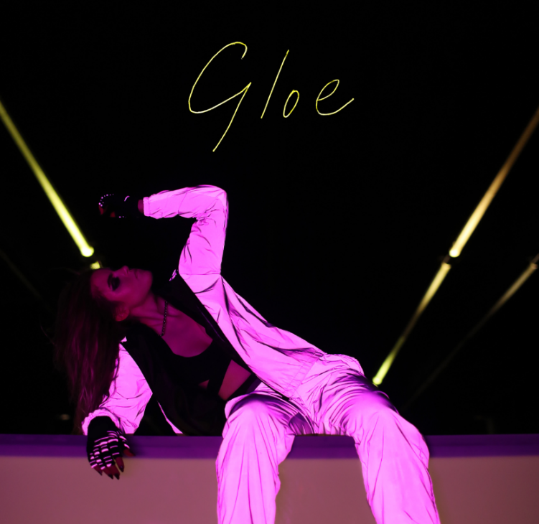
DOWNLOAD SINGLE ART HERE
DOWNLOAD PRESS IMAGE HERE

Los Angeles, CA (August 24, 2018) – Multi-platinum singer/songwriter KIIARA releases her mesmerizing new track “Gloe” along with its accompanying hypnotic music video. Watch HERE! Available today for download and streaming via Atlantic Records, the song highlights Kiiara’s entrancing vocals and signature electro-pop musical style. The track was written by Kiiara and Teddy Sinclair (Grammy nominated for Rihanna’s “Kiss It Better”) and produced by Stint (Lana Del Rey, Banks, Santigold, Gallant).

Kiiara recently announced she will embark on a 15+ date headline tour this fall, with support from labelmate ABIR. The tour kicks off on October 29 in Chicago, IL and will hit Brooklyn, NY, Los Angeles, CA, Austin, TX and more (see below for full tour itinerary.) Head to http://www.kiiara.com/ for more information. Kiiara’s latest single, “Messy” has already amassed more than 30-million streams and follows her 2018 Billboard Music Award nomination for Top Rock Song with “Heavy,” her duet with Linkin Park, and multi-platinum mega-hit, “Gold.”

STREAM/PURCHASE “GLOE” HERE
WATCH THE “GLOE” MUSIC VIDEO HERE

KIIARA FEAT. ABIR NORTH AMERICAN TOUR DATES –
All dates and venues subject to change.
Date | City, State | Venue
29-Oct | Chicago, IL | Lincoln Hall
31-Oct | Minneapolis, MN | Fine Line Music Café
1-Nov | Detroit, MI | The Shelter
5-Nov | Brooklyn, NY | Elsewhere
6-Nov | Philadelphia, PA | Theatre of Living Arts
8-Nov | Boston, MA | The Sinclair
10-Nov | Buffalo, NY | The Rec Room
11-Nov | Washington, DC | U Street Music Hall
12-Nov | Atlanta, GA | Terminal West
14-Nov | Dallas, TX | Trees
15-Nov | Houston, TX | Warehouse Live Studio
16-Nov | Austin, TX | Antone’s
18-Nov | Phoenix, AZ | Crescent Ballroom
19-Nov | Santa Ana, CA | Constellation Room
20-Nov | Los Angeles, CA | The Regent Theater
21-Nov | San Francisco, CA | August Hall

CONNECT WITH KIIARA:
INSTAGRAM
TWITTER
FACEBOOK
PRESS SITE

FOR MORE INFORMATION ON KIIARA:
Erica Gerard / Lauren Morris
PMK*BNC
Erica.Gerard@pmkbnc.com
Lauren.Morris@pmkbnc.com

Corey Brewer
Atlantic Records
Corey.Brewer@atlanticrecords.com

