FOR IMMEDIATE RELEASE
SEPTEMBER 8, 2020

KIIARA TEAMS UP WITH DEATHBYROMY AND PVRIS FOR MESMERIZING
NEW SINGLE “NUMB” – LISTEN HERE

TRACK WILL BE INCLUDED ON MULTI-PLATINUM PRINCESS OF CHOP POP’S
DEBUT ALBUM OUT THIS FALL

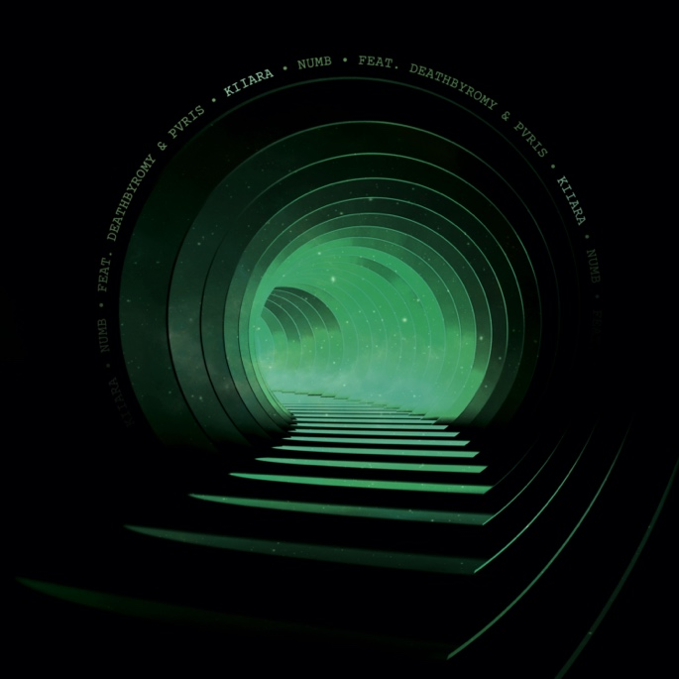
DOWNLOAD ARTWORK HERE

Atlantic Records recording artist Kiiara has released her new single “Numb” (feat. DeathbyRomy and PVRIS) – listen HERE. The track sees the multi-platinum “princess of chop pop” team up with dark-pop singer DeathbyRomy, whose latest single “Fiending For A Lover” is out now, and alt-pop’s PVRIS, whose new studio album Use Me was released last month. The mesmerizing song was produced by Marco “MAG” Borrero (Noah Cyrus, Bebe Rexha, Charlotte Lawrence) and Louis Schoorl (5 Seconds of Summer, Kesha) and co-written with Melanie Fontana (Justin Bieber, Britney Spears, Dua Lipa) and Michel “Lindgren” Schulz (BTS, Halsey, Cheat Codes).

Speaking about the inspiration for the track, Kiiara shared, “Too many people have tried to control me over the years and it had taken a toll on me. I became numb to what was going on around me. I was exhausted from trying to explain myself and it felt as if people would wait for me to be at my weakest and most vulnerable to swoop in and manipulate my view on things. It was debilitating and I felt like I was in a tunnel all alone. I shut down completely.”

On the collaboration, Kiiara stated, “It was great working with DeathbyRomy and PVRIS on ‘Numb’ because I’ve been fans of them for a while !! I love how unique each of their writing styles are and how well we all mesh together vocally even tho we’re all very different. This song to me screams girl gang and I’m just so grateful to have this energy around me. I love working with artists who aren’t afraid to be real and embrace darkness and vulnerability. ‘Numb’ is our emo anthem.” DeathbyRomy added, "When Kiiara asked me to jump on this song and I heard the production, I knew I’d kill it so I had to hehehe. Not to mention, three badass women on one song? No brainer.” PVRIS echoed this saying, “At the start of quarantine Kiiara sent the track over and I immediately loved the vibe and was excited to hop on the track. When I heard DeathbyRomy on the track as well, it became a no brainer. These girls kill it and I’m happy to be a part of such a great track.”

“Numb” comes on the heels of Kiiara’s impressive recent singles “I Still Do” and “Never Let You.” “I Still Do” was met with widespread critical acclaim upon release, with Refinery 29 encouraging readers to “dance out your feelings to the tune of Kiiara's all-too-relevant ‘I Still Do’” and MTV labeling the track “an infectious summer bop dripping with catchy vocals.” “Never Let You” followed the edgy track, garnering praise from Idolator and UPROXX, who included the song in their Best New Pop Music round-up and stated, “Kiiara has positioned herself as a strong songwriter.”

The latest singles have increased the widespread anticipation for the pop star’s debut album, with Billboard labeling “I Still Do” as “a tight, melodic first taste” and LADYGUNN predicting the album as “one for the top charts.” Earlier this summer, Kiiara released the “I Still Do” official video which introduced Lil Kiiwi, representing Kiiara in the earlier chapter of her career. In the video, flashbacks of Lil Kiiwi are intertwined with Kiiara’s present life, embodying the idea that while Kiiara is more composed and authentic today, she will always have a Lil Kiiwi side to her.

The impressive string of new singles follow Kiiara’s 3x Platinum breakout single “Gold” and last year’s acclaimed tracks, “Open My Mouth“ and “Bipolar.”

For updates and additional information on Kiiara please visit https://www.kiiara.com.

ABOUT KIIARA:
An unbelievable five-year trip brought Kiiara to self-discovery. In what feels like the blink of an eye, she went from uploading music out of her teenage bedroom in Illinois to multiplatinum pop stardom. In 2015, she quietly enchanted listeners everywhere with an uncompromising and unapologetic deconstruction of pop. Her triple-platinum breakout single “Gold” vaulted to the Top 5 of the Billboard Top Pop Songs Chart and the Top 15 of the Hot 100 in addition to generating over 700 million streams. It paved the way for the low kii savage EP as she sold out her first headline tour, graced the stage of Lollapalooza, and made her late-television debut on The Tonight Show Starring Jimmy Fallon. Plus, she garnered tastemaker praise from Variety, Rolling Stone, PAPER, and Idolator, to name a few. In addition to dropping fan favorites such as “Whippin” [feat. Felix Snow], “Messy,” and more, “Feels” achieved a gold certification. Simultaneously, she became a sought-after collaborator, contributing her instantly recognizable vocals to the Bright soundtrack banger “Darkside” by Ty Dolla $ign and Future, “Complicated” by Dimitri Vegas & Like Mike and David Guetta, “Be Somebody” by Steve Aoki and Nicky Romero, and the gold-certified smash “Heavy” by Linkin Park. Representing a full circle moment, she accompanied her “favorite band” on stage multiple times and honored the late frontman Chester Bennington by joining a stacked bill at the Linkin Park and Friends: Celebrate Life in Honor of Chester Bennington concert event. Kiiara is currently putting the finishing touches on her debut album to be released this fall.

ABOUT DEATHBYROMY:
Singer, songwriter, and dark-pop provocateur DeathbyRomy pays attention to every last detail. She pours both pain and euphoria into her catchy but heavy music, pitting electronic melodies and propulsive beats against hypnotic vocals and deeply personal lyrics. Now 20 years old, the Los Angeles-born Romy Flores wrote her first song at age 5 and began releasing her music at 15, mining inspiration from the iconoclastic artists she was raised on (The Beatles, Björk, Kanye West, to name a few). With her 2018 debut album Monsters, she soon drew an ardent following and found countless fans turning up to her shows adorned in her signature eye makeup. Her Capitol Records debut, 2019’s Love u—to Death EP, was short but sickly sweet, emphasizing her unique interweaving of rap boldness, electronic innovation, and raw rock ‘n’ roll passion. As Romy’s sound has taken shape, so has her DeathbyRomy persona: the Harajuku punk fashion, the corpsepaint-like makeup, and her hard-earned, utterly badass confidence.

ABOUT PVRIS:
PVRIS have officially entered their next chapter with widely-acclaimed new studio album, Use Me, as frontwoman, multi-instrumentalist, songwriter, and producer Lynn Gunn owns her role as PVRIS’ leader and sole architect. Growing up in Lowell, MA, Lynn taught herself drums, guitar, and bass by sneaking into her brother’s bedroom in grade school and playing for hours on end. During computer lab at school, she discovered production and recording software, tuning out the day’s lessons in order to tinker with her very first beats. This process carried over to PVRIS, which she officially formed in 2013. A year later, White Noise inspired a growing fan base and scored a silver certification in the UK. Meanwhile, 2017’s All We Know of Heaven, All We Need of Hell bowed in the Top 5 of the Billboard Top Alternative Albums Chart and ushered their stream tally past 220 million by 2020. Over the next seven years, PVRIS performed everywhere from Coachella, Lollapalooza, and Reading & Leads to Jimmy Kimmel LIVE! in addition to supporting Muse, Fall Out Boy, and 30 Seconds To Mars in arenas and selling out headline dates worldwide. At the same time, Vice, The New York Times, Medium, Rolling Stone, Billboard, Playboy, and more extended praise.

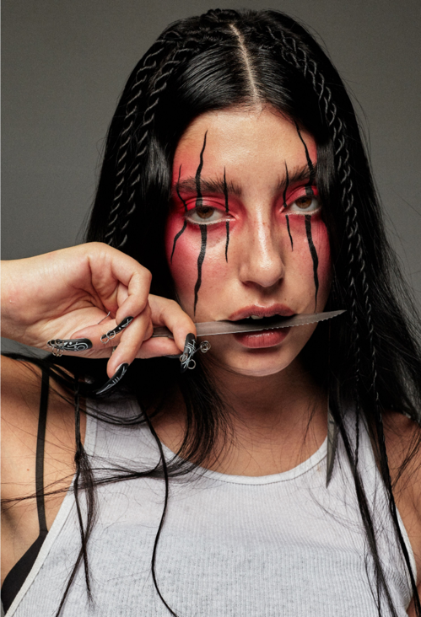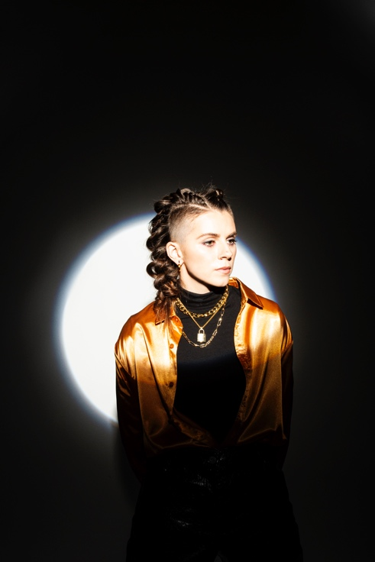
DOWNLOAD PRESS PHOTOS

CONNECT WITH KIIARA
INSTAGRAM
FACEBOOK
TWITTER
SPOTIFY
YOUTUBE

For press inquiries, please contact:
Kelly McWilliam // Kelly.McWilliam@atlanticrecords.com

