FOR IMMEDIATE RELEASE
OCTOBER 9, 2020

KIIARA RELEASES DEBUT ALBUM lil kiiwi

MULTI-PLATINUM PRINCESS OF CHOP POP TEAMS UP WITH BLACKBEAR FOR
IRRESISTIBLE NEW TRACK “SO SICK”

HIGHLY-ANTICIPATED DEBUT ALBUM INCLUDES 3X PLATINUM BREAKOUT TRACK “GOLD”
+ SIX BRAND-NEW TRACKS

LISTEN TO lil kiiwi HERE
DOWNLOAD ARTWORK HERE

After exploding onto the scene over five years ago, Atlantic Records recording artist Kiiara has released her highly-anticipated debut album lil kiiwi, streaming now HERE.

“With this album, I want to bring fans into the world of ‘lil kiiwi,’” Kiiara shared. “lil kiiwi being who I was early in my career. The queen of ignorance and bad decisions. During that time in my life, I didn’t think before I’d say or do anything, I was just living. I was unpredictable and reckless beyond belief. It took a few years to process and understand that side of me which will always remain a part of me. And I’m now ready to share my debut album with my fans and let them into that world... lil kiiwi’s world.”

The incredible project is highlighted by the princess of chop pop’s collaboration with superstar rapper blackbear, “So Sick” as well as six brand-new tracks, recently released singles “I Still Do,” “Never Let You” and “Numb (feat. DeathbyRomy and PVRIS),” and past hits “Gold,” Whippin (Feat. Felix Snow)”and “Feels.”

“’So Sick’ is a playful song about my relationship with blackbear back in 2016,” Kiiara says about the single. “We dated for a lil and this is a look into that. We stayed friends thru it all even tho I was blocked for a solid 2 years lolll. Bear is incredibly talented and he really brought this song to life.”

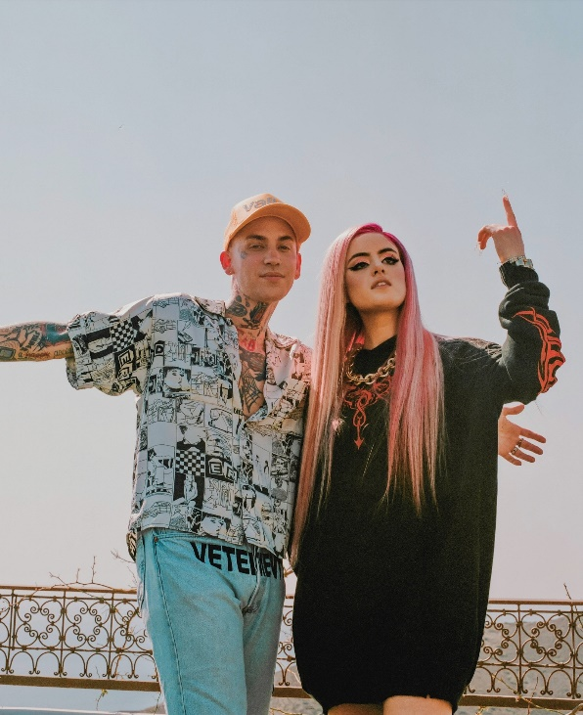

lil kiiwi finds Kiiara bringing a new level of self-possession to her music, fully embracing her instincts in every step of the process and capturing the strange complexities of love. This is exemplified in the track “So Sick (feat. blackbear),” a bold but brightly textured tale of a toxic romance. “As soon as I cut the vocals on that song I could hear him on it,” Kiiara recalls. “We hadn’t spoken in a long time but he hit me right back and said he’d love to do it. It ended up being a playful, dramatic song.”

Earlier this summer, Kiiara released the “I Still Do” official video which introduced the world to Lil Kiiwi, representing Kiiara in the earlier chapter of her career. In the video, flashbacks of Lil Kiiwi are intertwined with Kiiara’s present life. “It’s not an alter ego,” Kiiara says about Lil Kiiwi, “it’s a side of me that will always be there, even though I’m much better at handling my emotions now. I’ve learned a lot the hard way, and now I want to bring people into my world so they can understand it a little better. And if there are people out there who relate to the things I’ve gone through, I hope hearing these songs makes them feel less alone. I hope it helps them out in some way.”

The full length project arrives on the heels of Kiiara’s impressive recent singles “I Still Do,” “Numb (feat. DeathbyRomy and PVRIS)” and “Never Let You.” “I Still Do” was met with widespread critical acclaim upon release, with Refinery 29 encouraging readers to “dance out your feelings to the tune of Kiiara's all-too-relevant ‘I Still Do’” and MTV labeling the track “an infectious summer bop dripping with catchy vocals.” “Never Let You” followed the edgy track, garnering praise from Idolator and UPROXX, who included the song in their Best New Pop Music round-up and stated, “Kiiara has positioned herself as a strong songwriter.”

For updates and additional information on Kiiara please visit https://www.kiiara.com.

ABOUT KIIARA:
An unbelievable five-year trip brought Kiiara to self-discovery. In what feels like the blink of an eye, she went from uploading music out of her teenage bedroom in Illinois to multiplatinum pop stardom. In 2015, she quietly enchanted listeners everywhere with an uncompromising and unapologetic deconstruction of pop. Her triple-platinum breakout single “Gold” vaulted to the Top 5 of the Billboard Top Pop Songs Chart and the Top 15 of the Hot 100 in addition to generating over 700 million streams. It paved the way for the low kii savage EP as she sold out her first headline tour, graced the stage of Lollapalooza, and made her late-television debut on The Tonight Show Starring Jimmy Fallon. Plus, she garnered tastemaker praise from Variety, Rolling Stone, PAPER, and Idolator, to name a few. In addition to dropping fan favorites such as “Whippin” [feat. Felix Snow], “Messy,” and more, “Feels” achieved a gold certification. Simultaneously, she became a sought-after collaborator, contributing her instantly recognizable vocals to the Bright soundtrack banger “Darkside” by Ty Dolla $ign and Future, “Complicated” by Dimitri Vegas & Like Mike and David Guetta, “Be Somebody” by Steve Aoki and Nicky Romero, and the gold-certified smash “Heavy” by Linkin Park. Representing a full circle moment, she accompanied her “favorite band” on stage multiple times and honored the late frontman Chester Bennington by joining a stacked bill at the Linkin Park and Friends: Celebrate Life in Honor of Chester Bennington concert event.

DOWNLOAD PRESS PHOTOS

lil kiiwi Tracklist:
- So Sick (feat. blackbear)
- Feels
- Brightside
- Don’t Get Confused
- Whippin (feat. Felix Snow)
- I Still Do
- Gold
- Empty
- Never Let You
- Numb (feat. DeathbyRomy & PVRIS)
- Accidental
- Two Thumbs
- Bad One

CONNECT WITH KIIARA
INSTAGRAM
FACEBOOK
TWITTER
SPOTIFY
YOUTUBE

For press inquiries, please contact:
Kelly McWilliam // Kelly.McWilliam@atlanticrecords.com

