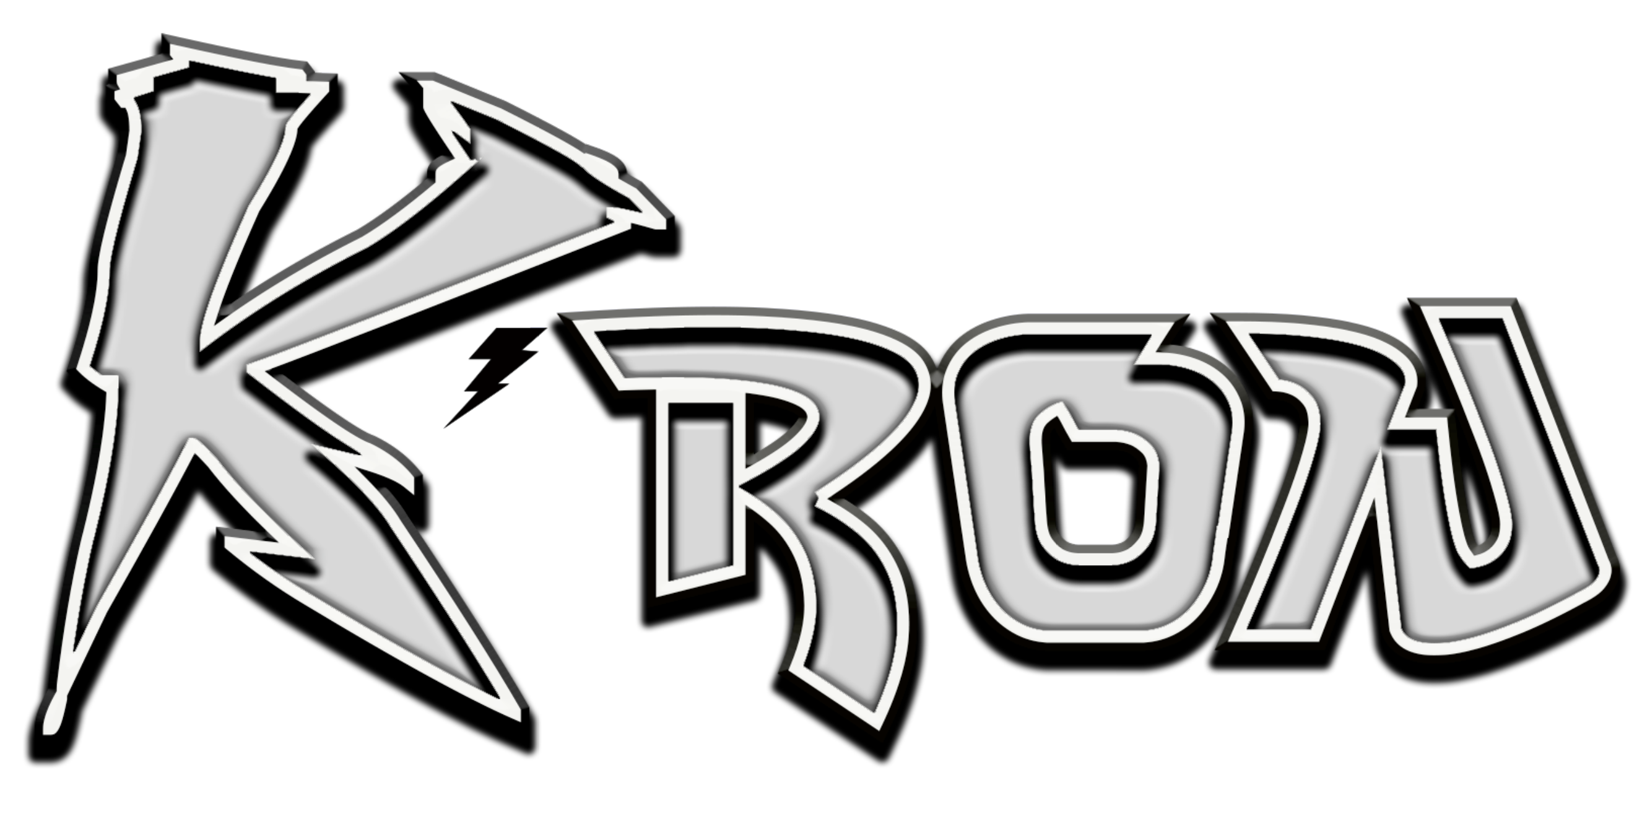
From young, K’Ron always knew what he wanted to be when got older. And it wasn’t anything normal or 9-5ish about it. He was determined to be one of the guys his parents turned the volume up for on the radio. Growing up in Temple Hills, Maryland just outside of D.C., his mother would often play R&B hits from Mint Condition and Jodeci. Dad would bump rap tunes from NYC titans Biggie and Nas. So dreams of rocking stages were all he knew. K’Ron couldn’t imagine anything else.
“You’re only going to put your best forward at what you really love to do,” he explains. “If you’re going to make a career out of something, it better be something that you love to do. Or else you’re going to feel like this is something you’re doing just to get by.”
You could say his smooth vocals have been earning him cash since middle and high school. One K’Ron started flaunting his burgeoning skills in the cafeteria one day, he was in business.
“From then on, little girls were trying to pay me to sing,” he recalls. “They’d be like, ‘Sing this!’ They were giving me their lunch money. That sparked me to believe in myself to sing.” From that moment on, he’d jump at the chance to perform at talent shows. His brother teaching him how to record himself to create his own songs was next, which would then lead K’ron to build himself a makeshift studio.
By the time he was in his late teens, K’ron was making strides towards his goal. He’d Google lyrics from tracks he tossed on YouTube and Soundcloud and see new fans were quoting them on Twitter. In 2016 record labels began courting K and his collection of R&B cuts dipped in the swagger of Hip-Hop, like his breakthrough single “Round of Applause” which has 15M+ streams to date. Eventually, he’d choose Atlantic Records. “Their roster is sweet,” he notes. It’s no surprise that the “No BFs,” the first single from the artist’s debut EP Wild Lova Vol. 1, featured label mate Ty Dolla $ign.
“We complement each other’s sound,” K says of the collab. “No BFs” proved a multi-platform sensation, inspiring Jackson State University’s world-renowned “Sonic Boom of the South” marching band to create their own exciting rendition. Coming off an HBCU tour in 2018, K’ron’s pleasant surprise was that he’s a bit more popular than he thought. “Certain places I went,” K starts, “I wasn’t even expecting them to know me. But they did. That let me know that I was doing something right.” 2019 introduced “Work It Out,” the soulful single that arrived in a series of back to back releases for K’ron that year, following “Decline” and “Slo-Mo.” K’ron – who in 2019 also wrapped a major North American concert tour supporting Melanie Fiona – has earned far-reaching applause for his distinctive blend of classic R&B with contemporary hip hop soul.

This year, K’ron released a remix to his 2014 standout, “Round of Applause,” accompanied by an intimate, 2-part quarantine-style music video. Most recently, he introduced “My Spot (Feat. Lil Keed & IIAN RICH),” which came with a gangster-movie companion visual. With time, K’ron continuously proves that the sky is the limit and that he is only getting started.

