LIL SKIES TEAMS UP WITH YUNG PINCH ON NEW SONG + VIDEO “I KNOW YOU”

RAPPER ON THE RISE SET TO JOIN WIZ KHALIFA AND RAE SREMMURD ON TOUR THIS SUMMER

LISTEN TO “I KNOW YOU” HERE: https://lilskies.lnk.to/IKYPR
WATCH “I KNOW YOU” VIDEO HERE: https://youtu.be/uZwsYdxecA8

*Download Hi-Res Art HERE*

Today, Lil Skies has unveiled a new track featuring Yung Pinch, available now at all DSPs at streaming services HERE. Skies and Pinch also dropped a video to accompany the track, directed by frequent collaborator Nicholas Jandora. Watch HERE.

Lil Skies – whose debut mixtape LIFE OF A DARK ROSE is still in the top 40 on billboard 200 over four months after release – recently wrapped his well-received first ever nationwide headline tour selling out venues across the country. Check out footage of the budding artist’s insane live show in a recent Noisey Raps episode, which also sheds light on the amazing backstory of Skies’ life to this point. Up next, the rapper on the rise will join Wiz Khalifa and Rae Sremmurd for select support dates on their headline Dazed & Blazed amphitheater tour beginning in Detroit on July 21st. For additional ticket information and a complete itinerary visit lilskiesofficial.com/tour.

Lil Skies released his critically acclaimed debut mixtape LIFE OF A DARK ROSE (All We Got Ent / Atlantic Records) on January 10, 2018. LIFE OF A DARK ROSE quickly entered the Billboard 200 peaking at #10 in its 2nd week, now with 389,279 sales equivalents and over 544 million streams to date, a rare feat for a new artist’s debut mixtape. The 14-track collection also soared to #6 on Billboard’s Top R&B/Hip-Hop Albums Chart, becoming the first set to ascend into the top 10 following its first full tracking week after not ​debuting there since Chance the Rapper’s Coloring Book.

LIFE OF A DARK ROSE is highlighted by Skies’ massive lead single “Red Roses” which has been praised by critics and fans alike. The visual for “Red Roses,” which was directed by new-rap impresario Cole Bennett of Lyrical Lemonade, garnered over 2 million views in the first 10 days of its release, and is now at over 55 million views and climbing. At the end of 2017, Lil Skies dropped another new track “Nowadays” feat. Landon Cube, alongside a visual also shot and directed by Bennett, which has garnered a stunning 64 million views since its release.

Hailed by Billboard, Complex and Pandora as an artist to watch in 2018, Lil Skies has been blowing up on both SoundCloud and YouTube and was recently dubbed by ROLLING STONE as “an artist you need to know,” with GENIUS declaring him “one of SoundCloud’s most promising young acts.” With both “Red Roses” and “Nowadays” streaming millions everyday around the globe, Skies is also popping up on viral Spotify charts worldwide including US, Canada, Australia, Germany, Poland and more.

LISTEN TO LIFE OF A DARK ROSE HERE
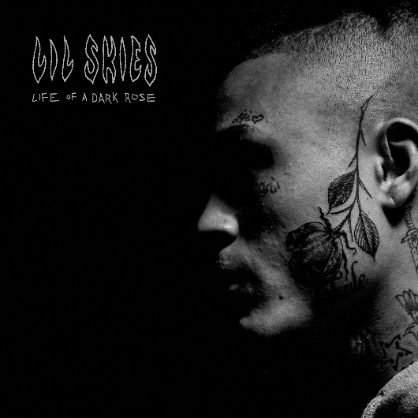

CONNECT WITH LIL SKIES
SOUNDCLOUD | FACEBOOK | TWITTER |INSTAGRAM | YOUTUBE | PRESS TOOLS

LIL SKIES TOUR DATES
WIZ KHALIFA AND RAE SREMMURD DAZED & BLAZED SUMMER 2018

07/21 – Detroit, MI @ DTE Energy Music Theatre
07/22 – Cleveland, OH @ Blossom Music Center
07/24 – Toronto, ON @ Budweiser Stage
07/25 – Saratoga Springs, NY @ Saratoga Performing Arts Center
07/26 – Burgettstown, PA @ KeyBank Pavilion
07/28 – Cincinnati, OH @ Riverbend Music Center
07/31 – Noblesville, IN @ Ruoff Home Mortgage Music Center
08/02 – Coney Island, NY @ Ford Amphitheatre
08/05 – Hartford, CT @ XFINITY Theatre
08/07 – Mansfield, MA @ Xfinity Center
08/09 – Bristow, VA @ Jiffy Lube Live
08/10 – Camden, NJ @ BB&T Pavilion
08/11 – Virginia Beach, VA @ Veterans United Home
08/12 – Raleigh, NC @ Coastal Credit Union Music Park
08/14 – Pelham, AL @ Oak Mountain Amphitheatre
08/15 – Jacksonville, FL @ Daily’s Place
08/16 – Tampa, FL @ MIDFLORIDA Credit Union Amphitheatre
08/17 – West Palm Beach, FL @ Coral Sky Amphitheatre
08/21 – Atlanta, GA @ Cellairis Amphitheatre
08/23 – Houston, TX @ Cynthia Woods Mitchell Pavilion
08/24 – Oklahoma City, OK @ Zoo Amphitheatre
08/25 – Austin, TX @ Austin360 Amphitheater
08/26 – Dallas, TX @ Dos Equis Pavilion
08/29 – Albuquerque, NM @ Isleta Amphitheater
08/30 – Phoenix, AZ @ Ak-Chin Pavilion

