FOR IMMEDIATE RELEASE
NOVEMBER 17, 2020

LIL UZI VERT AND FUTURE RELEASE THE DELUXE EDITION OF PLUTO X BABY PLUTO

DELUXE EDITION TO ACCLAIMED JOINT PROJECT FEATURES 8 NEW TRACKS

WATCH “OVER YOUR HEAD” HERE

WATCH “THAT’S IT” OFFICIAL VIDEO HERE

PLUTO X BABY PLUTO [DELUXE] AVAILABLE NOW AT ALL DSPS AND STREAMING SERVICES HERE

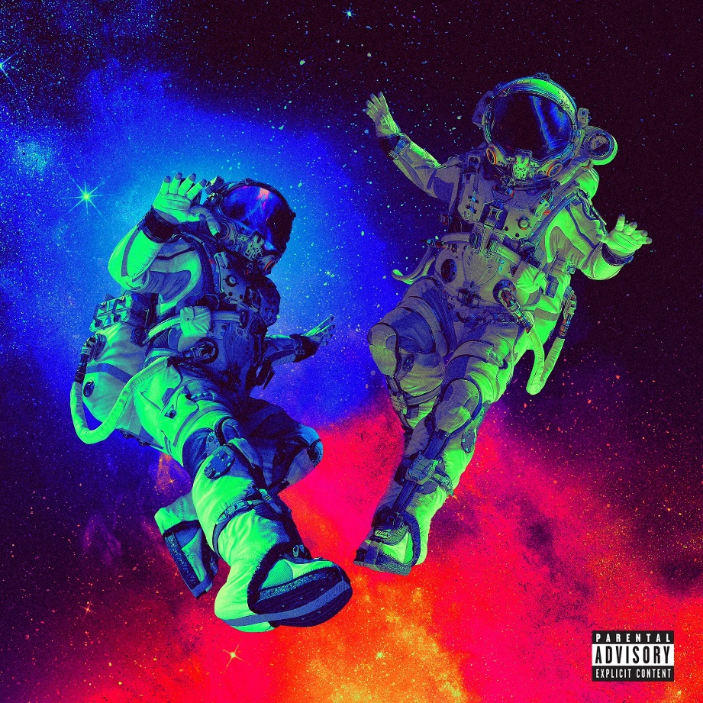

Following last week’s unveiling of their long-rumored joint project, PLUTO X BABY PLUTO, multi-platinum rap superstars Lil Uzi Vert and Future have released an explosive deluxe edition of the masterpiece. PLUTO X BABY PLUTO [DELUXE] features 8 all new tracks, along with the premiere of a brand new visual for “Over Your Head, directed by legendary filmmaker Hype Williams; check it out HERE. Listen to the deluxe edition of the now 24-track compilation, executive-produced by DJ ESCO, now via all digital retailers HERE.

Last week, PLUTO X BABY PLUTO – was heralded on Uzi and Future’s respective social media pages by a series of surprise video trailers directed by legendary filmmaker Hype Williams (streaming HERE). The two artists also recently teamed up with DJ ESCO for a special edition of Future’s Freebandz Radio, showcasing an early preview of the eagerly awaited joint project. PLUTO X BABY PLUTO was initially highlighted by the spectacular track “That’s It,” which arrived with a sporty companion video, streaming now at YouTube HERE

Lil Uzi Vert's ETERNAL ATAKE made an historic #1 debut on the SoundScan/Billboard 200 upon its March 2020 release. With over 400 million combined audio and video streams in its first week alone, and the second-biggest week of 2020 for any album. Uzi shocked the world one week later by quickly dropping ETERNAL ATAKE: DELUXE: LUV VS. THE WORLD 2. As if that weren’t enough, Uzi shocked the world one week later by quickly dropping ETERNAL ATAKE: DELUXE: LUV VS. THE WORLD 2, adding 14 additional tracks and features from Chief Keef, 21 Savage, Future, Young Thug, Gunna, Lil Durk, Young Nudy, and NAV.

Along with its phenomenal popular success, ETERNAL ATAKE has received wide-ranging critical applause around the globe, with Pitchfork raving, “ETERNAL ATAKE is Uzi’s greatest album to date, a scope-defying hour-long epic that couldn’t be made by anyone else.” “ETERNAL ATAKE is Lil Uzi Vert’s best album yet,” agreed Rolling Stone, “with a cohesiveness, slick concept, and performance that justifies every ounce of hype.”

In May of 2020 Future released his eight studio album, High Off Life which debuted No. 1 on the Billboard 200 albums chart; the Atlanta-bred superstar’s sixth such debut. In addition, High Off Life’s instant Gold certification makes Future a perfect eight-for-eight with Gold-certified studio albums and his forth Platinum certification.

Since the beginning of 2020, Future has been moving with a renewed vigor. Just 10 days into the year he released “Life Is Good” with Drake, yet another championship ring for the What A Time To Be Alive duo, which notched its highest Billboard Hot 100 placement (No. 2) to date with the track. Future followed “Life Is Good” by delivering a handful of his critically-acclaimed mixtapes (Beast Mode, 56 Nights, Purple Reign) to DSPs in April, an outcome his devoted fanbase has long clamored for. It’s allowed him to reflect on a legendary run from the decade prior while setting his sights on the one ahead.

PLUTO X BABY PLUTO [DELUXE]
TRACKLIST

1. Tic Tac
2. My Legacy
3. Heart In Pieces
4. Because of You
5. Bust a Move
6. Baby Sasuke
7. Stripes Like Burberry
8. Marni On Me
9. Sleeping On the Floor
10. Real Baby Pluto
11. Dranking N Smokin
12. Million Dollar Play
13. Plastic
14. That’s It
15. Bought A Bad Bitch
16. Rockstar Chainz
17. Lullaby
18. She Never Been To Pluto
19. Off Dat
20. I Don’t Wanna Break Up
21. Bankroll
22. Moment of Clarity
23. Patek
24. Over Your Head

CONNECT WITH LIL UZI VERT

INSTAGRAM | FACEBOOK | TWITTER | SOUNDCLOUD
WWW.LILUZIOFFICIAL.COM

FOR LIL UZI VERT INQUIRIES, PLEASE CONTACT

SYDNEY.MARGETSON@ATLANTICRECORDS.COM

JANA FLEISHMAN
JANAF@ROCNATION.COM

FOR FUTURE INQUIRIES, PLEASE CONTACT

Courtney Lowery
Courtney.Lowery@clmediaent.com

Ray Alba
Ray.Alba@epicrecords.com

