FOR IMMEDIATE RELEASE
NOVEMBER 13, 2020

LIL UZI VERT AND FUTURE UNITE FOR PLUTO X BABY PLUTO

MULTI-PLATINUM SUPERSTARS FINALLY UNVEIL LONG-RUMORED JOINT PROJECT

“THAT’S IT” OFFICIAL VIDEO PREMIERES TODAY VIA YOUTUBE

PLUTO X BABY PLUTO AVAILABLE NOW AT ALL DSPS AND STREAMING SERVICES HERE

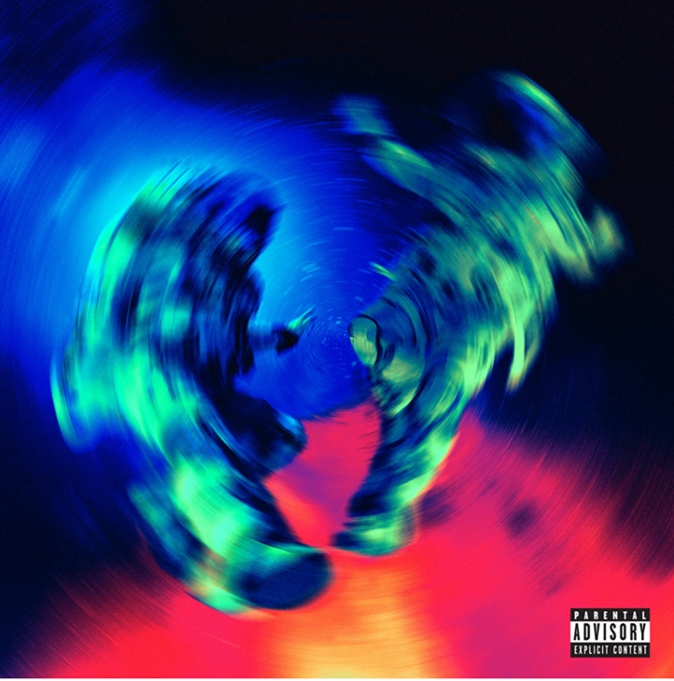

Multi-platinum rap superstars Lil Uzi Vert and Future are marking Friday the 13th with today’s much anticipated release of a carefully crafted, standout joint project. PLUTO X BABY PLUTO, executive-produced by DJ ESCO, is available now at all DSPs and streaming services HERE.

PLUTO X BABY PLUTO is highlighted by the spectacular track “That’s It,” accompanied by an equally explosive companion video, streaming now at YouTube HERE.

PLUTO X BABY PLUTO – was heralded on Uzi and Future’s respective social media pages by a series of surprise video trailers directed by legendary filmmaker Hype Williams (streaming HERE). In addition, the two artists recently teamed up with DJ ESCO for a special edition of Future’s Freebandz Radio, showcasing an early preview of their eagerly awaited joint project.

What’s more, this summer saw Uzi and Future celebrating the former’s 26th birthday – a.k.a. “Baby Pluto Day” – with a pair of collaborative singles, “Over Your Head” and “Patek,” both available now at all DSPs and streaming services. The acclaimed tracks followed previous partnerships from the pair, including “Wassup” (found on ETERNAL ATAKE: DELUXE: LUV VS. THE WORLD 2) and “All Bad” (featured on Future’s own chart-topping new album, HIGH OFF LIFE).

Lil Uzi Vert's ETERNAL ATAKE made an historic #1 debut on the SoundScan/Billboard 200 upon its March 2020 release. With over 400 million combined audio and video streams in its first week alone, and the second-biggest week of 2020 for any album. Uzi shocked the world one week later by quickly dropping ETERNAL ATAKE: DELUXE: LUV VS. THE WORLD 2.

As if that weren’t enough, Uzi shocked the world one week later by quickly dropping ETERNAL ATAKE: DELUXE: LUV VS. THE WORLD 2, adding 14 additional tracks and features from Chief Keef, 21 Savage, Future, Young Thug, Gunna, Lil Durk, Young Nudy, and NAV.

Along with its phenomenal popular success, ETERNAL ATAKE has received wide-ranging critical applause around the globe, with Pitchfork raving, “ETERNAL ATAKE is Uzi’s greatest album to date, a scope-defying hour-long epic that couldn’t be made by anyone else.” “ETERNAL ATAKE is Lil Uzi Vert’s best album yet,” agreed Rolling Stone, “with a cohesiveness, slick concept, and performance that justifies every ounce of hype.”

In May of 2020 Future released his eight studio album, High Off Life which debuted No. 1 on the Billboard 200 albums chart; the Atlanta-bred superstar’s sixth such debut. In addition, High Off Life’s instant Gold certification makes Future a perfect eight-for-eight with Gold-certified studio albums and his forth Platinum certification.

Since the beginning of 2020, Future has been moving with a renewed vigor. Just 10 days into the year he released “Life Is Good” with Drake, yet another championship ring for the What A Time To Be Alive duo, which notched its highest Billboard Hot 100 placement (No. 2) to date with the track. Future followed “Life Is Good” by delivering a handful of his critically-acclaimed mixtapes (Beast Mode, 56 Nights, Purple Reign) to DSPs in April, an outcome his devoted fanbase has long clamored for. It’s allowed him to reflect on a legendary run from the decade prior while setting his sights on the one ahead.

CONNECT WITH LIL UZI VERT

INSTAGRAM | FACEBOOK | TWITTER | SOUNDCLOUD
WWW.LILUZIOFFICIAL.COM

FOR LIL UZI VERT INQUIRIES, PLEASE CONTACT

SYDNEY.MARGETSON@ATLANTICRECORDS.COM

JANA FLEISHMAN
JANAF@ROCNATION.COM

FOR FUTURE INQUIRIES, PLEASE CONTACT

Courtney Lowery
Courtney.Lowery@clmediaent.com

Ray Alba
Ray.Alba@epicrecords.com

