FOR IMMEDIATE RELEASE
AUGUST 4TH, 2020

LIL UZI VERT RELEASES NEW SINGLES WITH FUTURE “OVER YOUR HEAD” AND “PATEK”

LISTEN TO “OVER YOUR HEAD” HERE

LISTEN TO “PATEK” HERE

ETERNAL ATAKE (DELUXE) - LUV VS. THE WORLD 2 AVAILABLE HERE

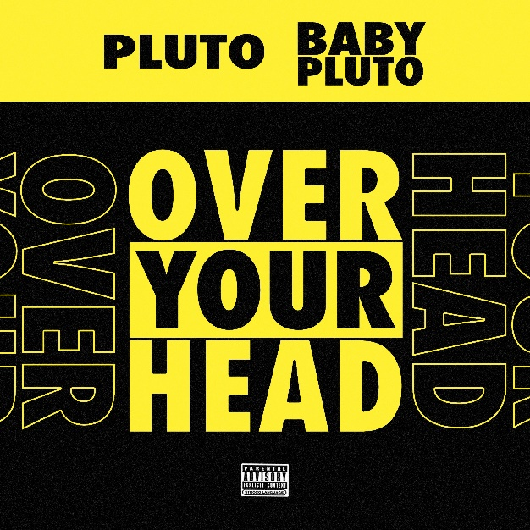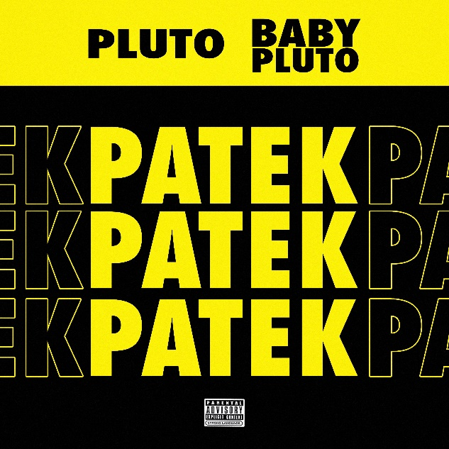

Over the weekend, GRAMMY® Award-nominated, multi-platinum superstar Lil Uzi Vert celebrated his birthday by unveiling two brand new singles with rap-superstar Future, “Over Your Head” and “Patek.” The melodic singles, which are accentuated by the dreamy collaboration, are both available via all digital retailers and streaming platforms.

Earlier this year, the musician made a historic #1 debut on the Billboard 200 with his critically acclaimed album, ETERNAL ATAKE. With over 400 million combined audio and video streams in its first week, the extraordinary success of ETERNAL ATAKE marked Lil Uzi Vert’s second #1 album (following 2017’s 2x RIAA platinum certified, chart-topping milestone, LUV IS RAGE 2) and the second-biggest week of 2020 for any album. In addition, ETERNAL ATAKE boasts the fourth-largest streaming week ever for an album, as well as the biggest streaming week for any album since Lil Wayne’s 2018 release, THA CARTER V. These records are not only huge for Lil Uzi Vert’s rockstar career, but for artists worldwide.

Along with its phenomenal popular success, ETERNAL ATAKE has received wide-ranging critical applause around the globe. “ETERNAL ATAKE is Lil Uzi Vert’s best album yet,” raved Rolling Stone, “with a cohesiveness, slick concept, and performance that justifies every ounce of hype.” The release was preceded by “BabyPluto,” a short film co-directed by Lil Uzi Vert and acclaimed filmmaker Gibson Hazard (Drake, Billie Eilish, G-Eazy) and streaming now via the official Lil Uzi Vert YouTube channel HERE.

Indeed, Lil Uzi Vert has swiftly racked up a long list of awards and other assorted honors, including prestigious GRAMMY® Award and MTV Video Music Award nominations for “Best New Artist” and the 2017 Billboard Touring Awards for both “Breakthrough Artist” and “Breakout Artist of the Year.” Additional nods include “Favorite Album – Rap/Hip-Hop” at the 2018 American Music Awards, “Best New Hip-Hop Artist” and “Hip-Hop Song of The Year” at the 2018 iHeart Radio Music Awards, and three leading nominations from the 2018 Billboard Music Awards: “Top Rap Artist,” “Top Rap Album” (for LUV IS RAGE 2), and “Top Streaming Song” (for “XO Tour Llif3”).

CONNECT WITH LIL UZI VERT
INSTAGRAM | FACEBOOK | TWITTER | SOUNDCLOUD
WWW.LILUZIOFFICIAL.COM

FOR ALL INQUIRIES, PLEASE CONTACT
SYDNEY.MARGETSON@ATLANTICRECORDS.COM
JANA FLEISHMAN
JANAF@ROCNATION.COM

