**LIN-MANUEL MIRANDA AND BEN PLATT PRESENT THE NEWEST HAMILDROP,** **“**[**FOUND/TONIGHT**](https://youtu.be/2aQykuIaJVI)**”**

***THEATRE MASHUP OF “YOU WILL BE FOUND” FROM DEAR EVAN HANSEN AND***

***“STORY OF TONIGHT” FROM HAMILTON***

***A PORTION OF ALL PROCEEDS TO GO TOWARDS*** [***MARCH FOR OUR LIVES***](https://protect-us.mimecast.com/s/0-2dC9rLglI88vP5f2I0Fn)

***LISTEN/WATCH*** [***HERE***](https://youtu.be/2aQykuIaJVI)

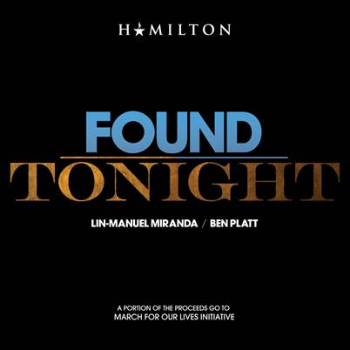

Since December, Lin-Manuel Miranda has been releasing Hamilton related content every month as part of the newly introduced Hamildrop series. In December it was “[Ben Franklin’s Song](https://protect-us.mimecast.com/s/RahUCgJQ2rs88rnLf8gkPF)” with The Decemberists, January was “[Wrote My Out](https://protect-us.mimecast.com/s/6vhBCjRO8xFgg2k7fzyhB0)” starring Nas, Dave East, Lin-Manuel Miranda and Aloe Blacc plus a [remix](https://protect-us.mimecast.com/s/b20HCkRO7yFgg7ZMf3IX2g) shortly after, then it continued in February with “[The Hamilton Polka](https://protect-us.mimecast.com/s/SctrClYM7zcLLyDBHJkHEo)” by none other than “Weird Al” Yankovic.

Now for March is a [March For Our Lives](https://protect-us.mimecast.com/s/0-2dC9rLglI88vP5f2I0Fn) inspired track, “[Found/Tonight](https://youtu.be/2aQykuIaJVI)” by Lin-Manuel Miranda and Ben Platt which is accompanied by a [new video](https://protect-us.mimecast.com/s/VP0eC0RXL1FjjKlRujIiYD) recently shot in the Atlantic Records’ studios. The new Hamildrop is ultimately a theatre mashup of “You Will Be Found” written by the songwriting duo Benj Pasek and Justin Paul along with “Story Of Tonight” written by Miranda, and is produced and arranged by Alex Lacamoire, the Grammy-winning Musical Supervisor of both productions. Sheet music for “Found/Tonight” is made available for free [here](http://www.hamildrops.com/sites/g/files/g2000007096/f/201803/47323%20Found_Tonight%20PV%20SHEET%20PF%202.pdf).

After witnessing thousands of courageous students across the nation mobilize following the Stoneman Douglas High School shooting in Parkland, FL just last month, Miranda was inspired to further support the movement. A portion of all proceeds will go towards the March For Our Lives Initiative. Platt has also joined Miranda in encouraging the rest of the industry to help spark a viral campaign by explaining why they march using the hashtag #IWillMarch.

“In the wake of Parkland, I was awestruck by the strength and leadership of the students and their ability to speak truth to power. In the midst of their grief, they mobilized the youth of our nation and created a movement. This is their moment. Not just for themselves, but for all of us. This song is my way of helping to raise funds and awareness for their efforts, and to say Thank You, and that we are with you so let’s keep fighting, together,” says Miranda.

Platt goes on to add, “When Lin called me to be a part of this mashup, I couldn’t say no. Better gun control is something that all Americans should be passionate about. These students are paving the way for future generations and it’s so inspiring to see young people standing up for what is probably the most important cause right now in this country, and demanding action.  I hope that this song can play some small part in bringing about real change.”

For more information about the March For Our Lives Initiative please visit [www.marchforourlives.com](https://protect-us.mimecast.com/s/UPagCn5NOBtnnzQJCX0jkI).

# # #

For press inquiries, please contact:

Atlantic Records:

Sheila Richman // [Sheila.Richman@atlanticrecords.com](mailto:Sheila.Richman@atlanticrecords.com)

Jason Davis // [Jason.Davis@atlanticrecords.com](mailto:Jason.Davis@atlanticrecords.com)

Lin-Manuel Miranda:

Charlie Guadano // [Guadano@sunshinesachs.com](mailto:Guadano@sunshinesachs.com)

Jason Lee // [Lee@sunshinesachs.com](mailto:Lee@sunshinesachs.com)

Ben Platt:

Michael Gagliardo // [Michael.Gagliardo@pmkbnc.com](mailto:Michael.Gagliardo@pmkbnc.com)