FOR IMMEDIATE RELEASE
DECEMBER 15, 2017

LIN-MANUEL MIRANDA ANNOUNCES THE HAMILDROPS

DOWNLOAD/STREAM “BEN FRANKLIN’S SONG” WITH
THE DECEMBERISTS HERE

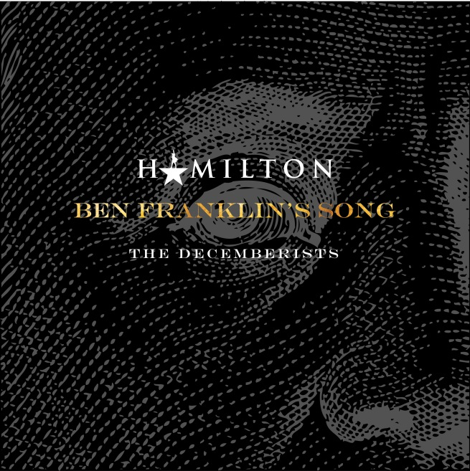

SOME REQUIRED READING ON THE HAMILTON MIXTAPE & NEW HAMILTON MUSIC.

A year ago this month we released The Hamilton Mixtape. It was the culmination of so many dreams come true. Every artist, every interpretation represented the original impulse I had for this story, even before this thing was a musical.

I know I promised you a Hamilton Mixtape Vol. 2, but nothing’s gonna match those songs in that order, beautifully sequenced by @J.period, at that moment in December 2016.

ALL THAT BEING SAID…

I STILL HAVE ALL THIS DOPE NEW SH*T TO SHARE WITH YOU.

So today, we begin THE HAMILDROPS. We’re gonna drop some new Hamilton content, every month, through December 2018. Something new, every month.

LET’S BEGIN!

DECEMBER’S #HAMILDROP. ‘member how I said I once wrote some Decemberists-esque lyrics for a Ben Franklin tune, but never set ‘em to music?

So I sent the lyrics to @ColinMeloy.

And HE set it to music as only he and his crew can. It absolutely blew me away. Went BACK to write lyrics for a bridge for him. He took it to @The Decemberists & they brought Ben Franklin to life.

So enjoy BEN FRANKLIN’S SONG. Music by The Decemberists, Lyrics by yours truly. Available now. #Hamildrops

Siempre,
Lin-Manuel

For more information/updates please visit www.hamildrops.com.
# # #
Atlantic Records:
Sheila Richman // Sheila.Richman@atlanticrecords.com
Jason Davis // Jason.Davis@atlanticrecords.com

Lin-Manuel Miranda:
Charlie Guadano // Guadano@sunshinesachs.com
Jason Lee // Lee@sunshinesachs.com

