**LIZZO RELEASES HIGHLY ANTICIPATED VIDEO FOR “TEMPO” FEATURING MISSY ELLIOTT**

**SOLD OUT FALL NORTH AMERICAN TOUR “CUZ I LOVE YOU TOO TOUR” DATES CONTINUE**

**SEPTEMBER 7th IN NEW ORLEANS**

[**WATCH “TEMPO” HERE**](https://Lizzo.lnk.to/INeedTempo)

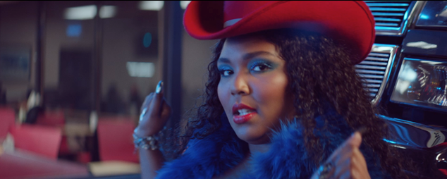

Today, Lizzo released the highly anticipated video for “[Tempo](https://Lizzo.lnk.to/INeedTempo)” featuring Missy Elliott. The video, directed by Andy Hines saw its premiere earlier this morning via an MTV Broadcast as well as a YouTube premiere. “Tempo” is of course highlighted on Lizzo’s critically acclaimed debut album *CUZ I LOVE YOU*, which has been featured on several “Best Of” lists as of late, including [Time](http://time.com/5588206/songs-of-the-half-year-2019/), [Rolling Stone](https://www.rollingstone.com/music/music-lists/50-best-albums-2019-so-far-846292/stephen-malkmus-groove-denied-847988/), [Vanity Fair](https://www.vanityfair.com/style/2019/06/song-of-the-summer-contenders-2019), [Variety](https://variety.com/2019/music/reviews/best-albums-2019-so-far-1203255278/) and [Entertainment Weekly](https://ew.com/music/2019/07/04/22-summer-pop-songs-playlist/) to name a few.

Lizzo is gearing up to head out on the road again on her sold out “Cuz I Love You Too Tour,” the second leg of her international “Cuz I Love You Tour.” Dates for the “Cuz I Love You Too Tour” began earlier this month in Troutdale, OR at Edgefield and will pick up again on September 7th at New Orleans’ The Filmore and eventually wrap in San Francisco at the Bill Graham Civic Auditorium on Ocotber 28th. For complete details and ticket information, please visit [www.lizzomusic.com/tour](http://www.lizzomusic.com/tour).

Lizzo released her Nice Life Recording Company/Atlantic Records debut album, [*CUZ I LOVE YOU*](https://lizzo.lnk.to/CuzILoveYouPR) to much on April 19th critical acclaim and the album debuted at #6 on the Billboard Top 200 Albums chart, which marks her first Billboard 200 entry. *CUZ I LOVE YOU* is also the #1 Pop album, #1 Digital album, #1 new release debut album and #2 on the Billboard Top Albums chart.

Lizzo marked the arrival of *CUZ I LOVE YOU* with a number of high profile TV appearances, including performances at the BET Awards, on the nationally syndicated [Ellen DeGeneres Show](https://www.youtube.com/watch?v=N8ZI1Jlrf-w), NBC’s [The Tonight Show Starring Jimmy Fallon](https://www.youtube.com/watch?v=6lsJIeazws8) and [TODAY](https://www.today.com/video/watch-lizzo-perform-juice-live-on-today-1488239683693), and ABC’s [Jimmy Kimmel Live!](https://www.youtube.com/watch?v=g0hsHxuSk1I) and HBO’s [2 Dope Queens](https://www.youtube.com/watch?v=Nc5Oy1BdFZI&t=18s), as well as visits to Comedy Centrals [The Daily Show with Trevor Noah](http://www.cc.com/episodes/4rkajm/the-daily-show-with-trevor-noah-extended---april-11--2019---lizzo-season-24-ep-24091) and Bravo’s [Watch What Happens Live with Andy Cohen](https://www.bravotv.com/watch-what-happens-live-with-andy-cohen/season-16/tamar-braxton-lizzo) as well as E! News’ [Busy Tonight](https://www.youtube.com/watch?v=aupXTGjOo4E). Lizzo is also set to perform on the Today Show Summer Concert Series on August 23rd.

In addition, Lizzo has been featured in a remarkable range of worldwide media outlets and national publications, spanning [The New York Times](https://www.nytimes.com/2019/04/23/arts/music/lizzo-juice.html), [GQ](https://www.gq.com/story/lizzo-loves-you-like-she-loves-herself),  [Billboard](https://www.billboard.com/articles/news/pride/8507133/janelle-monae-lizzo-coming-out-sexual-fluidity-them-interview), [TIME](http://time.com/5568320/lizzo-music-album-review/), [Entertainment Weekly](https://ew.com/music/2019/04/15/lizzo-cuz-i-love-you-interview/) and [Playboy](https://www.playboy.com/read/lizzo-the-incomparable) to the covers of [V Magazine](https://vmagazine.com/article/v119-lizzo-by-sam-smith/), [New York Magazine's](https://www.thecut.com/2019/02/lizzo-flute-pop-star.html) Spring Fashion Issue, [Allure](https://www.allure.com/story/lizzo-cover-interview-2019), [Essence](https://www.essence.com/feature/lizzo-talks-cuz-i-love-you-album-body-positivity/) and more. Additionally, Lizzo attended this years annual Met Gala with Marc Jacobs.

CONNECT WITH LIZZO

[LIZZOMUSIC.COM](http://www.lizzomusic.com/)

[FACEBOOK](http://www.facebook.com/LizzoMusic)

[TWITTER](https://twitter.com/lizzo)

[INSTAGRAM](http://instagram.com/lizzobeeating)

[YOUTUBE](http://www.youtube.com/user/Lizz0plusLarvaInkand)

**CUZ I LOVE YOU TOO**

U.S. FALL TOUR 2019

[www.lizzomusic.com](http://www.lizzomusic.com/)

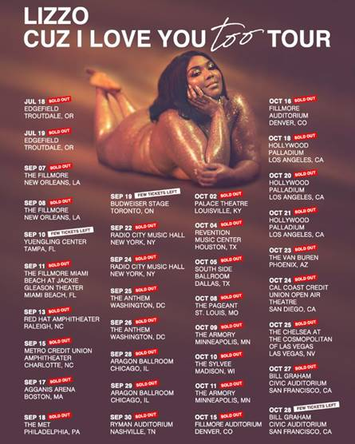

**JULY**

18 – Troutdale, OR – Edgefield **SOLD OUT**

19 – Troutdale, OR – Edgefield **SOLD OUT**

**SEPTEMBER**

7 – New Orleans, LA – The Filmore **SOLD OUT**

8 – New Orleans, LA – The Filmore **SOLD OUT**

10 – Tampa, FL – Yuengling Center \***VENUE UPGRADE**

11 – Miami Beach, FL – The Fillmore Miami at Jackie Gleason Theater **SOLD OUT**

13 – Raleigh, NC – Red Hat Amphitheater **SOLD OUT**

15 – Charlotte, NC – Metro Credit Union Amphitheater **SOLD OUT**

17 – Boston, MA – Agganis Arena **SOLD OUT**

18 – Philadelphia, PA – The Met **SOLD OUT**

19 – Toronto, ON – Budweiser Stage **\*VENUE UPGRADE**

22 – New York, NY – Radio City Music Hall **SOLD OUT**

24 – New York, NY – Radio City Music Hall **SOLD OUT**

25 – Washington, DC – The Anthem **SOLD OUT**

26 – Washington, D.C. –  The Anthem **SOLD OUT**

28 – Chicago, IL – Aragon Ballroom **SOLD OUT**

29 – Chicago, IL – Aragon Ballroom **SOLD OUT**

30 – Nashville, TN – Ryman Auditorium **SOLD OUT**

**OCTOBER**

2 – Louisville, KY – Palace Theatre **SOLD OUT**

4 – Houston, TX – Revention Music Center – **SOLD OUT**

5 – Dallas, TX – South Side Ballroom – **SOLD OUT**

8 -Saint Louis, MO – The Pageant **SOLD OUT**

9 – Minneapolis, MN – The Armory **SOLD OUT**

10 – Madison, WI – The Sylvee **SOLD OUT**

11 – Minneapolis, MN – The Armory **SOLD OUT**

15 – Denver, CO – Fillmore Auditorium **SOLD OUT**

16 – Denver, CO – Fillmore Auditorium **SOLD OUT**

18 – Los Angeles, CA – Hollywood Palladium **SOLD OUT**

20 – Los Angeles, CA – Hollywood Palladium **SOLD OUT**

21 – Los Angeles, CA – Hollywood Palladium **SOLD OUT**

23 – Phoenix, AZ – The Van Buren **SOLD OUT**

24 – San Diego, CA – Cal Coast Credit Union Open Air Theatre **SOLD OUT**

25 – Las Vegas, NV – The Chelsea at the Cosmopolitan of Las Vegas **SOLD OUT**

27 – San Francisco, CA – Bill Graham Civic Auditorium **SOLD OUT**

28 – San Francisco, CA – Bill Graham Civic Auditorium ***SECOND DATE ADDED***

**Contact Information:**

Ashley Kalmanowitz

[Ashley.Kalmanowitz@atlanticrecords.com](mailto:Ashley.Kalmanowitz@atlanticrecords.com)

212.707.2025

Tour/Online

Jessica Nall

[Jessica.Nall@atlanticrecords.com](mailto:Jessica.Nall@atlanticrecords.com)

(818)-238-6835