LIZZO ANNOUNCES FALL NORTH AMERICAN TOUR
“CUZ I LOVE YOU TOO”

SECOND LEG OF SOLD OUT “CUZ I LOVE YOU TOUR” KICKS OFF
JULY 18th IN PORTLAND AND CONTINUES THROUGH OCTOBER

“CUZ I LOVE YOU TOUR” KICKS OFF TONIGHT IN SAN FRANCISCO

TOUR DATES INCLUDE EAGERLY ANTICIPATED FESTIVAL PERFORMANCES
FOLLOWING EPIC SETS AT COACHELLA

DEBUT ALBUM CUZ I LOVE YOU AVAILABLE NOW

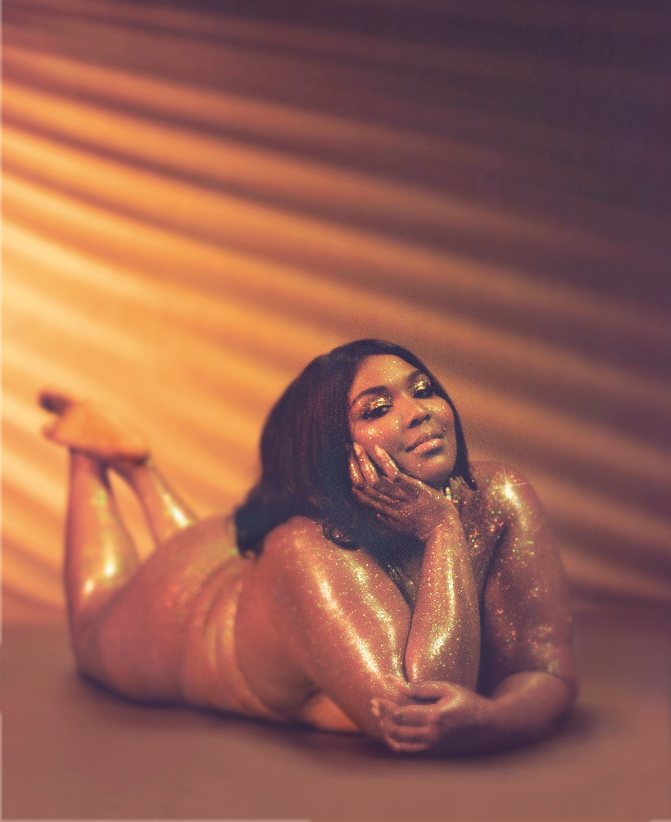

Days after releasing her Nice Life Recording Company/Atlantic Records debut album CUZ I LOVE YOU, Lizzo has announced her fall North American tour, “Cuz I Love You Too.”

Produced by Live Nation, “Cuz I Love You Too” dates begin July 18th at Edgefield in Portland, OR and will make stops in Toronto, New York, Chicago, Los Angeles and more before wrapping October 27th at the Bill Graham Civic Auditorium in San Francisco, CA. Tickets go on sale to the general public beginning Friday, April 26th at 10am local time at LiveNation.com. American Express® Card Members can purchase tickets in select markets before the general public beginning Tuesday, April 23rd at 10am local time through Thursday, April 25th at 10pm local time

“Cuz I Love You Tour” kicks off this week, April 22nd at The Warfield in San Francisco, CA. All dates on the North American headline trek are sold out, including a tour-closing headline date at New York City’s Terminal 5 set for May 23rd. Support throughout comes from Atlantic Records labelmate Tayla Parx. For complete details and ticket information, please visit www.lizzomusic.com/tour.

CUZ I LOVE YOU arrived to critical acclaim on Friday, April 19th with Variety declaring, “Her debut's sexy, smart, scuffed-up R&B establishes Lizzo as an immediate star.” Esquire affirmed, “ ’You’ reveals another bullet point on her already spectacular resume: Lizzo can sing. Boy, can she sing. Her rich, raw vocal is on display all across the LP, but it’s especially striking on affecting ballads like the blow-your-hair-back title track, produced by X Ambassadors, or the throbbing “Jerome,” which sees her pleading with a suitor who leaves her wanting to come back “when you’re grown.” (“Poor little baby,” she chides. “Who told you that you stood a chance with this royalty?”)”

Lizzo has marked the arrival of CUZ I LOVE YOU with a number of high profile TV appearances, including performances on the nationally syndicated Ellen DeGeneres Show, NBC’s The Tonight Show Starring Jimmy Fallon and TODAY, and ABC’s Jimmy Kimmel Live! and HBO’s 2 Dope Queens, as well as visits to Comedy Centrals The Daily Show with Trevor Noah and Bravo’s Watch What Happens Live with Andy Cohen. Upcoming appearances include E! News’ Busy Tonight, set for April 22nd.

In addition, Lizzo has been featured in a remarkable range of worldwide media outlets and national publications, spanning Billboard, TIME, Entertainment Weekly and Playboy to the covers of New York Magazine's Spring Fashion Issue, Allure, and more.

Yesterday, Lizzo wrapped up an epic 2-weekend run at Indio, CA’s Coachella Valley Music & Arts Festival earning her further acclaim. “Lizzo has quickly cemented herself as one of 2019’s preeminent pop figures,” wrote Consequence of Sound. “(Her) set only spanned 12 songs, but every track got the crowd grooving more than the last. The show attracted the most tightly packed audience in the Mojave tent across the whole weekend… Lizzo’s energy went unmatched, and, like she proclaimed at the beginning of her set, it’s likely that she will be headlining festivals in the years to come — especially if she keeps up her tempo.”

CONNECT WITH LIZZO
LIZZOMUSIC.COM
FACEBOOK
TWITTER
INSTAGRAM
YOUTUBE

LIZZO
CUZ I LOVE YOU
WORLD TOUR 2019

APRIL
22 – San Francisco, CA – The Warfield SOLD OUT
24 – San Francisco, CA – The Warfield SOLD OUT
26 – Portland, OR – Roseland Theater SOLD OUT
27 – Portland, OR – Roseland Theater SOLD OUT
28 – Seattle, WA – Showbox SoDo SOLD OUT
30 – Salt Lake City, UT – The Union Event Center SOLD OUT

MAY
1 – Denver, CO – The Ogden Theatre SOLD OUT
3 – Chicago, IL – Riviera Theater SOLD OUT
4 – Chicago, IL – Riviera Theater SOLD OUT
5 – St. Paul, MN – Palace Theatre SOLD OUT
7 – Nashville, TN – Cannery Ballroom SOLD OUT
9 – Atlanta, GA – Tabernacle SOLD OUT
10 – Raleigh, NC – Ritz Raleigh SOLD OUT
12 – Brooklyn, NY – Brooklyn Steel SOLD OUT
13 – Brooklyn, NY – Brooklyn Steel SOLD OUT
15 – Detroit, MI – St. Andrew’s Hall SOLD OUT
16 – Toronto, ON – The Danforth Music Hall SOLD OUT
18 – Philadelphia, PA – TLA SOLD OUT
19 – Washington, DC – 9:30 Club SOLD OUT
20 – Washington, DC – 9:30 Club SOLD OUT
22 – Boston, MA – House of Blues Boston SOLD OUT
23 – New York, NY – Terminal 5 SOLD OUT
26 – Manchester, UK – O2 Ritz Manchester SOLD OUT
27 – London, UK – O2 Forum Kentish Town SOLD OUT
29 – Paris, FR – L’Alhambra SOLD OUT
31 – Nimes, FR – This Is Not A Love Song *

JUNE
1 – Barcelona, ES – Primavera Sound *
2 – Beekse Bergen, Hilvarenbeek, NL – Best Kept Secret *
7– Minneapolis, MN – KDWB Star Party +
8 – Indianapolis, IN – Indy Pride Festival +
9 – Sacramento, CA – SacPride +
19 – Covington, KY – KISS 107.1 Loud & Proud + SOLD OUT
21 – Kansas City, MO – Mix 93.3 Red, White, & Boom +
22 – Houston, TX – Houston LGBT Pride Celebration® 2019 at Houston City Hall+
27 – Milwaukee, WI – Summerfest*
29 – Worthy Farm, UK – Glastonbury Festival*
30 – Belgium – Rock Werchter

JULY
2 – Amsterdam, NL – Paradiso Noord SOLD OUT
3 – Amsterdam, NL – Paradiso Noord SOLD OUT
5 – Arras, FR – Main Square Festival *
6 – Roskilde, DK – Roskilde Festival *
11 – Montreux, CH – Montreux Jazz Festival *
13 – Gunnersbury Park, UK – Lovebox Festival *
14 – Boulogne-Billancourt, FR – AFROPUNK FEST Paris *
19-21 – Seattle, WA – Capitol Hill Block Party *
25 – Baltimore, MD – Z104.3 Summer Concert Series + SOLD OUT
27 – Detroit, MI – Mo Pop Festival 2019 *

* FESTIVAL PERFORMANCE
+ RADIO PERFORMANCE

CUZ I LOVE YOU TOO
U.S. FALL TOUR 2019
www.lizzomusic.com

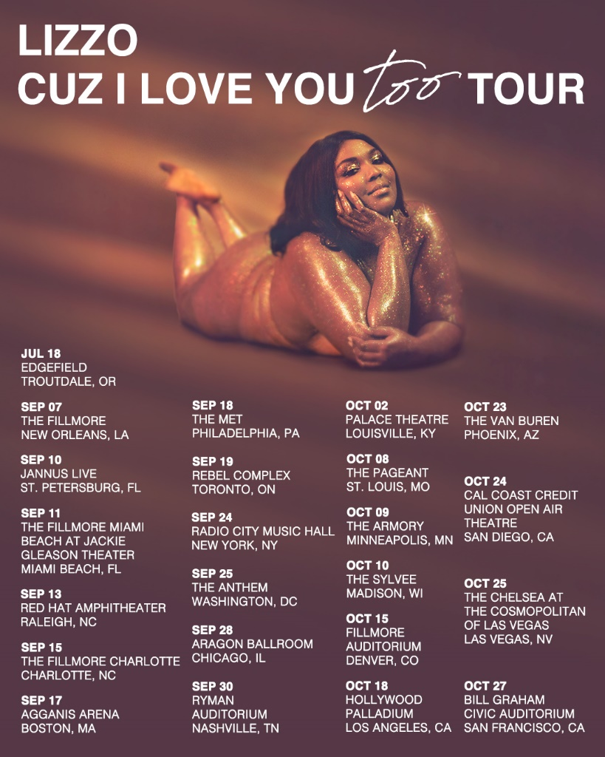
JULY
18 – Troutdale, OR – Edgefield

SEPTEMBER
7 – New Orleans, LA – The Filmore
10 – Saint Petersburg, FL – Jannus Live
11 – Miami Beach, FL – The Fillmore Miami at Jackie Gleason Theater
13 – Raleigh, NC – Red Hat Amphitheater
15 – Charlotte, NC – The Fillmore Charlotte
17 – Boston, MA – Agganis Arena
18 – Philadelphia, PA – The Met
19 – Toronto, ON – Rebel Complex
24 – New York, NY – Radio City Music Hall
25 – Washington, DC – The Anthem
28 – Chicago, IL – Aragon Ballroom
30 – Nashville, TN – Ryman Auditorium

OCTOBER
2 – Louisville, KY – Palace Theatre
8 -Saint Louis, MO – The Pageant
9 – Minneapolis, MN – The Armory
10 – Madison, WI – The Sylvee
15 – Denver, CO – Fillmore Auditorium
18 – Los Angeles, CA – Hollywood Palladium
23 – Phoenix, AZ – The Van Buren
24 – San Diego, CA – Cal Coast Credit Union Open Air Theatre
25 – Las Vegas, NV – The Chelsea at the Cosmopolitan of Las Vegas
27 – San Francisco, CA – Bill Graham Civic Auditorium

About Live Nation Entertainment:
Live Nation Entertainment (NYSE: LYV) is the world’s leading live entertainment company comprised of global market leaders: Ticketmaster, Live Nation Concerts, and Live Nation Sponsorship. For additional information, visit www.livenationentertainment.com.

Lizzo Press Contacts:
Ashley Kalmanowitz
Ashley.Kalmanowitz@atlanticrecords.com
212.707.2051

Tour/Online
Jessica Nall
Jessica.Nall@atlanticrecords.com
(818)-238-6835

Live Nation U.S. Concerts Contacts:
Emily Bender
EmilyBender@livenation.com

Monique Sowinski
MoniqueSowinski@livenation.com

