MARINA RETURNS WITH “MAN’S WORLD EMPRESS OF REMIX (FEAT. PABLLO VITTAR)”

“MAN’S WORLD EMPRESS OF REMIX (FEAT. PABLLO VITTAR)”
AVAILABLE NOW VIA NEON GOLD/ATLANTIC

“One of the most consistently innovative acts in alt-pop.”
- VOGUE

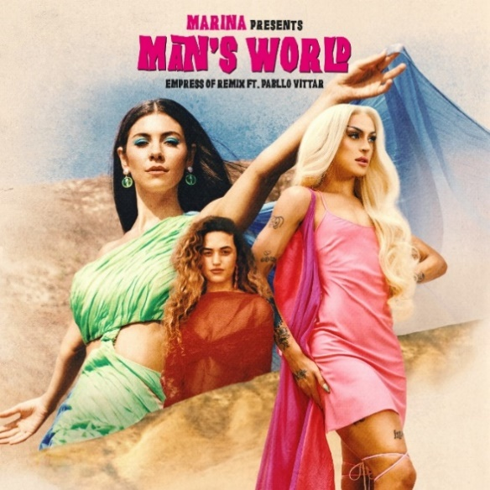
DOWNLOAD PRESS IMAGES HERE

Neon Gold/Atlantic recording artist MARINA has announced today’s premiere of “Man’s World Empress Of Remix (Feat. Pabllo Vittar),” available now at all DSPs and streaming services HERE. The track unites MARINA with a pair of truly remarkable collaborators in acclaimed singer-songwriter-producer Empress Of and award-winning Brazilian drag queen superstar Pabllo Vittar.

Hailed by Billboard as “some of MARINA’s most important work to date,” the original version of “Man’s World” arrived last year amidst wide-ranging critical applause. The track – available for streaming and download HERE – was written solely by MARINA, produced by GRAMMY® Award nominee Jennifer Decilveo (Bat For Lashes, Hinds, Demi Lovato), co-produced by MARINA and engineered by the first-ever female GRAMMY® Award winner for “Best Engineered Album, Non-Classical,” Emily Lazar (Sia, Clairo, Haim). In addition, the track’s companion video and photography was led by acclaimed filmmaker/photographers Alexandra Gavillet and Coughs; acclaimed by Vogue as “one of the most compelling clips in (MARINA’s) decade-plus career,” the “Man’s World” video is streaming now at YouTube HERE.

“Man’s World” was received with high praise in a wide range of media outlets. One of the “Best Songs of the Week,” noted Variety, while E! News praised “Man’s World” as “an ethereal pop song all about her extreme dissatisfaction with the patriarchy. It’s heavy stuff that goes down gently thanks to MARINA’s unrelenting Midas touch.” “(MARINA) shares a laser sharp takedown of the patriarchy,” wrote Refinery 29, “offering up a poetic critique of society’s deep history of misogyny and homophobia.”

Marina is an award-winning, platinum-selling singer-songwriter who burst on to the scene in 2009, she has released four UK Top 10 albums including the Gold certified ‘The Family Jewels’ (2010) and ‘Electra Heart’ (2012) which debuted at Number 1 on the UK’s Official Charts. Each of Marina’s records have been accompanied by global sell-out headline tours with shows at some of the most prestigious venues in the UK (Roundhouse, London Palladium) and US (Greek Theatre, Terminal 5). She has also performed at world renowned festivals including Glastonbury, Coachella, Governors Ball. Marina has amassed over 2 billion worldwide streams and over 640 million video views. A socially engaged figure, she has given an address at the Oxford Union and has an incredibly passionate global fan base with an online following in excess of 7 million. Marina’s previous two part album, Love + Fear debuted TOP 5 in the UK and Top 10 on the U.S. Albums chart.

ABOUT PABLLO VITTAR:

Drag queen and singer-songwriter Pabllo Vittar is a 26-year-old Latin Grammy nominee, MTV EMA & MIAW Award-winner, and a "Next Generation Leader," according to TIME Magazine. In 2017, Pabllo released her debut album Vai Passar Mal that included "K.O." and "Corpo Sensual", both peaking #1 in the Brazilian market. In 2018, her second album Não Para Não was released and broke the record of the most streamed album on Spotify Brazil in the first 24 hours with all tracks charting on the Spotify Top 40. Pabllo Vittar is currently the most followed drag queen on social media worldwide and is #1 on Vevo & Spotify globally. She has starred in campaigns for international brands such as Coke, Adidas, Sky Vodka, & Calvin Klein and has been highlighted by major international media outlets such as Billboard, The New York Times, The Guardian, Vogue, Gay Times, Rolling Stone, Paper Magazine, & GQ. With over 3 billion streams and views combined, Pabllo Vittar has joined forces with international acts, including Charli XCX on "Flash Pose," Major Lazer & Anitta on "Sua Cara,” and Sofi Tukker on "Energia" - just to name a few!

ABOUT EMPRESS OF:

Under the name Empress Of, Honduran-American songwriter, musician and producer Lorely Rodriguez creates introspective, self-empowering pop music centered around her impressive, acrobatic vocals. On her 2015 debut album, Me, she established a danceable, spontaneous sound that embraced whimsicality and percussiveness. With her 2018 sophomore album, Us, Rodriguez wanted to facilitate a more equal exchange of energy between herself and her listeners, to create a community. Her third album - I'm Your Empress Of came on the heels of touring with Lizzo, Blood Orange, Maggie Rogers and Mura Masa and followed her collaborations with Khalid, MØ, DJDS and her song "Wild Girl" with KITO. Lorely shares, "After writing three albums, no process has been the same. This record wasn't written in a remote location. It wasn't written in a collaborative effort. It was written in my small studio in Highland Park, Los Angeles over two months in between touring the world. Music is magic. Something that possesses me, shows me things about myself that aren't easy to see. It's called I'm Your Empress Of because I've always felt that once a song is done, and the emotion is there and it's not inside me anymore, it belongs to the world."

# # #

CONNECT WITH MARINA
OFFICIAL
FACEBOOK
TWITTER
INSTAGRAM
YOUTUBE

