MARINA UNVEILS “MAN’S WORLD”

NEW SONG & VIDEO CREATED IN PARTNERSHIP
WITH ALL-STAR TEAM OF FEMALE COLLABORATORS

OFFICIAL VIDEO PREMIERES TODAY – WATCH HERE

“MAN’S WORLD” AVAILABLE NOW VIA NEON GOLD/ATLANTIC

“I’m creating my next project, and this story can only be told by women.”
– MARINA

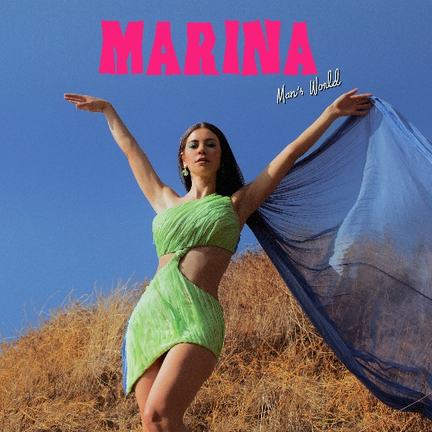

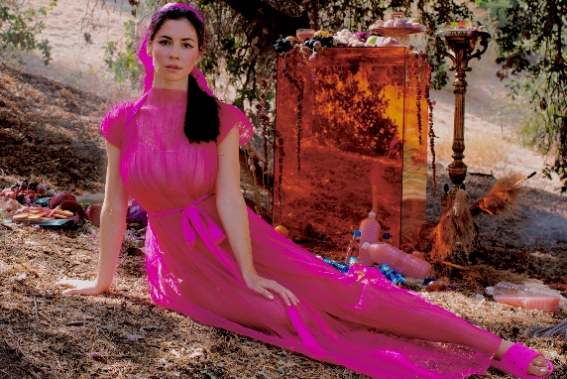
DOWNLOAD PRESS IMAGES HERE

Neon Gold/Atlantic recording artist MARINA has announced today’s premiere of her new single. “Man’s World” is available now at all DSPs and streaming services HERE; an official companion video is streaming now at YouTube HERE.

“Man’s World” sees MARINA delivering on her promise to produce new music created alongside female collaborators, an endeavor which began last year upon learning that women account for only two percent of producers and three percent of engineers involved in popular music. “I’m creating my next project,” she announced on social media, “and this story can only be told by women.”

A year later, MARINA has fully delivered on that promise. Written solely by MARINA, “Man’s World” was produced by GRAMMY® Award nominee Jennifer Decilveo (Bat For Lashes, Hinds, Demi Lovato), co-produced by MARINA and engineered by the first-ever female GRAMMY® Award winner for “Best Engineered Album, Non-Classical,” Emily Lazar (Sia, Clairo, Haim). In addition, the track’s companion video and photography was helmed by an all-female creative team led by acclaimed filmmaker/photographers Alexandra Gavillet and Coughs. Furthermore, “Man’s World” will be joined in the coming weeks by a series of remixes from such visionary female artists as MUNA, Empress Of, and more.

MARINA is an award-winning, platinum-selling singer-songwriter who burst on to the scene in 2009. She has since released four UK Top 10 albums including the Gold certified ‘The Family Jewels’ (2010), ‘Electra Heart’ (2012), which debuted at Number 1 on the UK’s Official Charts, and FROOT (2015). Marina’s most recent album, Love + Fear (2019) debuted TOP 5 in the UK and Top 10 on the U.S. Albums chart. Each of Marina’s records have been accompanied by global sell-out headline tours with shows at some of the most prestigious venues in the UK (Roundhouse, London Palladium) and US (Greek Theatre, Terminal 5). She has also performed at world renowned festivals including Glastonbury, Coachella, Governors Ball. Marina has amassed 2 billion worldwide streams and over 600 million video views. A socially engaged figure, she has given an address at the Oxford Union and has an incredibly passionate global fan base with an online following in excess of 7 million.

LOVE + FEAR was instantly met with worldwide acclaim upon its April 2019 release. “A mix of vulnerable and introspective songs, LOVE + FEAR centers on a longing to enjoy life,” wrote ELLE, “the desire for unity within the human race, and the process of finding purpose. The result? One of MARINA’s most compelling albums to date.” MARINA celebrated the acclaimed album on her LOVE + FEAR TOUR, with sold out headline dates and show-stopping festival sets around the world. In addition, MARINA made a number of high profile TV appearances, including live performances of “Karma” on ABC’s Jimmy Kimmel Live! and “Orange Trees” on NBC’s Late Night With Seth Meyers.

# # #

CONNECT WITH MARINA
OFFICIAL
FACEBOOK
TWITTER
INSTAGRAM
YOUTUBE

