MARINA RETURNS WITH “PURGE THE POISON”
OFFICIAL MUSIC VIDEO PREMIERES TODAY
LISTEN/WATCH

NEW SONG HERALDS EAGERLY ANTICIPATED FIFTH STUDIO ALBUM,
ANCIENT DREAMS IN A MODERN LAND,
ARRIVING FRIDAY JUNE 11TH

ALBUM PRE-ORDERS AVAILABLE NOW HERE

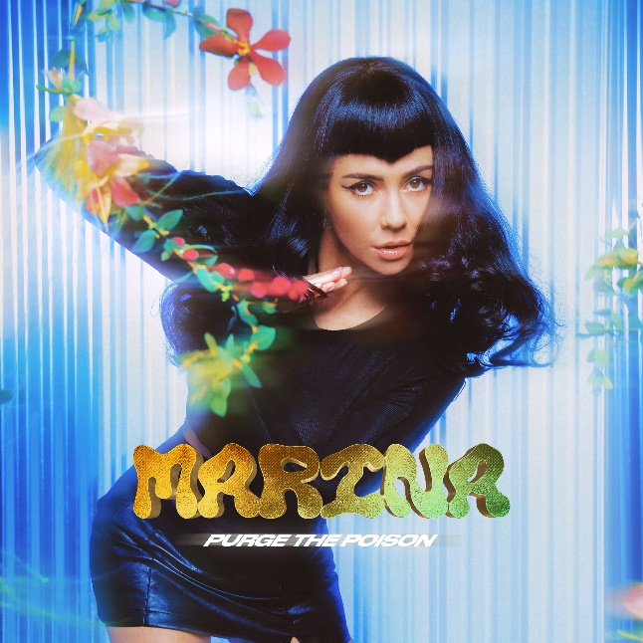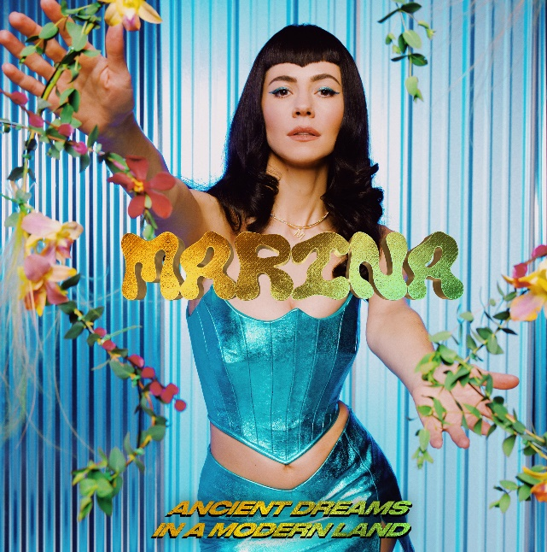

DOWNLOAD PRESS IMAGES HERE

“One of the most consistently innovative acts in alt-pop.”
- VOGUE

Neon Gold/Atlantic recording artist MARINA has announced today’s premiere of “Purge The Poison,” available now at all DSPs and streaming services HERE. The track is joined by an official music video, directed by Weird Life Films and streaming now HERE.

“Purge The Poison” heralds MARINA’s anticipated new album, ANCIENT DREAMS IN A MODERN LAND, due everywhere on Friday, June 11th; pre-orders are available now HERE.

ANCIENT DREAMS IN A MODERN LAND marks MARINA’s fifth studio album and first full-length release since 2019’s acclaimed LOVE + FEAR. The self-penned new album also sees MARINA co-producing six tracks alongside songwriter/producer James Flanigan (Dua Lipa, Carly Rae Jepsen, Hayley Kiyoko) and GRAMMY® Award-nominated producer/multi-instrumentalist Jennifer Decilveo (Andra Day, Bat For Lashes, Hinds).

ANCIENT DREAMS IN A MODERN LAND includes the already released track, “Man’s World.” Written solely by MARINA in reaction to the startling statistics that only two percent of producers and three percent of engineers across popular music are women, “Man’s World” was produced by Decilveo and co-produced by MARINA, and engineered by the first-ever female GRAMMY® Award winner for “Best Engineered Album, Non-Classical,” Emily Lazar (Sia, Clairo, Haim). The song and accompanying video were met by high praise from a wide range of international media outlets, with Billboard declaring it among “MARINA’s most important work to date.” “Man’s World” is “a laser sharp takedown of the patriarchy,” raved Refinery29, while BlackBook applauded the track as “just the sort of inspiration we need right now.”

“Man’s World” is accompanied by an official companion video, created in collaboration with acclaimed filmmaker/photographers Alexandra Gavillet and Coughs. Hailed by Vogue as “one of the most compelling clips in (MARINA’s) decade-plus career,” “Man’s World” is streaming now at the official MARINA YouTube channel HERE.

With over 2.3 billion worldwide streams and over 660 million video views, MARINA is an award-winning, platinum-selling singer-songwriter who burst onto the scene in 2009. MARINA has since released four Top 10 albums including 2010’s gold certified THE FAMILY JEWELS, 2012’s ELECTRA HEART (which debuted at #1 on the UK’s Official Charts), and 2015’s FROOT, which reached #1 on the iTunes ‘Top Albums’ chart in a range of countries including the US, the UK, Argentina, and more. MARINA’s most recent album, 2019’s LOVE + FEAR, debuted among the Top 5 in the UK and in the Top 10 on the US Albums chart. All four albums were accompanied by global sell-out headline tours featuring shows at some of the world’s most prestigious venues, including the London’s famed Roundhouse and London Palladium, Los Angeles’ Greek Theatre, and New York City’s Terminal 5. MARINA has also performed at a number of world renowned festivals, including Glastonbury, Coachella, and Governors Ball. A socially engaged artist, MARINA has given a powerful address at the Oxford Union and boasts an incredibly passionate global fan base with an online following in excess of 7M.

# # #

MARINA
ANCIENT DREAMS IN A MODERN LAND
(Neon Gold/Atlantic)
Release Date: Friday, June 11th

TRACKLIST

1. Ancient Dreams In A Modern Land
2. Venus Fly Trap
3. Man’s World
4. Purge The Poison
5. Highly Emotional People
6. New America
7. Pandora’s Box
8. I Love You But I Love Me More
9. Flowers
10. Goodbye

# # #

CONNECT WITH MARINA
OFFICIAL
TWITTER
INSTAGRAM
YOUTUBE
FACEBOOK

