**MASON RAMSEY READIES *TWANG* EP**

**RISING COUNTRY SUPERSTAR TO RELEASE 5-SONG COLLECTION OF NEW MUSIC**

**INCLUDING INSTANT FAN-FAVORITE TITLE TRACK “TWANG”**

**HIGHLIGHTED AS STAND OUT FEATURE ON BLOCKBUSTER REMIX OF LIL NAS X’S RECORD-BREAKING SINGLE “OLD TOWN ROAD”**

***TWANG* EP ARRIVES THIS FRIDAY, JULY 26**

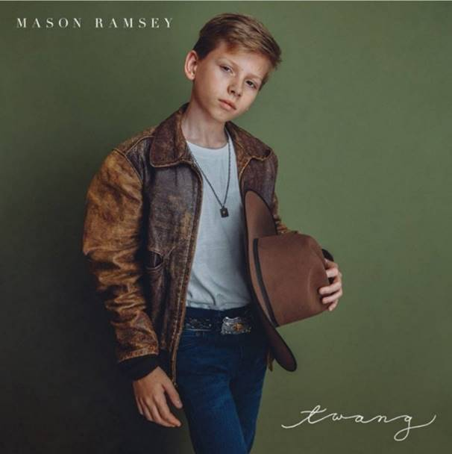

**NEW YORK, NY** (July 22, 2019) — 12-year-old rising Country superstar, **MASON RAMSEY** returns with ***TWANG* EP**, his first collection of new music in over a year. The 5-song EP – which features the instant fan-favorite title track – also marks the **first time Ramsey is credited as a co-writer**, an impressive feat for a 12-year-old. Adding to this, the companion visual to “Twang,” which was released last month, currently has over 5 million views on [YouTube](https://youtu.be/xwe8F_AhLY0), with no signs of slowing down.

***TWANG* EP arrives at all digital retailers and streaming partners this Friday, July 26 via Big Loud Records/Atlantic Records.**

The release of ***TWANG* EP**, comes on the heels of Ramsey’s **stand out feature** on the much talked about remix to **Lil Nas X’s “Old Town Road” (with Billy Ray Cyrus and Young Thug)**,” which exceeded 20M+ streams globally~~,~~ in the first week alone and catapulted Ramsey **to Twitter’s #1 Worldwide Trending Topic**. The blockbuster song’s remix was accompanied by two viral visuals including an [**emoji-filled lyric video**](https://youtu.be/loSuMqwQA38) and an [**Area 51-inspired visual**](https://youtu.be/aA7xDP9sQzk), which have a combined total of over **25M+ views** on YouTube.

***TWANG* EP Track List:**

1. Twang

2. Puddle of Love

3. How Could I Not

4. On My Way

5. Before I Knew It

* * *

**ABOUT MASON RAMSEY:**

As the youngest major label Country artist signed in the genre in nearly two decades, Mason Ramsey continues his fast-track to stardom after being discovered singing in an aisle at his local Walmart. Praised by ***THE NEW YORK TIMES*** as delivering "a stylistically diverse country and roots music EP,” the **BIG LOUD RECORDS** and **ATLANTIC RECORDS** artist’s debut ***FAMOUS EP*** spawned a hit single of the same name which scored a **#4 spot on *Billboard*’s Hot Country Songs Chart**. In addition to making his debut at the famed Grand Ole Opry, the Golconda, IL-bred phenom has also performed at several high-profile festivals including **CMA FEST**, **iHEARTCOUNTRY FESTIVAL**, **STAGECOACH**, and **COACHELLA**, and was also nominated for the *Social Star Award* at the 2019 iHeartRadio Awards. Ramsey has also made major television appearances on ***THE TODAY SHOW***,  ***GOOD MORNING AMERICA***and ***ELLEN***. Named among ***Billboard*’s “21 Under 21” class of 2018**, Ramsey has supported multi-platinum duo Florida Georgia Line during their FLORIDA GEORGIA LINE LIVE FROM LAS VEGAS residency and labelmate Chris Lane. After completing his first sold-out headline tour this past spring, Ramsey will hit the road for the fall leg of his headlining HOW’S UR GIRL & HOW’S UR FAMILY PT. 2 TOUR.

**NEW PRESS IMAGE – PHOTO CREDIT: NICK SWIFT**

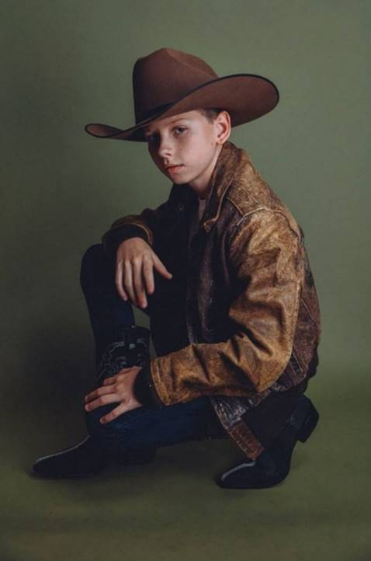

* * *

**MEDIA CONTACTS:**

Jason Davis, Atlantic Records (National) - [Jason.Davis@atlanticrecords.com](mailto:Jason.Davis@atlanticrecords.com)

Andrew George, Atlantic Records (Tour/Online) - [andrew.george@atlanticrecords.com](mailto:andrew.george@atlanticrecords.com)

Jensen Sussman, Sweet Talk Publicity - [jensen@sweettalkpr.com](mailto:jensen@sweettalkpr.com)

Julianne Cassidy, Sweet Talk Publicity - [jcassidy@sweettalkpr.com](mailto:jcassidy@sweettalkpr.com)

# # #