**MASON RAMSEY RETURNS WITH “TWANG”**

[**WATCH HERE**](https://masonramsey.lnk.to/TwangVideoPR)

[Directed by Justin Clough]

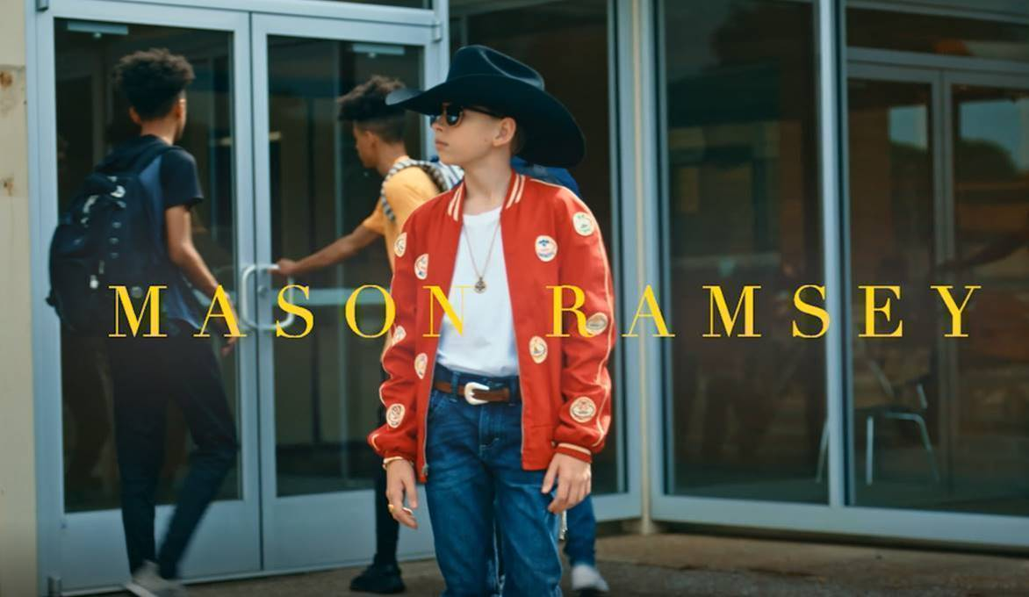

12-year-old **MASON RAMSEY** is back with a brand new single, “**Twang**,” and a smooth companion music video to match. As the youngest major label country artist signed in the genre in nearly two decades, Ramsey continues his fast-track to stardom after being discovered singing in an aisle at his local Walmart. Praised by ***THE NEW YORK TIMES*** as delivering "a stylistically diverse country and roots music EP,” the **BIG LOUD RECORDS** and **ATLANTIC RECORDS** artist’s debut ***FAMOUS EP*** spawned a hit single of the same name which scored a **#4 spot on *Billboard*’s Hot Country Songs Chart**. In addition to making his debut at the famed Grand Ole Opry, the Golconda, IL-bred phenom has also performed at several high-profile festivals including **CMA FEST**, **iHEARTCOUNTRY FESTIVAL**, **STAGECOACH**, and **COACHELLA**, and was also nominated for the *Social Star Award* at the 2019 iHeartRadio Awards. Ramsey has also made major television appearances on **THE TODAY SHOW**,  **GOOD MORNING AMERICA** and **ELLEN**. Named among ***Billboard*’s “21 Under 21” class of 2018**, Ramsey has supported multi-platinum duo Florida Georgia Line during their Florida Georgia Line Live From Las Vegas residency and labelmate Chris Lane. After completing his first sold-out headline tour this past Spring, Ramsey will hit the road later this year for the Fall leg of his headlining “**How’s Ur Girl & How’s Ur Family Pt. 2**” **Tour**.

[**“TWANG”**](https://masonramsey.lnk.to/Twang)is available at all digital retailers & streaming partners.

**MEDIA CONTACTS:**

Jason Davis, Atlantic Records (National) - [Jason.Davis@atlanticrecords.com](mailto:Jason.Davis@atlanticrecords.com)

 Andrew George, Atlantic Records (Tour/Online) - [andrew.george@atlanticrecords.com](mailto:andrew.george@atlanticrecords.com)

 Jensen Sussman, Sweet Talk Publicity - [jensen@sweettalkpr.com](mailto:jensen@sweettalkpr.com)

Julianne Cassidy, Sweet Talk Publicity - [jcassidy@sweettalkpr.com](mailto:jcassidy@sweettalkpr.com)

* * *

**VIDEO LINK:** <https://masonramsey.lnk.to/TwangVideo>

**AUDIO LINK:**<https://masonramsey.lnk.to/Twang>

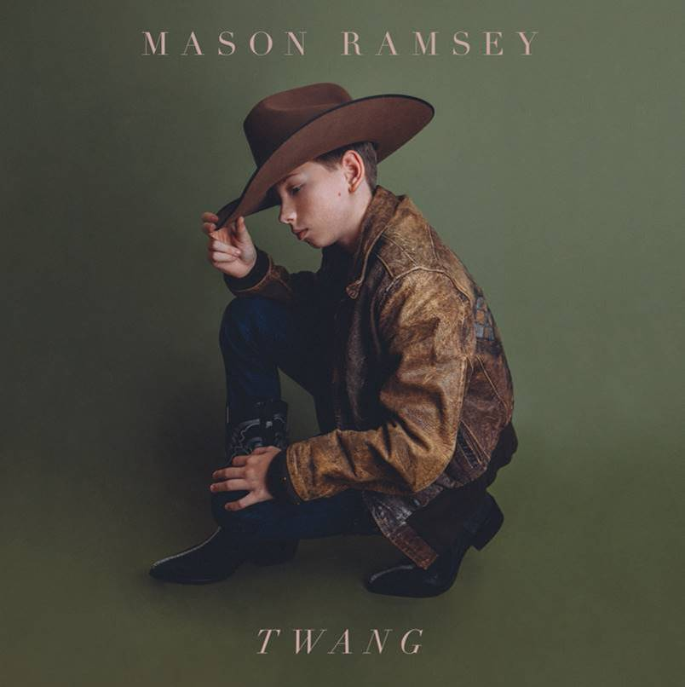

[Photo by **Nick Swift**]

# # #