**MASTER KATO UNVEILS “RIDE AROUND”**

**SHORELINE MAFIA RAPPER RELEASES VISUAL**

**FOR HIS PREVIOUSLY RELEASED SINGLE**

[**WATCH “RIDE AROUND” HERE**](https://www.youtube.com/watch?v=z4ozAy2HTKU&feature=youtu.be)

[**EMBED CODE**](iframe%20width=%22560%22%20height=%22315%22%20src=%22https:/www.youtube.com/embed/z4ozAy2HTKU%22%20frameborder=%220%22%20allow=%22accelerometer;%20autoplay;%20encrypted-media;%20gyroscope;%20picture-in-picture%22%20allowfullscreen%3e%3c/iframe)

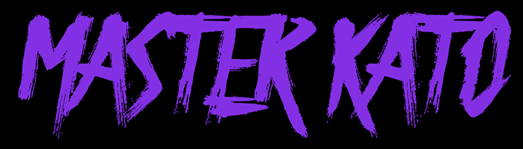

**Master Kato of Shoreline Mafia** is on the scene with visuals to his debut single “Ride Around,” which premiered today. Directed by **Juddyremixdem** with additional animation by **Andrew William Ralph**, the video vibes with psychedelic elements and gives its listener a seat on the couch at a classic Compton, CA party. The track, which dropped last month, was produced by prolific LA-based **Ron-Ron**.

*“Master Kato is the unsung member of Shoreline Mafia. “Ride Around” is a showcase for the gravel-voice rapper as he jumps on a breezy beat from prolific West Coast producer Ron-Ron. It makes you realize how deep Shoreline Mafia is when the group has a rapper this capable lingering in the background.”*

***PITCHFORK***

Coming off of a successful third headlining tour with **SHORELINE MAFIA**, Rob Vicious and Master Kato rolled onto their MAFIA TWINS tour through the month of November. As the most played artist on Spotify in California, Shoreline Mafia is gearing up to hit the stage for their last performance of the year at **Rolling Loud** in Los Angeles in December.

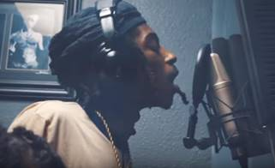

**CATCH MASTER KATO + ROB VICIOUS ON THEIR “MAFIA TWINS” TOUR**

**TOUR DATES:**

**11/16  Portland, OR**

**11/17  Vancouver, BC**

**11/18 Seattle, WA**

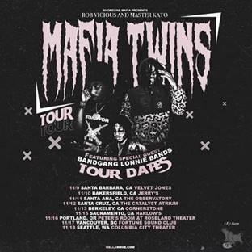

**CONNECT WITH SHORELINE MAFIA**

[FACEBOOK](https://www.facebook.com/ShorelineMafia/) | [INSTAGRAM](https://www.instagram.com/shorelinemafia/) | [TWITTER](https://twitter.com/SHORELINEMAFIA)