MATT MAESON TO JOIN JAYMES YOUNG ON NORTH AMERICAN SUMMER TOUR

“CRINGE” HIGHLIGHTED IN THIS MONTH’S VEVO DSCVR SERIES – WATCH here

WHO KILLED MATT MAESON OUT EVERYWHERE NOW
“On first glance, there's nothing fancy about Virginia-born singer-songwriter Matt Maeson: just a guy and his guitar. But his raw performance of cutting emotional ballad "Straight Razor" is bound to get right under your skin as its intensity builds.” – TIME

“If the name Matt Maeson is unfamiliar, take note because it won’t be for long. ‘If Tyler Joseph of twenty one pilots were to go solo and write an alternative/indie song, it’s outcome may very well be this.’ And I say this in the best way possible.” – PASTE

“He just released his first EP, Who Killed Matt Maeson, a six-song collection that blends giant pop hooks, foot-stomping nods to roots music, and alt-rock leaning production reminiscent of acts like Manchester Orchestra and Twenty One Pilots to create a sound unlike much else out there. – AMERICAN SONGWRITER

Neon Gold/Atlantic Records singer/songwriter Matt Maeson has announced plans to join label-mate Jaymes Young on his “Feel Something” summer headline tour, which kicks off at the famed Troubadour in Los Angeles on July 11th. The tour includes a stop at Bowery Ballroom in New York City on July 27th before wrapping up at Exit/In in Nashville on August 2nd.

Maeson, who is celebrating the release of his March debut EP, WHO KILLED MATT MAESON, available now in stores and at all online retailers here, is in Europe for select dates and showcases; including a show at London’s Heaven on Tuesday, May 16, alongside Dan Croll (see full dates attached).

In more news, VEVO launched their latest installment of VEVO dscvr – which includes a beautifully shot, acoustic performance of lead single “Cringe.” The video, shot in New York City at the VEVO studio, showcases his raw, soulful vocals in a stripped down manner; watch here.

Maeson has been on a remarkable journey all his life. The Norfolk, VA-native grew up on tour, traveling and performing with his parents’ prison ministry at maximum-security penitentiaries across America. His experiences – which include winning over crowds of naked women and Hells Angels at the world famous Sturgis Motorcycle Rally in South Dakota – inspired him to begin writing songs, spare and powerful confessionals infused with additional strength via his soulful vocal approach.

Maeson posted his first songs online in late 2015 and immediately drew attention as a major new songwriting voice. In summer 2016, Maeson embarked on his first US headline tour, presented by Communion, the influential artists’ collective co-founded by Mumford and Sons’ Ben Lovett, to great success.

“Cringe” proved a breakthrough upon its release last year, earning over 600,000 streams in its first month alone, driving the track to #12 on Spotify’s “US Viral 50” chart as well as #17 on the “Global Viral 50” ranking. The single is accompanied by a striking companion video, acclaimed by SPIN in its world premiere as “a battered and bloodied portrait of the musician, laying bare struggles with faith as he slowly, triumphantly surmounts the odds.” “Roots of rock weave through Maeson’s classic-sounding debut single,” added The Line of Best Fit, “fortifying its anthemic pop chorus.” “Cringe” is streaming now at Maeson’s official YouTube channel. “Tribulation” followed, “If Tyler Joseph of Twenty One Pilots were to go solo and write an alternative/indie song, its outcome may very well be this. And I say this in the best way possible.,” noted Paste. The single proved as popular as its predecessor, drawing over 100,000 streams in its first 24 hours alone.

WHO KILLED MATT MAESON is further highlighted by “Straight Razor,” whose raw companion visual, filmed earlier this year in an Altadena, CA church, reveals Matt lamenting about the mistakes he's made in the past to his younger self. Watch the video here. “Straight Razor” pairs its title with “stargazer” in the first two lines, an ember that catches fire in the track’s anthemic gang vocal finale.

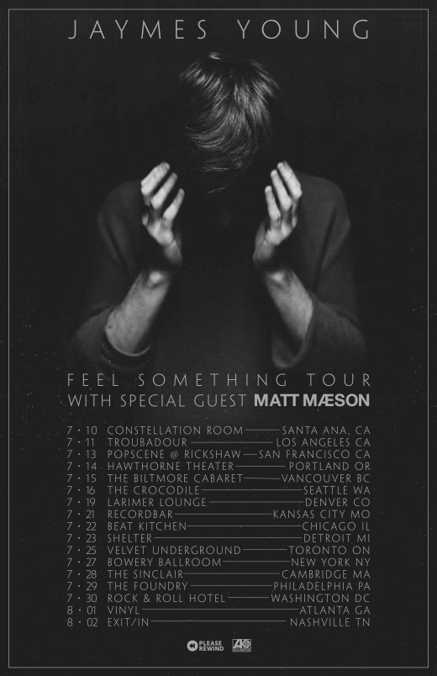

2017 EUROPEAN TOUR DATES
May 16 - London, UK - Heaven w/Dan Croll
May 19 - Brighton, UK - Komedia - TGE Communion Showcase
May 20 - Brighton, UK - Coalition - TGE New Shapes Showcase

2017 NORTH AMERICAN TOUR DATES
supporting Jaymes Young on all dates unless noted otherwise
7/10 – Constellation Room – Santa Ana, CA
7/11 – Troubadour – Los Angeles, CA
7/13 – Popscene @ Rickshaw Stop – San Francisco, CA
7/14 – Hawthorne Theater – Portland, OR
7/15 – The Biltmore Cabaret – Vancouver, BC
7/16 – The Crocodile – Seattle, WA
7/19 – Larimer Lounge – Denver, CO
7/21 – recordBar – Kansas City, MO
7/22 – Beat Kitchen – Chicago, IL
7/23 – Shelter – Detroit, MI
7/25 – Velvet Underground – Toronto, ON
7/27 – Bowery Ballroom – New York, NY
7/28 – The Sinclair – Cambridge, MA
7/29 – The Foundry – Philadelphia, PA
7/30 – Rock & Roll Hotel – Washington, DC
8/1 – Vinyl – Atlanta, GA
8/2 – Exit/In – Nashville, TN

