**MAX FROST ANNOUNCES THE A.D.D. TOUR**

**HEADLINE RUN BEGINS SEPTEMBER 25TH IN PHOENIX, AZ**

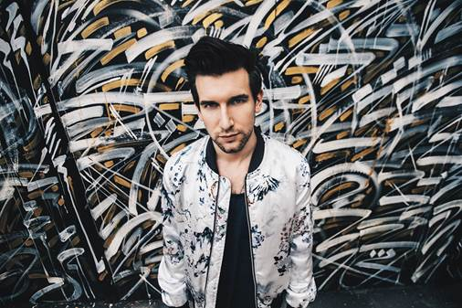

[THE A.D.D. TOUR ANNOUCEMENT VIDEO](https://www.youtube.com/watch?v=SusmukZblXM&feature=youtu.be)

Max Frost will embark on his first national headline tour on September 25th in Phoenix, AZ at Crescent Ballroom. Continuing through the Fall, Max will play venues in major cities including Los Angeles, New York, and Chicago. Max finished off a stellar 2016 by releasing the addicting single “Adderall”, which continues to rack up streams, finding its way into largely followed Spotify playlists.

Last month, Viacom premiered an original virtual reality music experience for Max’s song “Withdrawal" at the Microsoft Build Developer Conference. The video harnesses cutting-edge Microsoft Mixed Reality capture technology, bringing fans face-to-face with photorealistic holographs of Max performing in an immersive, underwater environment.

Max has spent the past couple years on the road, touring in the US, as well as in Europe and Australia, all the while finding time to release two EPs, and several singles, as he readies more music to be released this summer, followed by his debut album later this year.

Max has toured with Gary Clark Jr., Fitz & The Tantrums, HONNE and Wild Child.

**MAX FROST HEADLINE TOUR**

9/25: Crescent Ballroom - Phoenix, AZ  
9/26: Club Congress - Tucson, AZ  
9/29: Dada - Dallas, TX  
9/30: The Belmont - Austin, TX  
10/1: House of Blues (Bronze Peacock) - Houston, TX  
10/3: The Syndicate Lounge - Birmingham, AL  
10/5: The High Watt - Nashville, TN  
10/6: Masquerade (Purgatory Stage) - Atlanta, GA  
10/7: Cat’s Cradle (Back Room) - Carrboro, NC  
10/9: DC9 - Washington, DC  
10/10: Boot & Saddle - Philadelphia, PA  
10/11: Rough Trade - Brooklyn, NY  
10/12: Great Scott - Boston, MA  
10/14: The Ritz - Montreal, QC  
10/15: Drake Hotel - Toronto, ON  
10/17: The Basement - Columbus, OH  
10/18: Pike Room - Pontiac, MI  
10/20: Lincoln Hall - Chicago, IL  
10/21: 7th Street Entry - Minneapolis, MN  
10/22: The Riot Room - Kansas City, MO  
10/24: Globe Hall - Denver, CO  
10/26: Kilby Court - Salt Lake City, UT  
10/27: Neurolux - Boise, ID  
10/28: Doug Fir Lounge - Portland, OR  
10/30: Fox Cabaret - Vancouver, BC  
10/31: Barboza - Seattle, WA  
11/2: Rickshaw Stop - San Francisco, CA  
11/3: Constellation Room - Santa Ana, CA  
11/4: Irenic - San Diego, CA  
11/8: The Echo - Los Angeles, CA

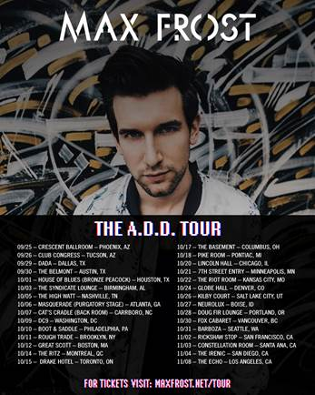

**FOR MORE ON MAX FROST, VISIT:**

[http://press.atlanticrecords.com/max-frost/](https://protect-us.mimecast.com/s/mmoXBOiwxl9bHb)

[www.youtube.com/user/maxfrostofficial](https://protect-us.mimecast.com/s/kJ5aBxSq8e4dCE)

[https://www.instagram.com/maxfrost/](https://protect-us.mimecast.com/s/pVqrBztg9L3oiD)

[www.facebook.com/maxfrostmusic](https://protect-us.mimecast.com/s/LLO4Bkcz64amsz)

[https://twitter.com/maxfrost](https://protect-us.mimecast.com/s/GWDgBlumNgKOCd)

[http://maxfrost.net/](https://protect-us.mimecast.com/s/Y1MQBNipb4KLIW)

Contact Info

Christina Kotsamanidis

212-707-2241

[Christina.Kotsamanidis@atlanticrecords.com](mailto:Christina.Kotsamanidis@atlanticrecords.com)

Amy Laudicano

212.707.3067

[Amy.Laudicano@atlanticrecords.com](mailto:Amy.Laudicano@atlanticrecords.com)