MAX FROST UNVEILS “BACK IN THE SUMMER” VIDEO
WATCH HERE

“The video for ‘Back In The Summer’ was far and away the most seamless video I’ve ever been a part of,” Max says. “It was the first time I received a first treatment and instantly thought: that’s the one. I shot it in Melbourne, Australia right after my tour with Bastille with a really cool director named Josh Harris. He and the crew put a lot of love into it.”

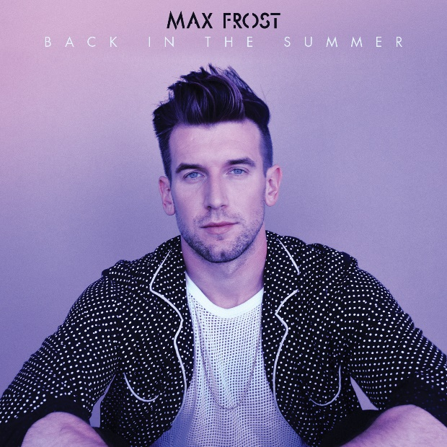

Max Frost has unveiled a companion video for his new track, “Back In The Summer;” which is available at all DSPs and streaming services now. The video directed by Josh Harris brings summery warmth and whimsy- watch HERE. “Back In The Summer” follows his previously-released track “Perfect Man” and debut album “Gold Rush,” and precedes more new music to come through the spring.

An energetic solo performer hailed for his captivating one-man-band performances, Frost has been touring extensively in support of his debut album “Gold Rush”, including tours with twenty one pilots, Panic! At The Disco, and on his own sold out national headline Gold Rush Tour.

Album “Gold Rush,” boasts his break-through single “Good Morning.” “Good Morning” was featured in a yearlong advertising campaign launching Pepsi’s new bubbly™ line of sparkling waters and on ESPN’s COLLEGE GAMEDAY. The song was also been included in promotional spots for ESPN’s new morning show, GET UP, as well as in recent episodes of ABC’s AMERICAN IDOL and GREY’S ANATOMY.

Frost has made a series of high profile national TV appearances in recent months, including ABC’s GOOD MORNING AMERICA, highlighted by live performances of both “Good Morning” and “Eleven Days,” and the nationally syndicated LIVE! WITH KELLY AND RYAN, featuring a live take on “Good Morning.”

Named by both NPR and Rolling Stone as one of “10 Artists You Need To Know,” Max Frost has earned acclaim with his electrifyingly idiosyncratic sonic blend, a musical merging of soul, funk, alternative, pop, and electronica that has seen him lauded in such high profile national outlets as Interview, Billboard, Idolator, and NPR Music.

MAXFROST.NET
FACEBOOK
TWITTER
INSTAGRAM
YOUTUBE

