**MAX FROST RELEASES NEW SONG “HIGH ALL DAY”**

**HEADLINE TOUR BEGINS SEPTEMBER 25TH IN PHOENIX, AZ**

[**LISTEN TO “HIGH ALL DAY”**](https://atlantic.lnk.to/HighAllDay)

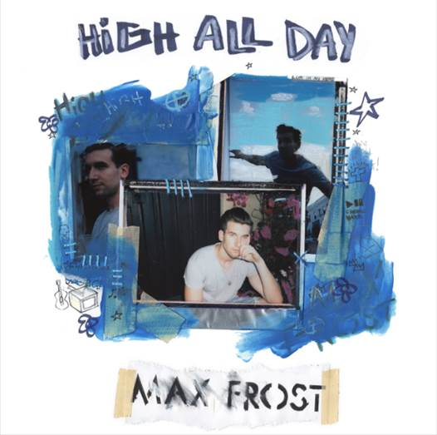

Max Frost has released a brand new song, “High All Day,” co-written with Michael “Fitz” Fitzpatrick (Fitz and The Tantrums). The new track is streaming here: <https://atlantic.lnk.to/HighAllDay>.

Max Frost will embark on his first national headline tour on September 25th in Phoenix, AZ at Crescent Ballroom. Continuing throughout the Fall, Max will play venues in major cities including Los Angeles, New York, and Chicago. Max finished off a stellar 2016 by releasing the addicting single “Adderall”, which continues to rack up streams, finding its way into largely followed Spotify playlists.

Max has spent the past couple years on the road, touring in the US, as well as in Europe and Australia, all the while finding time to release two EPs, and several singles, as he readies more music to be released in the coming months, followed by his debut album in 2018.

Max has toured with Gary Clark Jr., Fitz & The Tantrums, HONNE and Wild Child.

**MAX FROST HEADLINE TOUR**

9/25: Crescent Ballroom - Phoenix, AZ  
9/26: Club Congress - Tucson, AZ  
9/29: Dada - Dallas, TX  
9/30: The Belmont - Austin, TX  
10/1: House of Blues (Bronze Peacock) - Houston, TX  
10/3: The Syndicate Lounge - Birmingham, AL  
10/5: The High Watt - Nashville, TN  
10/6: Masquerade (Purgatory Stage) - Atlanta, GA  
10/7: Cat’s Cradle (Back Room) - Carrboro, NC  
10/9: DC9 - Washington, DC  
10/10: Boot & Saddle - Philadelphia, PA  
10/11: Rough Trade - Brooklyn, NY  
10/12: Great Scott - Boston, MA  
10/14: The Ritz - Montreal, QC  
10/15: Drake Hotel - Toronto, ON  
10/17: The Basement - Columbus, OH  
10/18: Pike Room - Pontiac, MI  
10/20: Lincoln Hall - Chicago, IL  
10/21: 7th Street Entry - Minneapolis, MN  
10/22: The Riot Room - Kansas City, MO  
10/24: Globe Hall - Denver, CO  
10/26: Kilby Court - Salt Lake City, UT  
10/27: Neurolux - Boise, ID  
10/28: Doug Fir Lounge - Portland, OR  
10/30: Fox Cabaret - Vancouver, BC  
10/31: Barboza - Seattle, WA  
11/2: Rickshaw Stop - San Francisco, CA  
11/3: Constellation Room - Santa Ana, CA  
11/4: Irenic - San Diego, CA  
11/8: The Echo - Los Angeles, CA

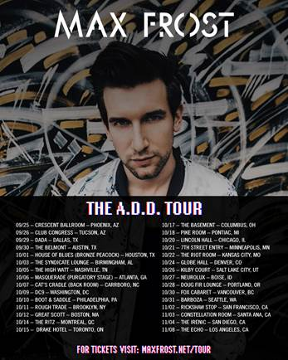

**FOR MORE ON MAX FROST, VISIT:**

[http://press.atlanticrecords.com/max-frost/](https://protect-us.mimecast.com/s/mmoXBOiwxl9bHb)

[www.youtube.com/user/maxfrostofficial](https://protect-us.mimecast.com/s/kJ5aBxSq8e4dCE)

[https://www.instagram.com/maxfrost/](https://protect-us.mimecast.com/s/pVqrBztg9L3oiD)

[www.facebook.com/maxfrostmusic](https://protect-us.mimecast.com/s/LLO4Bkcz64amsz)

[https://twitter.com/maxfrost](https://protect-us.mimecast.com/s/GWDgBlumNgKOCd)

[http://maxfrost.net/](https://protect-us.mimecast.com/s/Y1MQBNipb4KLIW)

Contact Info

Christina Kotsamanidis

212-707-2241

[Christina.Kotsamanidis@atlanticrecords.com](mailto:Christina.Kotsamanidis@atlanticrecords.com)

Amy Laudicano

212.707.3067

[Amy.Laudicano@atlanticrecords.com](mailto:Amy.Laudicano@atlanticrecords.com)