MESSIAH RELEASES NEW SINGLE "NO GRATIS"

ANNOUNCES MIXTAPE “B.E.N.I.T.O.” COMING JULY 10TH

Photo Credit: Jared Ryder

LISTEN/WATCH: https://youtu.be/o4vVRukX9fw
BUY/STREAM: https://Atlantic.lnk.to/NoGratisPR

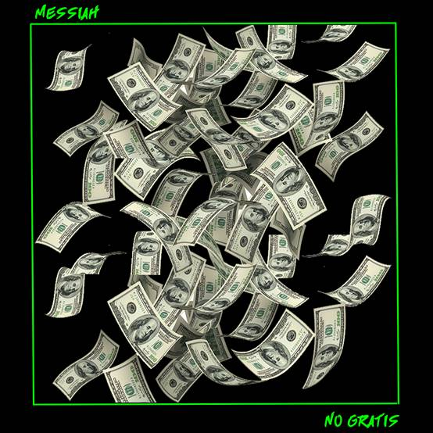

PERFORMING AT S.O.B.’S IN NEW YORK CITY ON JULY 13
Latium Entertainment/Atlantic recording artist MESSIAH has announced the release of his new single "NO GRATIS", available worldwide today across all platforms. Listen HERE! The record will be featured on Messiah’s forthcoming mixtape, "B.E.N.I.T.O", set for release on July 10th. Both "No Gratis" and "B.E.N.I.T.O" are being released under his record label Latium Entertainment/Atlantic.

"No Gratis" was penned by Benito Emmanuel Garcia (Messiah), Garcia Brian Anthony, and Edward Joshua Thomas, and produced by Peoples & Shyboogs.

Recognized in the mainstream and Latin markets as a founder of Latin Trap, the Dominican artist has performed at iconic venues including New York City's Madison Square Garden and Stage 48, becoming the first Latin artist to sell out the latter.

Messiah is currently preparing for his upcoming show at SOB’s in New York on July 13, where he’ll be turning up the heat with the tracks that have catapulted him to stardom.

Messiah has collaborated with artists such as Cardi B, Elvis Crespo, Tory Lanez, and Bad Bunny, among others, and his new mixtape will not spare any room for chart-topping club bangers, as well as multiple collaborations.
###

For more information about MESSIAH visit:
FACEBOOK | TWITTER | INSTAGRAM | YOUTUBE | ATLANTICRECORDS.COM

Press inquiries: Nayira Castellanos, 305.721.6082, Nayira@beatspr.com

Corey Brewer, 212.707.2151, corey.brewer@atlanticrecords.com

