FOR IMMEDIATE RELEASE

FEBRUARY 7, 2020

**MILCK RETURNS WITH POWERFUL ANTHEM “**[**IF I RULED THE WORLD**](https://Milck.lnk.to/IIRTWPR)**”**

[**WATCH THE EMBOLDENING AND ASPIRATIONAL LYRIC VIDEO**](https://Milck.lnk.to/IIRTWPR/youtube)

**[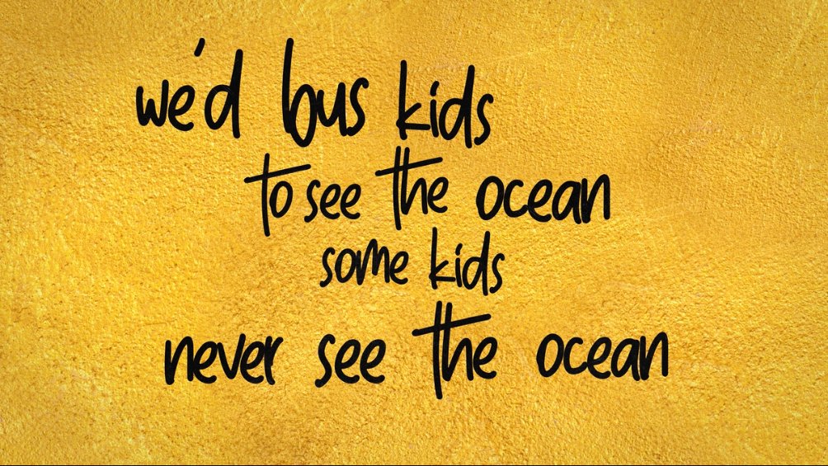](https://Milck.lnk.to/IIRTWPR/youtube)**

**TRANSFORMATIVE *INTO GOLD* EP OUT FRIDAY, FEBRUARY 21ST**

Inspirational singer-songwriter-activist **MILCK,** who first made waves with her global fight song “[Quiet](https://nam04.safelinks.protection.outlook.com/?url=https%3A%2F%2Fwww.youtube.com%2Fwatch%3Fv%3DTl_Qfj8780M&data=02%7C01%7CMegan.Rasmussen%40atlanticrecords.com%7Cd33d5075a31540b4da2908d7a51a538b%7C8367939002ec4ba1ad3d69da3fdd637e%7C0%7C0%7C637159404960382486&sdata=u%2B2cQbfDoSdapLvEXv%2BX7mxwcxDY%2BBQv%2B3NP25MZpgw%3D&reserved=0),” which went viral at the inaugural Women’s March, is back with her valiant and empowering new single, “**If I Ruled The World,**” available now via Atlantic Records at all streaming and download services [HERE](https://Milck.lnk.to/IIRTWPR). The visionary and uplifting anthem is accompanied by a poignant lyric video, streaming now via YouTube [HERE](https://Milck.lnk.to/IIRTWPR/youtube).

“*If I ruled, it would be less about me, more about you* is the heartbeat lyric of this song,” says **MILCK**. “In my journey since ‘Quiet,’ I have found that focusing on the world we *want* is far more powerful than focusing on what we *don’t want*.  Activism doesn’t always have to be arduous. We can find joy within our fight. It’s my vision for a better world.”

*\*Check out MILCK’s full quote on her Instagram* [*HERE*](https://www.instagram.com/milckmusic/)*\**

“If I Ruled The World” is MILCK’s confident vision of a better world and the lead single off of her highly anticipated EP, ***Into Gold****,* due Friday, February 21st. MILCK’s forthcoming *Into Gold* EP is the journey of a woman leaving a safe relationship in search of her authentic place in the world. The project starts with “If I Ruled The World,” and as the EP unfolds, listeners will be able peel back the layers of MILCK’s story, revealing stages of heartbreak and vulnerability as well as the internal revolution she went through to arrive at the confident and joyous “If I Ruled The World.” The EP is a universal lesson in how to show up for ourselves in order to be a positive force for others.

Over the last three years, MILCK has performed alongside such like-minded artists as Ani DiFranco, Amy Shark and her multiple GRAMMY® Award-winning Atlantic Records labelmate, Jason Mraz. MILCK will be performing a special live show at Hotel Café in Los Angeles on March 4th. She is looking forward to celebrating *Into Gold* with additional live dates later this year. For updates, please visit

[www.milckmusic.com/new-events/](http://www.milckmusic.com/new-events/).

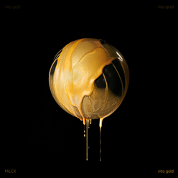 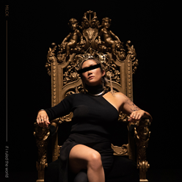

[**DOWNLOAD ARTWORK HERE**](https://nam04.safelinks.protection.outlook.com/?url=https%3A%2F%2Fwarnermusicgroup.box.com%2Fs%2Fsoj66dfa3b0rctntirw3m4mhvxw7rinx&data=02%7C01%7CMegan.Rasmussen%40atlanticrecords.com%7Cacefad4826584eefbf5708d7a519ea7b%7C8367939002ec4ba1ad3d69da3fdd637e%7C0%7C0%7C637159403030701560&sdata=23CuQtGi599DsFMIGu%2FDQi2yuL6VhkM84L3xrCnwSqo%3D&reserved=0)

**ABOUT MILCK**

*Into Gold* follows MILCK’s acclaimed debut 2018 EP, [*THIS IS NOT THE END*](https://nam04.safelinks.protection.outlook.com/?url=https%3A%2F%2Fatlantic.lnk.to%2FThisIsNotTheEndAY&data=02%7C01%7CMegan.Rasmussen%40atlanticrecords.com%7Cacefad4826584eefbf5708d7a519ea7b%7C8367939002ec4ba1ad3d69da3fdd637e%7C0%7C0%7C637159403030651582&sdata=Un7tXknwvs7ya5xwCugYTSCgNHx6da%2F5NlnOLM8%2BNLc%3D&reserved=0), highlighted of course by her breakthrough hit single, “[Quiet](https://nam04.safelinks.protection.outlook.com/?url=https%3A%2F%2Fatlantic.lnk.to%2FQuiet&data=02%7C01%7CMegan.Rasmussen%40atlanticrecords.com%7Cacefad4826584eefbf5708d7a519ea7b%7C8367939002ec4ba1ad3d69da3fdd637e%7C0%7C0%7C637159403030651582&sdata=cLB%2Bxjyb7ROgRQL1VMSw901CazVwKZNnepu%2BllBFhiw%3D&reserved=0).” The EP received extensive critical attention upon its arrival, with [NPR](https://nam04.safelinks.protection.outlook.com/?url=https%3A%2F%2Fwww.npr.org%2F2018%2F01%2F15%2F577194212%2Ffirst-listen-milck-this-is-not-the-end&data=02%7C01%7CMegan.Rasmussen%40atlanticrecords.com%7Cacefad4826584eefbf5708d7a519ea7b%7C8367939002ec4ba1ad3d69da3fdd637e%7C0%7C0%7C637159403030661576&sdata=rIQ4zC4ainE%2BsvMGPU5AbzzmkhZqViZWv9K6Q58W2A0%3D&reserved=0) writing, “*Artists of every genre have sparked conversations about women's liberation, political resistance and reclamation of power in their music during the past year. With THIS IS NOT THE END, MILCK joins the chorus of uplifted voices, adding anthemic ballads to a growing list of modern protest songs.*” “*With THIS IS NOT THE END*,” declared [OUT](https://nam04.safelinks.protection.outlook.com/?url=https%3A%2F%2Fwww.out.com%2Fout-exclusives%2F2018%2F1%2F19%2Fmilck-proves-not-end-womens-empowerment&data=02%7C01%7CMegan.Rasmussen%40atlanticrecords.com%7Cacefad4826584eefbf5708d7a519ea7b%7C8367939002ec4ba1ad3d69da3fdd637e%7C0%7C0%7C637159403030661576&sdata=E9WhWIQjvz3FiN4pAi9CTYLiFDi65LKsdkLKsgCngrI%3D&reserved=0), “*the woman born Connie Lim has cemented her status as one of music's most important voices for the women's movement.”*

The unofficial anthem of last year’s historic Women’s March On Washington, “Quiet” caused a worldwide sensation after MILCK teamed with two dozen female singers to perform acapella flash mobs of the song on the streets in Washington, DC. A video captured by award-winning director Alma Har’el quickly went viral, drawing over 14 million plays in just two days. In November 2017, MILCK released a new studio recording of “Quiet” as her “musical #METOO” in light of the massive movement of women and survivors speaking out against sexual assault. [Billboard](https://nam04.safelinks.protection.outlook.com/?url=https%3A%2F%2Fwww.billboard.com%2Farticles%2Fcolumns%2Fpop%2F8063598%2Fbest-protest-songs-of-2017-top-20&data=02%7C01%7CMegan.Rasmussen%40atlanticrecords.com%7Cacefad4826584eefbf5708d7a519ea7b%7C8367939002ec4ba1ad3d69da3fdd637e%7C0%7C0%7C637159403030671578&sdata=CE1bjWoSaN7xoL4oDyexmGU9PIwArs4DwhMYsRHpO4M%3D&reserved=0) later named “Quiet” as that year’s “Best Protest Song,” writing, “*The ‘one-woman riot’ MILCK sings of was anything but, as hundreds of thousands, even millions, have heard her emotional plea…‘Quiet’ easily sums up the sentiment of so many political movements – the time to speak out, to take action, is now.*” In addition, last year saw [NPR](https://nam04.safelinks.protection.outlook.com/?url=https%3A%2F%2Fwww.npr.org%2F2019%2F01%2F14%2F683694934%2Fmilck-quiet-womens-march-american-anthem&data=02%7C01%7CMegan.Rasmussen%40atlanticrecords.com%7Cacefad4826584eefbf5708d7a519ea7b%7C8367939002ec4ba1ad3d69da3fdd637e%7C0%7C0%7C637159403030671578&sdata=FXGp6JZlcJONjv5upW3eRJ8n9X61CDLrXRtMqNOSSok%3D&reserved=0) include “Quiet” as part of its landmark “American Anthem” series on songs that rouse, unite, celebrate and call to action.

MILCK marked the release of *THIS IS NOT THE END* with a remarkably powerful solo piano version of “Quiet” on NBC’s TODAY. Other milestone performances include a headline appearance at 2018’s Women’s March on NYC, performing alongside such iconic names as Yoko Ono, Halsey, and Whoopi Goldberg.

FOR MORE, PLEASE VISIT:

[MILCKMUSIC.COM](https://nam04.safelinks.protection.outlook.com/?url=http%3A%2F%2Fwww.milckmusic.com%2F&data=02%7C01%7CMegan.Rasmussen%40atlanticrecords.com%7Cacefad4826584eefbf5708d7a519ea7b%7C8367939002ec4ba1ad3d69da3fdd637e%7C0%7C0%7C637159403030671578&sdata=tVs%2BXoK4Izd%2F76Ar7JnzsmmcZuNAjaOnOul64pNA3SI%3D&reserved=0)

[FACEBOOK](https://nam04.safelinks.protection.outlook.com/?url=http%3A%2F%2Fwww.facebook.com%2Fmilckmusic&data=02%7C01%7CMegan.Rasmussen%40atlanticrecords.com%7Cacefad4826584eefbf5708d7a519ea7b%7C8367939002ec4ba1ad3d69da3fdd637e%7C0%7C0%7C637159403030681569&sdata=X%2BV8xmvCeyaWIKtgYmYd8nGUa4MpGeYS%2BtZM1cWSP%2FM%3D&reserved=0)

[INSTAGRAM](https://nam04.safelinks.protection.outlook.com/?url=http%3A%2F%2Finstagram.com%2Fmilckmusic&data=02%7C01%7CMegan.Rasmussen%40atlanticrecords.com%7Cacefad4826584eefbf5708d7a519ea7b%7C8367939002ec4ba1ad3d69da3fdd637e%7C0%7C0%7C637159403030681569&sdata=N3G4nZiBXnIaVgCyX2qKgqFOyInyZR77ac5GcF9kc2s%3D&reserved=0)

[TWITTER](https://nam04.safelinks.protection.outlook.com/?url=https%3A%2F%2Ftwitter.com%2FMILCKMUSIC&data=02%7C01%7CMegan.Rasmussen%40atlanticrecords.com%7Cacefad4826584eefbf5708d7a519ea7b%7C8367939002ec4ba1ad3d69da3fdd637e%7C0%7C0%7C637159403030691563&sdata=X6iSgtssk74ksMDZxDHhsk%2BukqFswO3C8IxAz0EjRSg%3D&reserved=0)

[YOUTUBE](https://nam04.safelinks.protection.outlook.com/?url=https%3A%2F%2Fwww.youtube.com%2Fchannel%2FUCVOL6yCyx-llAU25lAv45JA&data=02%7C01%7CMegan.Rasmussen%40atlanticrecords.com%7Cacefad4826584eefbf5708d7a519ea7b%7C8367939002ec4ba1ad3d69da3fdd637e%7C0%7C0%7C637159403030691563&sdata=j7wJrYorzGvODrHqpSNFGstPwFmfkwEcbwhWUDqGU6Y%3D&reserved=0)

[PRESS ASSETS](https://nam04.safelinks.protection.outlook.com/?url=https%3A%2F%2Fpress.atlanticrecords.com%2Fmilck%2F&data=02%7C01%7CMegan.Rasmussen%40atlanticrecords.com%7Cacefad4826584eefbf5708d7a519ea7b%7C8367939002ec4ba1ad3d69da3fdd637e%7C0%7C0%7C637159403030691563&sdata=1yxaClDIYQBoj1F6w%2F8pDUsc745hu0QyqNXxz1y1pZY%3D&reserved=0)

FOR MORE INFO ON MILCK CONTACT:

Chelsey Northern // [Chelsey.Northern@atlanticrecords.com](mailto:Chelsey.Northern@atlanticrecords.com) (National)

Andrew George // [Andrew.George@atlanticrecords.com](mailto:Andrew.George@atlanticrecords.com) (Tour/Online)

**MILCK**

***INTO GOLD***

TRACKLISTING

1. If I Ruled The World
2. Gold
3. Ready
4. Slow Fade
5. Don’t Make It Easy

# # #