**Multi-Platinum Rapper A Boogie Wit Da Hoodie Returns With New Single “Mood Swings”**

***‘Hoodie SZN’ Amasses over 2 Billion Streams in the US to Date***

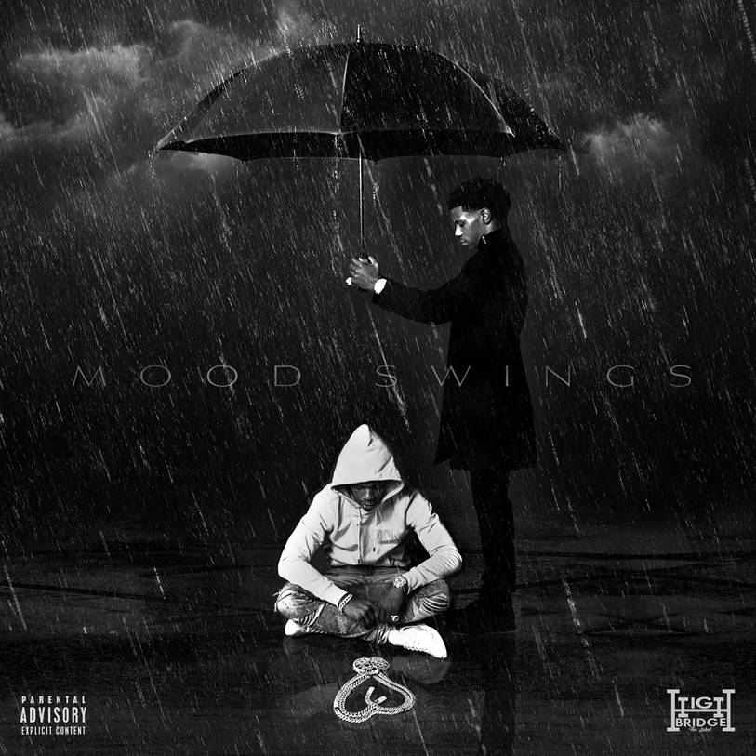

[**Click Here to Buy/Stream/Download “Mood Swings”**](https://aboogie.lnk.to/MoodSwings)

[**Click Here to Download Single Artwork**](https://www.dropbox.com/sh/e123rug9ogflj8d/AACCsbjJwJt7L099cY3HuO4Qa?dl=0)

[**Click Here to Download Hi-Res Images of A Boogie**](https://www.dropbox.com/s/g08di9fhqugdyt7/Main%20Press%201%20%281%29.jpeg?dl=0)

**New York, NY - September 13, 2019** *-* Today, multi-platinum rapper and entrepreneur **A Boogie Wit Da Hoodie** drops his new single **“Mood Swings”** via Highbridge The Label/Atlantic Records. A Boogie comes back with strong bars giving fans a preview of his highly-anticipated forthcoming album *Artist 2.0*.

“Mood Swings” pulls the curtain back on A Boogie’s life as his journey continues, dealing with the rollercoaster of fame that comes with impulsive behaviors and emotions. The track opens up with a smooth guitar and high-hat beats that leads to his hard-hitting and rhythmic intro. “I’m a beast, I’m a God,” A Boogie is feeling at the height of his game and no one can get in his way. Alongside the rise of his influence in the game, he’s grappling with fame, trust, materialism, and the highs and lows that this life brings.

This year alone, he’s crossed genres having graced **50 Cent’s “Big Rich Town” feat. Trey Songs**, **Khalid’s “Right Back,”** **Rick Ross’ “Running the Streets” feat. Denzel Curry, Lil Durk’s “U Said,” Ed Sheeran’s “1000 Nights” feat. Meek Mill, Mustard’s “Baguettes in the Face” feat. NAV and Playboi Carti, J Alvarez’s “Tricks,” Maroon 5’s “Wait,”** and many more. Along with the most recent release of [**2x platinum “Look Back At It” that got a Tiësto and SWACQ Remix**](https://weraveyou.com/2019/09/a-boogie-wit-da-hoodie-look-back-at-it-tiesto-swacq-remix/) end of August.

To date, A Boogie’s critically acclaimed *Hoodie SZN,* which spent three weeks at number one on the [**Billboard Top 200**](https://www.billboard.com/articles/columns/chart-beat/8497489/a-boogie-wit-da-hoodies-hoodie-szn-returns-to-no-1-on-billboard-200-chart) and top 10 for 16 consecutive weeks, is certified platinum in both the US and Canada; along with his hit track “Look Back At It,” which made it to #1 at both Urban & Rhythm formats, is certified 3x platinum in Canada, certified 2x platinum in the US, certified gold in Australia and Switzerland, and the local remix feat. Capo Plaza is certified platinum in Italy. Most recently, his hit track “**Swervin feat. 6ix9ine**,” is now certified platinum in Australia. A Boogie received an honorary plaque at a celebratory dinner for generating 200 million+ streams on Audiomack, and won an award for **Top R&B and Hip-Hop Song** for his featured role on "Pills and Automobiles" at the **ASCAP Rhythm and Soul Music Awards**. Continuing the momentum, his singles “Demons & Angels” and “Startender feat. Offset & Tyga” are now gold-certified. Along with a successful album release, A Boogie sold out 26 shows for over 50,000 fans during his **Monster Outbreak Tour: A Boogie vs. Artist.**

**About A Boogie Wit Da Hoodie:**

The Bronx-bred rapper Artist Dubose, better known as A Boogie Wit Da Hoodie, first hit the rap scene with the breakout hit “Still Think About You” which was featured on his 2016 debut mixtape, ARTIST. The mixtape also introduced fans to “My Shit” which went on to become RIAA certified platinum and was also listed as one of “The Best Songs of 2016” on Apple Music. A Boogie quickly proved himself to be one of the game’s newest heavyweights after XXL dubbed him as “one of the hottest and newest up-and-comers in hip-hop” and included him in the 2017 Freshman Class. The young star also went on to release the 3x platinum “Drowning feat. Kodak Black” along with the platinum certified singles “Jungle” and “Timeless.” During the fall of 2017, A Boogie went on to release his highly anticipated, now gold certified, debut album, THE BIGGER ARTIST, which quickly sprung into the Top 5 on Billboard’s Top 200. He also became the top emerging acting in the U.S. as he simultaneously sprung to #1 on Billboard’s Emerging Artists chart. It is easy to see why The New York Times named A Boogie “the most promising young rapper the city has produced in some time.” A Boogie earned a BET Award Nomination for “Best New Artist” at the end of 2018 in addition to releasing his gold-certified sophomore album, HOODIE SZN, which made its debut at #2 before spending three nonconsecutive weeks at #1 and maintaining a stunning 17 week streak within the top 10 on the Billboard Top 200 chart. The album also soared on streaming, garnering over 83 million streams the week it went #1. Following his latest album as well as his “A Boogie Vs. Artist” tour which wrapped with 26 of its 30 dates sold out, there’s no doubt A Boogie will continue to make waves and redefine the sound of New York rap.

**NEW PRESS PHOTO:**

*[Photo Credit: Jimmy Fontaine]*

[DOWNLOAD HIGH-RES IMAGE HERE](http://press.atlanticrecords.com/wp-content/uploads/2019/09/Main-Press-Photo-PC-Jimmy-Fontaine.jpeg)

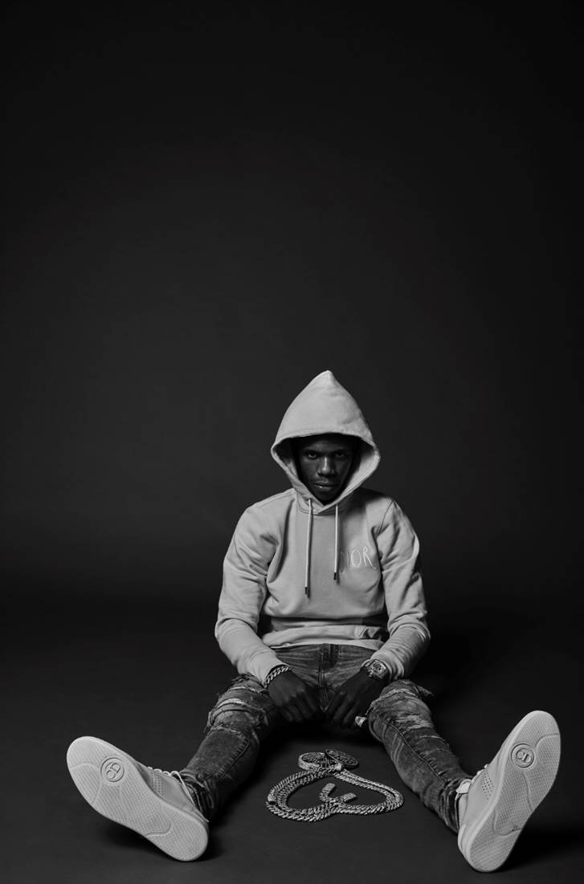

[Click here to view Twitter](https://twitter.com/ArtistHBTL)

[Click here to view Instagram](https://www.instagram.com/artisthbtl/)

[Click here to view Facebook](https://www.facebook.com/ArtistHBTL/)