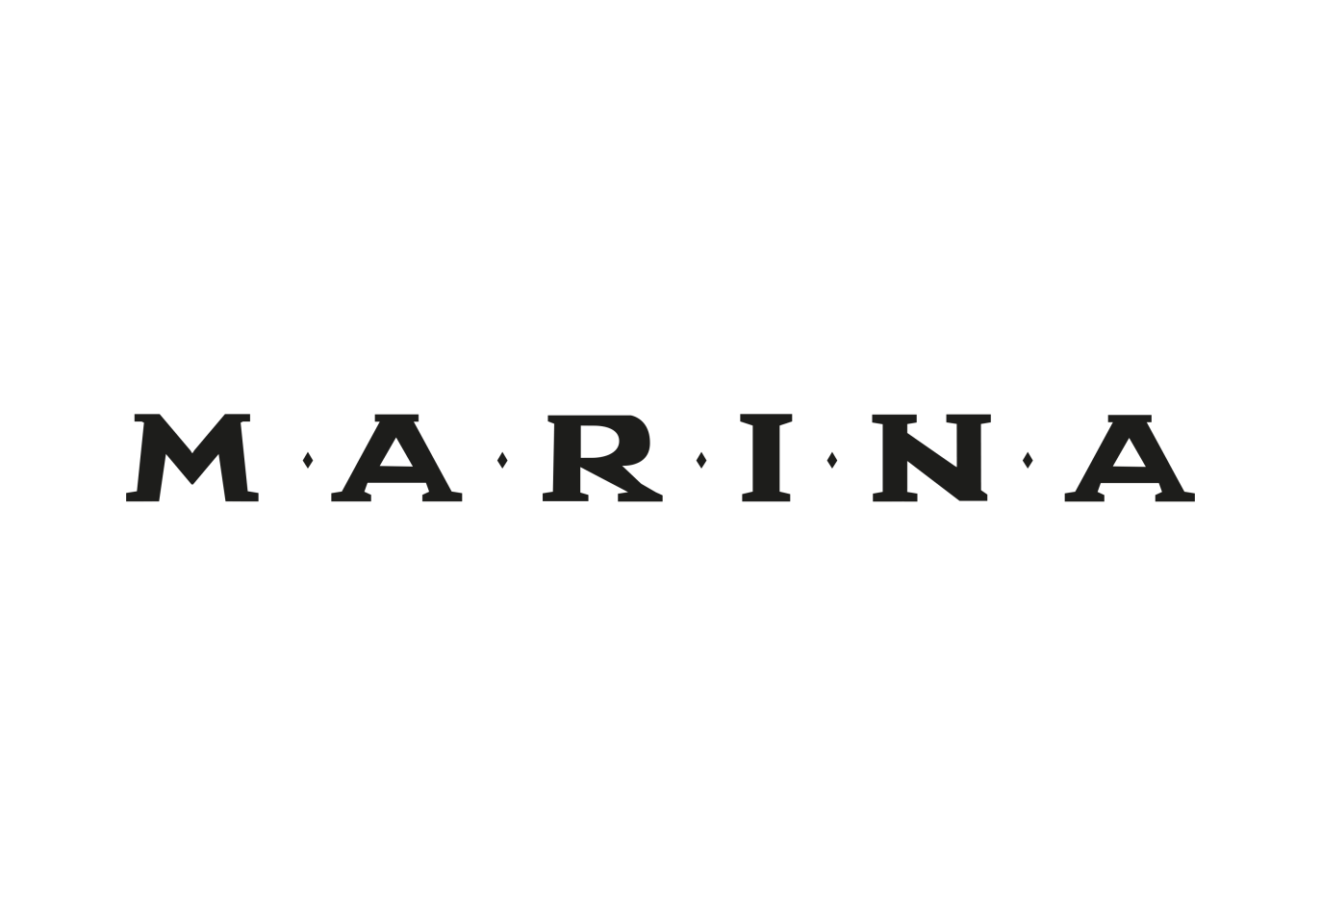

**UNVEILS OFFICIAL VIDEO FOR ‘TO BE HUMAN’**

**WATCH** [**HERE**](https://youtu.be/DM8Tm9ycGz4)

**PERFORMANCE OF “ORANGE TREES” ON**

**LATE NIGHT WITH SETH MEYERS STREAMING** [**HERE**](https://www.youtube.com/watch?v=SDxDTC1NkGY&feature=youtu.be)

**NEW TWO-PART ALBUM ‘LOVE + FEAR’ AVAILABLE APRIL 26TH**

**PRE-ORDER** [**HERE**](https://marina.lnk.to/loveandfear-preorder)

**STREAM / DOWNLOAD ‘LOVE’** [**HERE**](https://marina.lnk.to/loveandfear-preorder)



MARINA has unveiled the powerful video for captivating new album track ‘To Be Human’. Watch here: <https://youtu.be/DM8Tm9ycGz4>

Written by MARINA and produced by GRAMMY Award-winner Joel Little (Lorde, Khalid, Sam Smith), ‘To Be Human’ is from the ‘[LOVE](https://marina.lnk.to/love)’ collection of songs which arrived as a surprise last week and has already garnered over 20 million streams worldwide.

Yesterday, Marina made her TV debut performance of “Orange Trees” off ‘LOVE’ on Late Night with Seth Meyers – streaming [here](https://www.youtube.com/watch?v=SDxDTC1NkGY&feature=youtu.be).

*“Thematically, ‘To Be Human’ sums up the head space that I’ve come from in the past three years”* Marina explains. *“The subject matter is really important. I talk about unity, name checking a lot of places around the world to create this picture of humanity because in our current political climate we are constantly being made to see different people as ‘other’ and I hate that.”*

The full, eagerly anticipated album set ‘LOVE + FEAR’ will be released via Atlantic Records on April 26th and is available to pre-order now: <https://marina.lnk.to/loveandfear-preorder>

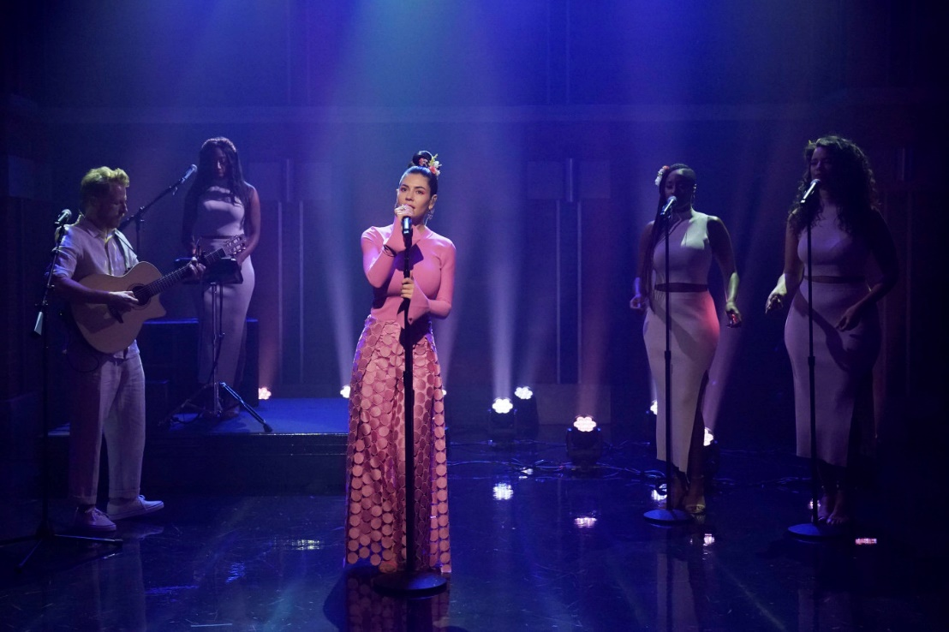

Credit: Lloyd Bishop/NBC

**‘LOVE’ is available to download and stream now:** [**https://marina.lnk.to/love**](https://marina.lnk.to/love)

**Tickets for the ‘LOVE + FEAR Tour’ are available at** [**https://www.marinaofficial.co.uk/tour**](https://protect-us.mimecast.com/s/ZlWfCG6Q8Dh8W6yOCQWdCi)

**2019 TOUR DATES**

**APRIL 2019**

29 – Newcastle, Newcastle O2 Academy

30 – Glasgow, O2 Academy Glasgow \***SOLD OUT\***

**MAY 2019**

3 – London - Royal Albert Hall **\*SOLD OUT\***

7 – Bournemouth - O2 Academy Bournemouth

9 – Birmingham - Birmingham O2 Academy

10 – Manchester - Manchester Apollo **\*SOLD OUT\***

26 – Boston Calling Music Festival

**JULY 2019**

4 – Open’er Festival

6 – Roskilde Festival

7 – Ruisrock Festival

**SEPTEMBER 2019**

10 – Toronto, ON – Rebel

11 – Montreal, QC – MTelus

14 – Philadelphia, PA – The Met

16 – NYC, NY – Central Park Summerstage

18 – Washington, D.C. –The Anthem

20 – Nashville, TN – Ryman Auditorium

21 – Atlanta, GA – Coca-Cola Roxy

23 – Chicago, IL – Aragon Ballroom

24 – Minneapolis, MN – Orpheum Theatre

26 – Houston, TX – Revention Music Center

27 – Dallas, TX – The Bomb Factory

28 – Austin, TX – ACL Live at the Moody Theater

30 – Denver, CO – The Mission Ballroom

**OCTOBER 2019**

1 – Salt Lake City, UT – The Union Event Center

4 – Los Angeles, CA – Greek Theatre

5 – San Francisco, CA – The Masonic **\*SOLD OUT\***

7 – Portland, OR – Arlene Schnitzer Concert Hall

8 – Seattle, WA – Paramount Theatre

9 – Vancouver, BC – Orpheum Theatre

**Connect with Marina**

[Instagram](https://protect-us.mimecast.com/s/0SiyCv29ZNcDwoGruXyKDq)

[Twitter](https://protect-us.mimecast.com/s/KA3ECwpRrOFDlX7gu94q_0)

[Facebook](https://www.facebook.com/marinadiamandis/)

**For more information please contact:**

Christina Kotsamanidis

212.707.2241

[Christina.Kotsamanidis@atlanticrecords.com](mailto:Christina.Kotsamanidis@atlanticrecords.com)