For Immediate Release
September 21, 2020

Matchbox Twenty announce blockbuster career-spanning 2020 boxset

Limited edition vinyl collection to include all 5 studio albums (3 debut pressings),
including ‘Exile On Mainstream Revisited’ with rare bonus tracks,
plus retrospective booklet

Boxset available November 20th, pre-order available now via https://mb20.lnk.to/20BoxSetPR

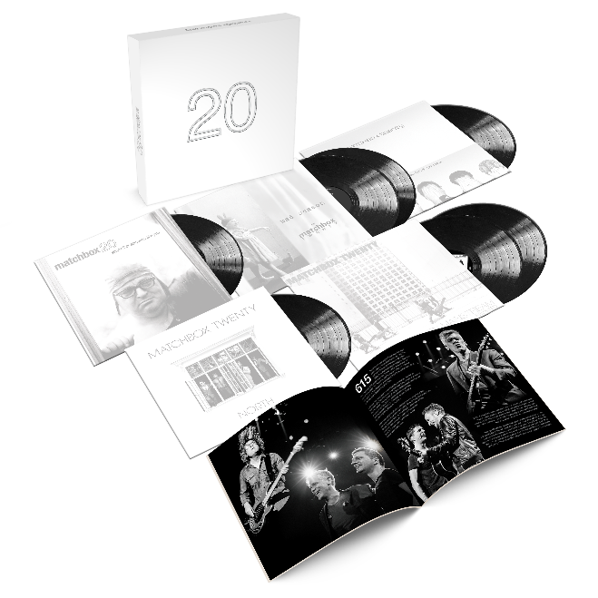

Multi-platinum, superstar hit making pop-rockers Matchbox Twenty have announced a blockbuster career-spanning 2020 vinyl boxset – arriving November 20th and available now for pre-order with the first 100 copies signed by the band. The limited edition collection will include all of the band’s studio albums, including debut pressings of Mad Season, More Than You Think You Are & North. The five album set also includes Exile on Mainstream Revisited, a re-imagined version including 10 additional bonus and rare tracks also pressed for the first time on vinyl.

The package, exclusively announced yesterday to MB20 fan club subscribers, will include a beautifully detailed 24-page booklet featuring exclusive band photographs, liner notes and a career retrospective penned by Billboard executive editor Melinda Newman. Fans can also look forward to an extensive rollout of archival footage and newly remastered music videos over the coming months, in addition to contesting opportunities to win autographed box sets, a signed test print of Yourself or Someone Like You, summer 2021 concert tickets & more.

Matchbox Twenty is also slated to hit the road for their rescheduled summer tour with special guest The Wallflowers, kicking off July 16, 2021 at the Mohegan Sun Arena in Uncasville, CT and wrapping up October 7th at the Hollywood Bowl. Produced by Live Nation, the 2021 tour is the band’s first since 2017’s “A Brief History of Everything” tour which marked the 20th anniversary of their RIAA Diamond-certified album Yourself or Someone Like You. For full routing and ticket information, please visit MatchboxTwenty.com/Events.

ABOUT MATCHBOX TWENTY:
Matchbox Twenty is Kyle Cook, Paul Doucette, Rob Thomas and Brian Yale. The group has sold over 40 million records worldwide, and earned multiple chart-topping singles, countless accolades, including five GRAMMY® nominations, four American Music Award nods, and the 2004 People's Choice Award for "Favorite Musical Group."

Fueled by such classic songs as “Real World,” “Back 2 Good” and the No. 1 smash hits “Push” and “3AM,” 1996’s RIAA Diamond-certified Yourself or Someone Like You proved a worldwide sensation and instantly established Matchbox as global superstars. 2000 saw the band release the four-times Platinum Mad Season, containing the No. 1 singles “Bent” and “If You’re Gone.” Matchbox’s third release, More Than You Think You Are, also was certified Platinum and featured the No. 1 hit, “Unwell.” 2007’s greatest hits compilation album with six new songs, Exile On Mainstream yielded yet another No. 1 track, “How Far We’ve Come,” while the band’s most recent album, 2012’s North, exploded into the top position on the Billboard 200 – Matchbox Twenty’s first-ever chart-topper and No. 1 debut.
CONNECT:
MatchboxTwenty.com | Instagram | YouTube | Twitter | Facebook | Press Assets

CONTACT:
Sheila Richman | Sheila.Richman@AtlanticRecords.com
Ted Sullivan | Ted.Sullivan@AtlanticRecords.com

