**CHART-TOPPING SINGER-SONGWRITER MATT MAESON UNVEILS POWERFUL NEW SONG “NELSONWOOD LANE”**

**WATCH THE OFFICIAL MUSIC VIDEO** [**HERE**](https://www.youtube.com/watch?v=4U70W3vXfu0&ab_channel=MattMaeson)

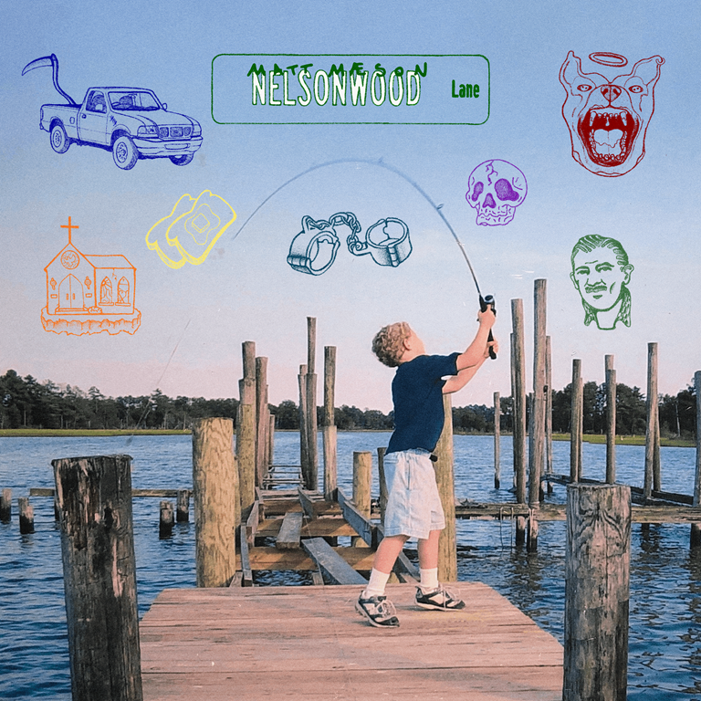

*ARTWORK AVAILABLE TO DOWNLOAD* [*HERE*](https://nam04.safelinks.protection.outlook.com/?url=https%3A%2F%2Fwarnermusicgroup.box.com%2Fs%2Fs1ep0zylrk9fksjq6s3a82161kpqp7i3&data=04%7C01%7CGabrielle.Reese%40atlanticrecords.com%7C518486a4458f40fccb0d08d92607ffe6%7C8367939002ec4ba1ad3d69da3fdd637e%7C0%7C0%7C637582638068905969%7CUnknown%7CTWFpbGZsb3d8eyJWIjoiMC4wLjAwMDAiLCJQIjoiV2luMzIiLCJBTiI6Ik1haWwiLCJXVCI6Mn0%3D%7C1000&sdata=9Bt4AbDW5EtO2PznJNmc52sqcf3w3wZBoVGZF0H%2B0Mk%3D&reserved=0)

RIAA Gold-certified singer-songwriter **Matt Maeson** releases emotional new fan track “Nelsonwood Lane” today, one of his most personal songs to date. Listen [HERE](https://mattmaeson.lnk.to/NelsonwoodLanePR). The powerful, piano-driven track is joined by an official music video starring Maeson and streaming now [HERE.](https://www.youtube.com/watch?v=4U70W3vXfu0&ab_channel=MattMaeson)

“*Nelsonwood Lane is a street I used to live on in a small town called Gloucester, VA when I was about 10*,” says Maeson. “*When I started writing the tune, my intention was to write about a specific occurrence that happened in my life when I lived there, but what happened is, it started to turn into some kind of time-lapse of many different experiences that, for the first time in my life, I realized we’re connected in a lot of ways. It felt like I was babbling to a therapist about traumatic memories and the lyrics just kept coming. Whenever that happens, I know it’s going to be something very important to me and hopefully becomes something very important to someone else.*”

Currently hard at work on the hugely anticipated follow-up to his 2019 breakthrough debut album, *Bank On The Funeral*, Maeson recently unveiled his new project, USERx, an extraordinary musical partnership with his longtime collaborator, producer/designer Rozwell. Pronounced simply as “USER,” USERx made their beautifully warped debut with the self-titled *USERx* EP, available now [HERE](https://nam04.safelinks.protection.outlook.com/?url=https%3A%2F%2Fuserx.lnk.to%2FUSERxPR&data=04%7C01%7CGabrielle.Reese%40atlanticrecords.com%7C518486a4458f40fccb0d08d92607ffe6%7C8367939002ec4ba1ad3d69da3fdd637e%7C0%7C0%7C637582638068905969%7CUnknown%7CTWFpbGZsb3d8eyJWIjoiMC4wLjAwMDAiLCJQIjoiV2luMzIiLCJBTiI6Ik1haWwiLCJXVCI6Mn0%3D%7C1000&sdata=tFCaEbLuoo%2Fu%2B77tQ0%2FLZiPoY3YgguLkeP4m0MHHSvs%3D&reserved=0). The EP, which sees the two hometown friends sharing lead vocal duties, Maeson on guitar and Rozwell programming and producing, includes such remarkable tracks as “[My Body Left My Soul (Feat. Pusha-T)](https://nam04.safelinks.protection.outlook.com/?url=https%3A%2F%2Fwww.youtube.com%2Fwatch%3Fv%3DOFG7ti6zWh4&data=04%7C01%7CGabrielle.Reese%40atlanticrecords.com%7C518486a4458f40fccb0d08d92607ffe6%7C8367939002ec4ba1ad3d69da3fdd637e%7C0%7C0%7C637582638068905969%7CUnknown%7CTWFpbGZsb3d8eyJWIjoiMC4wLjAwMDAiLCJQIjoiV2luMzIiLCJBTiI6Ik1haWwiLCJXVCI6Mn0%3D%7C1000&sdata=Xfb%2Bpdn%2B57pL8nE8aOvLXTnHp5JuVIgEGUstODxaeKA%3D&reserved=0),” “[Waterman](https://nam04.safelinks.protection.outlook.com/?url=https%3A%2F%2Fyoutu.be%2FGuvPTeWQ268&data=04%7C01%7CGabrielle.Reese%40atlanticrecords.com%7C518486a4458f40fccb0d08d92607ffe6%7C8367939002ec4ba1ad3d69da3fdd637e%7C0%7C0%7C637582638068915924%7CUnknown%7CTWFpbGZsb3d8eyJWIjoiMC4wLjAwMDAiLCJQIjoiV2luMzIiLCJBTiI6Ik1haWwiLCJXVCI6Mn0%3D%7C1000&sdata=bt7ltRLZoFhEtxcKIE6b%2FT2Ym4Z8IoqrCFRwXksjxH8%3D&reserved=0),” “[Above (Feat. Masego & West Banks)](https://nam04.safelinks.protection.outlook.com/?url=https%3A%2F%2Fatlantic.lnk.to%2FUSERxAbovePR&data=04%7C01%7CGabrielle.Reese%40atlanticrecords.com%7C518486a4458f40fccb0d08d92607ffe6%7C8367939002ec4ba1ad3d69da3fdd637e%7C0%7C0%7C637582638068915924%7CUnknown%7CTWFpbGZsb3d8eyJWIjoiMC4wLjAwMDAiLCJQIjoiV2luMzIiLCJBTiI6Ik1haWwiLCJXVCI6Mn0%3D%7C1000&sdata=n%2BTyLMPqShK3DsEQgl2ZuOgE0NPGKMNqVvkzum4THmc%3D&reserved=0),” and “[Headsick (Feat. Manchester Orchestra)](https://nam04.safelinks.protection.outlook.com/?url=https%3A%2F%2Fwww.youtube.com%2Fwatch%3Fv%3DWK9rq5GoqY4%26ab_channel%3DMattMaeson&data=04%7C01%7CGabrielle.Reese%40atlanticrecords.com%7C518486a4458f40fccb0d08d92607ffe6%7C8367939002ec4ba1ad3d69da3fdd637e%7C0%7C0%7C637582638068925872%7CUnknown%7CTWFpbGZsb3d8eyJWIjoiMC4wLjAwMDAiLCJQIjoiV2luMzIiLCJBTiI6Ik1haWwiLCJXVCI6Mn0%3D%7C1000&sdata=Rfhg1JT5su5OIgqQwGyHC4IBeqVw5DQeeRPDmh5jhmY%3D&reserved=0).”

Last August saw Maeson making history with the chart-topping “[Hallucinogenics (Feat. Lana Del Rey)](https://nam04.safelinks.protection.outlook.com/?url=https%3A%2F%2Fwww.youtube.com%2Fwatch%3Fv%3DdoRUhDIB29s&data=04%7C01%7CGabrielle.Reese%40atlanticrecords.com%7C518486a4458f40fccb0d08d92607ffe6%7C8367939002ec4ba1ad3d69da3fdd637e%7C0%7C0%7C637582638068925872%7CUnknown%7CTWFpbGZsb3d8eyJWIjoiMC4wLjAwMDAiLCJQIjoiV2luMzIiLCJBTiI6Ik1haWwiLCJXVCI6Mn0%3D%7C1000&sdata=Rqb9bXrTt%2B7Jtpv2SiFWu3%2BW%2BjRlkKNzyDPo8rfzAIk%3D&reserved=0" \t "_blank),” affirming him as the first ever male solo artist to earn two #1 Alternative Radio hits from a full-length debut album. RIAA Gold “Hallucinogenics” – which spent three weeks at #1 while also proving Maeson’s first multi-format hit by also topping Triple A airplay charts nationwide – follows 2019’s RIAA Gold smash single,  “[Cringe](https://nam04.safelinks.protection.outlook.com/?url=https%3A%2F%2Fwww.youtube.com%2Fwatch%3Fv%3DeoJtlPQzqkQ&data=04%7C01%7CGabrielle.Reese%40atlanticrecords.com%7C518486a4458f40fccb0d08d92607ffe6%7C8367939002ec4ba1ad3d69da3fdd637e%7C0%7C0%7C637582638068935837%7CUnknown%7CTWFpbGZsb3d8eyJWIjoiMC4wLjAwMDAiLCJQIjoiV2luMzIiLCJBTiI6Ik1haWwiLCJXVCI6Mn0%3D%7C1000&sdata=QsoynzWuto6tJc1BbXJsLFfHVFrkxH4NKC94MDh5ZxM%3D&reserved=0),” which spent four consecutive weeks atop *Billboard*’s “Alternative Songs” chart after a steady 25-week climb.

Hailed by *American Songwriter* for “(creating) a sound unlike much else out there,” Matt Maeson has been on a remarkable journey all his life. The Chesapeake Bay, VA-native grew up on tour, traveling and performing with his parents’ prison ministry at maximum-security penitentiaries across America. His experiences – which include winning over crowds of naked women and Hells Angels at the world-famous Sturgis Motorcycle Rally in South Dakota – inspired him to begin writing songs, spare and powerful confessionals infused with additional strength via his raw, soulful vocal approach. Maeson posted his first songs online in late 2015 and the following summer, embarked on his first US headline tour, presented by Communion, the influential artists’ collective co-founded by Mumford and Sons’ Ben Lovett.

[*Bank On The Funeral*](https://nam04.safelinks.protection.outlook.com/?url=https%3A%2F%2Fatlantic.lnk.to%2FBankOnTheFuneralID&data=04%7C01%7CGabrielle.Reese%40atlanticrecords.com%7C518486a4458f40fccb0d08d92607ffe6%7C8367939002ec4ba1ad3d69da3fdd637e%7C0%7C0%7C637582638068935837%7CUnknown%7CTWFpbGZsb3d8eyJWIjoiMC4wLjAwMDAiLCJQIjoiV2luMzIiLCJBTiI6Ik1haWwiLCJXVCI6Mn0%3D%7C1000&sdata=Eekl9slDN581QHNcY1TdrWLBZZ92Xw9mUdnDif806rQ%3D&reserved=0) – available now at all DSPs and streaming services [HERE](https://nam04.safelinks.protection.outlook.com/?url=https%3A%2F%2Fatlantic.lnk.to%2FBankOnTheFuneralID&data=04%7C01%7CGabrielle.Reese%40atlanticrecords.com%7C518486a4458f40fccb0d08d92607ffe6%7C8367939002ec4ba1ad3d69da3fdd637e%7C0%7C0%7C637582638068935837%7CUnknown%7CTWFpbGZsb3d8eyJWIjoiMC4wLjAwMDAiLCJQIjoiV2luMzIiLCJBTiI6Ik1haWwiLCJXVCI6Mn0%3D%7C1000&sdata=Eekl9slDN581QHNcY1TdrWLBZZ92Xw9mUdnDif806rQ%3D&reserved=0) – earned wide-ranging critical applause upon its April 2019 release. “Maeson has been impressing the world with his dynamically emotional lyrics and equally powerful melodies with every song he releases,” raved[*Ones To Watch*](https://nam04.safelinks.protection.outlook.com/?url=https%3A%2F%2Fdev.onestowatch.com%2Fblog%2Fmatt-maeson-finds-light-at-the-end-of-the-tunnel&data=04%7C01%7CGabrielle.Reese%40atlanticrecords.com%7C518486a4458f40fccb0d08d92607ffe6%7C8367939002ec4ba1ad3d69da3fdd637e%7C0%7C0%7C637582638068945792%7CUnknown%7CTWFpbGZsb3d8eyJWIjoiMC4wLjAwMDAiLCJQIjoiV2luMzIiLCJBTiI6Ik1haWwiLCJXVCI6Mn0%3D%7C1000&sdata=xRvInFxw69wixWPAb%2Fsw7qA6m9K8lkYQiMgAS4EtJU0%3D&reserved=0), “and *Bank On The Funeral* is no different. His authoritative voice commands the attention of anyone in earshot. Maeson strays on the lines between folk and alternative-pop, showcasing his diverse inspirations ranging from Johnny Cash to Kurt Cobain.”

Now based in Austin, TX, Maeson has spent much the past half decade on the road, including his own headline tours,  support runs alongside artists like Jaymes Young, Bishop Briggs, and Vallis Alps, and show-stopping sets at such top festivals as Bonnaroo, Lollapalooza, Forecastle, and more.

**CONNECT WITH MATT MAESON**

[MATTMAESON.COM](https://nam04.safelinks.protection.outlook.com/?url=http%3A%2F%2Fmattmaeson.com%2F&data=04%7C01%7CGabrielle.Reese%40atlanticrecords.com%7C518486a4458f40fccb0d08d92607ffe6%7C8367939002ec4ba1ad3d69da3fdd637e%7C0%7C0%7C637582638068945792%7CUnknown%7CTWFpbGZsb3d8eyJWIjoiMC4wLjAwMDAiLCJQIjoiV2luMzIiLCJBTiI6Ik1haWwiLCJXVCI6Mn0%3D%7C1000&sdata=p4Y4Is39vXwVEIqx7Aby1FZpzP%2FWBXCjtWaupTpafMg%3D&reserved=0) | [FACEBOOK](https://nam04.safelinks.protection.outlook.com/?url=https%3A%2F%2Fwww.facebook.com%2Fmattmaeson%2F&data=04%7C01%7CGabrielle.Reese%40atlanticrecords.com%7C518486a4458f40fccb0d08d92607ffe6%7C8367939002ec4ba1ad3d69da3fdd637e%7C0%7C0%7C637582638068945792%7CUnknown%7CTWFpbGZsb3d8eyJWIjoiMC4wLjAwMDAiLCJQIjoiV2luMzIiLCJBTiI6Ik1haWwiLCJXVCI6Mn0%3D%7C1000&sdata=UU4%2FIBfb7PQy7kndMS%2BegVaiO8V1wYrVK6MnhXtl2dw%3D&reserved=0) | [TWITTER](https://nam04.safelinks.protection.outlook.com/?url=https%3A%2F%2Ftwitter.com%2Fmattmaeson&data=04%7C01%7CGabrielle.Reese%40atlanticrecords.com%7C518486a4458f40fccb0d08d92607ffe6%7C8367939002ec4ba1ad3d69da3fdd637e%7C0%7C0%7C637582638068955748%7CUnknown%7CTWFpbGZsb3d8eyJWIjoiMC4wLjAwMDAiLCJQIjoiV2luMzIiLCJBTiI6Ik1haWwiLCJXVCI6Mn0%3D%7C1000&sdata=49jPuxVNXhHqQAOkKipQDWbis29v0doDdqsHP6OCLk4%3D&reserved=0) | [INSTAGRAM](https://nam04.safelinks.protection.outlook.com/?url=https%3A%2F%2Fwww.instagram.com%2Fmattmaeson%2F&data=04%7C01%7CGabrielle.Reese%40atlanticrecords.com%7C518486a4458f40fccb0d08d92607ffe6%7C8367939002ec4ba1ad3d69da3fdd637e%7C0%7C0%7C637582638068955748%7CUnknown%7CTWFpbGZsb3d8eyJWIjoiMC4wLjAwMDAiLCJQIjoiV2luMzIiLCJBTiI6Ik1haWwiLCJXVCI6Mn0%3D%7C1000&sdata=iI6ekuUq7o5lEu9L%2FtBPiU%2FMmclgCjGGmkZUp7zBRUs%3D&reserved=0) | [NEON GOLD](https://nam04.safelinks.protection.outlook.com/?url=http%3A%2F%2Fneon.gold%2Freleases%2Fwhokilledmattmaeson%2F&data=04%7C01%7CGabrielle.Reese%40atlanticrecords.com%7C518486a4458f40fccb0d08d92607ffe6%7C8367939002ec4ba1ad3d69da3fdd637e%7C0%7C0%7C637582638068955748%7CUnknown%7CTWFpbGZsb3d8eyJWIjoiMC4wLjAwMDAiLCJQIjoiV2luMzIiLCJBTiI6Ik1haWwiLCJXVCI6Mn0%3D%7C1000&sdata=dl3HtbJtPrwO21Psa8H9HM0JGTQqEKrLQxYqF4bopWM%3D&reserved=0)

Press contact: [corey.brewer@atlanticrecords.com](mailto:corey.brewer@atlanticrecords.com)