**MAX FROST ANNOUNCES DEBUT ALBUM *GOLD RUSH***

**EXECUTIVE PRODUCED BY**

**MICHAEL “FITZ” FITZPATRICK OF FITZ AND THE TANTRUMS**

**ARRIVES EVERYWHERE ON FRIDAY, OCTOBER 5TH**

**“THE GOLD RUSH TOUR” BEGINS OCTOBER 9TH IN SANTA CRUZ, CA**

**ACCLAIMED SINGER/SONGWRITER/PRODUCER CELEBRATES WITH LIVE PERFORMANCE OF BREAKTHROUGH SINGLE “**[**GOOD MORNING**](https://www.youtube.com/watch?v=N5xMlDeGFBU)**” ON**

**TODAY’S EPISODE OF ABC’S** [**GOOD MORNING AMERICA**](https://www.goodmorningamerica.com/Culture/video/max-frost-performs-good-morning-live-gma-56807006)

***NEW TRACK, “***[**ELEVEN DAYS**](https://Atlantic.lnk.to/elevendaysPR)***,” AVAILABLE TODAY AT ALL DSPS AND STREAMING SERVICES***

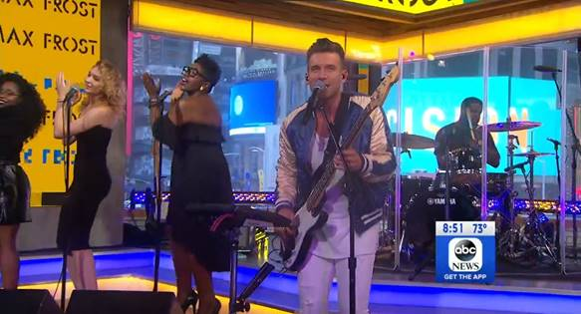

[**Watch “Good Morning” on Good Morning America**](https://www.goodmorningamerica.com/Culture/video/max-frost-performs-good-morning-live-gma-56807006)

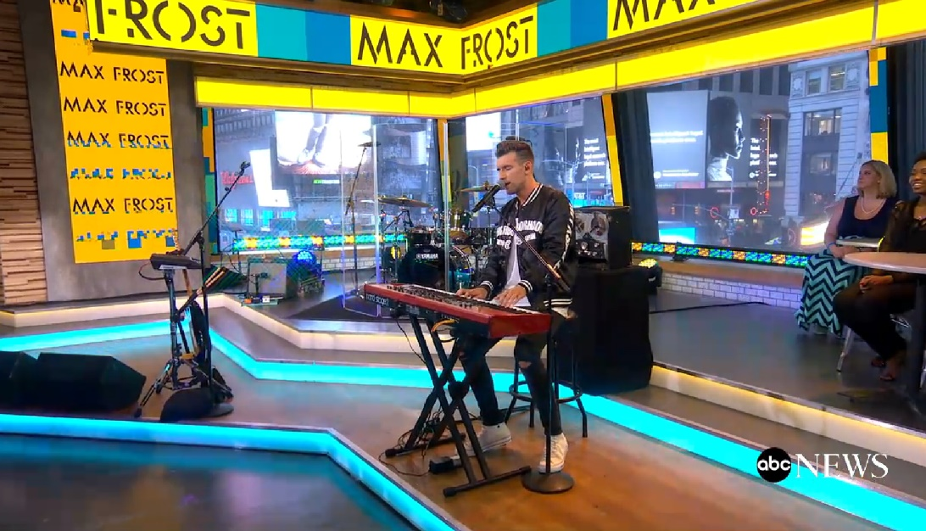

[**Watch “Eleven Days” as a GMA Web Exclusive**](https://www.goodmorningamerica.com/culture/video/max-frost-plays-instruments-live-eleven-days-performance-56807339)

Atlantic recording artist Max Frost has announced the release of his eagerly awaited debut album. GOLD RUSH – which includes the breakthrough hit, “Good Morning” – arrives at all music retailers and streaming services on Friday, October 5th.

Executive produced by Michael “Fitz” Fitzpatrick (Fitz and the Tantrums) with production by Mick Schultz (Rihanna, Jeremih, YG), GOLD RUSH is heralded by today’s arrival of Frost’s latest track, “[Eleven Days](https://Atlantic.lnk.to/elevendaysPR),” available now at all DSPs and streaming services.

Frost celebrated the announcement earlier this morning with a high profile national TV appearance on ABC’s Good Morning America featuring live performances of both “[Good Morning](https://www.goodmorningamerica.com/Culture/video/max-frost-performs-good-morning-live-gma-56807006)” and “[Eleven Days](https://www.goodmorningamerica.com/Culture/video/max-frost-plays-instruments-live-eleven-days-performance-56807339).” The appearance follows Frost’s recent national TV debut performance of “Good Morning” on the nationally syndicated LIVE! With Kelly and Ryan, streaming [HERE](https://www.youtube.com/watch?v=XZrQNRdN9aM).

A remarkable solo performer hailed for stealing the show with his captivating one-man-band performances, Frost will introduce fans to GOLD RUSH on a wide-ranging North American headline tour. “The Gold Rush Tour” hits the road beginning October 9th at Santa Cruz, CA’s The Catalyst Atrium and then travels through mid-November (see attached itinerary). For complete details and ticket availability, please see [maxfrost.net/tour](http://maxfrost.net/tour).

In addition, Frost will be joining Panic! At The Disco for three dates on their Pray For The Wicked Tour – August 3rd in Houston (Toyota Center), August 4th in Dallas (American Airlines Center), and August 5th in Tulsa (BOK Center).

“[Good Morning](https://atlantic.lnk.to/GoodMorningID)” is available now at all DSPs and streaming services. The track is joined by an equally colorful companion visual, streaming now at Max’s official YouTube channel [HERE](https://www.youtube.com/watch?v=N5xMlDeGFBU); along with the recently released acoustic video of “Good Morning,” which can be viewed [HERE](https://www.youtube.com/watch?v=Fr3-CSGCUMs).

“Good Morning” can be heard sound tracking a yearlong advertising campaign launching Pepsi’s new bubly™ line of sparkling waters. In addition, “Good Morning” has been featured in promotional spots for ESPN’s new morning show, GET UP, as well as in recent episodes of ABC’s hugely popular AMERICAN IDOL and GREY’S ANATOMY. Additionally, “Good Morning” is featured in an advertising campaign for Vodafone in Germany. Named by both NPR and Rolling Stone as one of “10 Artists You Need To Know,” Max Frost has earned acclaim with his electrifyingly idiosyncratic sonic blend, a musical merging of soul, funk, hip-hop, and pop that saw 2013’s breakthrough single, “White Lies,” lauded in such high profile national outlets as Interview, Billboard, and NPR Music.

Max Frost has also become an in-demand collaborator in his own right, including DJ Snake’s hit single, “[Broken Summer (Feat. Max Frost)](http://smarturl.it/BrokenSummer).” Most recently, Frost had a once in a lifetime experience working with **Elton John** in a London studio for an upcoming collaboration with **DJ Mustard**.

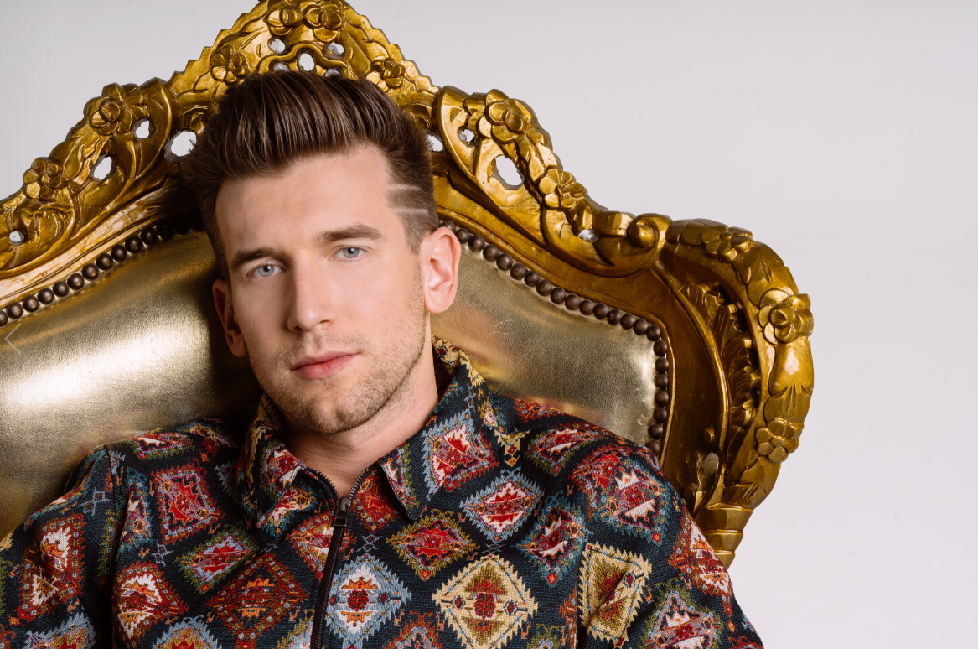

For more news and information, please visit

[SITE](maxfrost.net)

[FACEBOOK](https://www.facebook.com/maxfrostmusic)

[TWITTER](https://twitter.com/maxfrost)

[INSTAGRAM](https://www.instagram.com/maxfrost/)

[YOUTUBE](https://www.youtube.com/maxfrostmusic)

**MAX FROST**

**“THE GOLD RUSH TOUR”**

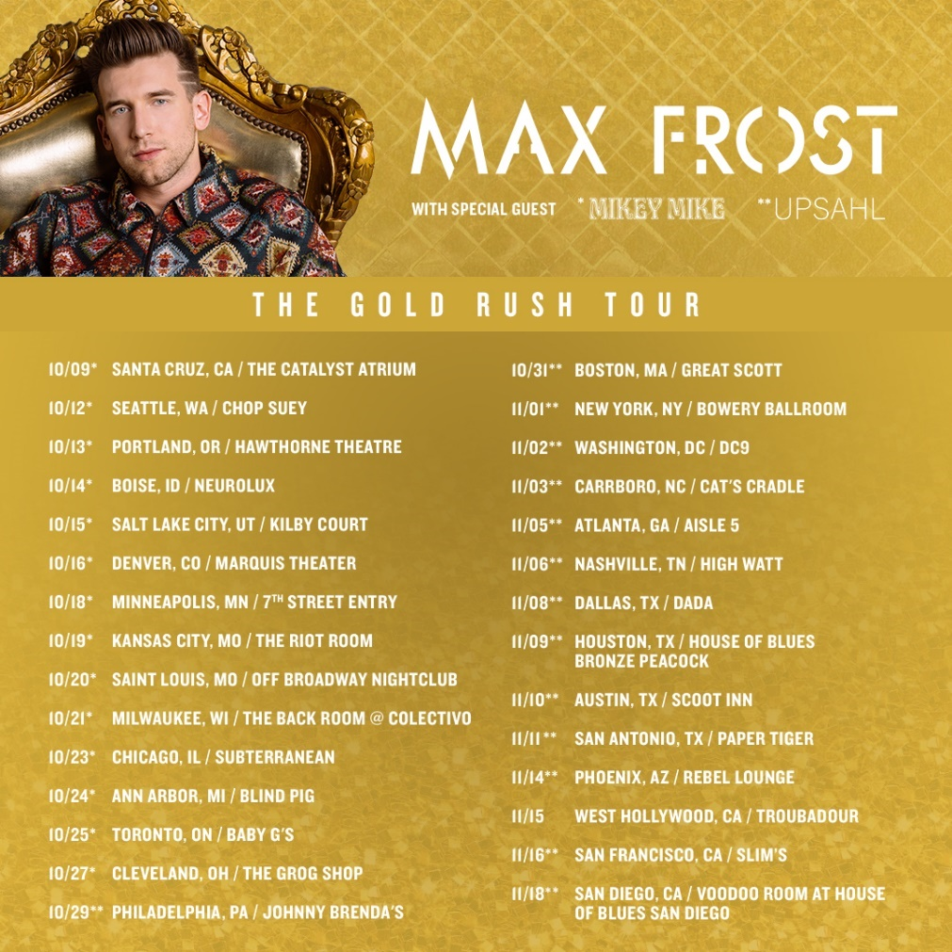

**AUGUST *Supporting Panic! At The Disco**

3 Houston, TX Toyota Center

4 Dallas, TX American Airlines Center

5 Tulsa, OK BOK Center

**OCTOBER**

9           Santa Cruz, CA              The Catalyst Atrium

12         Seattle, WA                   Chop Suey

13         Portland, OR                  Hawthorne Theatre

14         Boise, ID                         Neurolux

15         Salt Lake City, UT         Kilby Court

16         Denver, CO                    Marquis Theater

18         Minneapolis, MN         7th Street Entry

19         Kansas City, MO           The Riot Room

20         St. Louis, MO                 Off Broadway Nightclub

21         Milwaukee, WI             The Back Room @ Collectivo

23         Chicago, IL                     Subterranean

24         Ann Arbor, MI               Blind Pig

25         Toronto, ON                  Baby G’s

27         Cleveland, OH               The Grog Shop

29         Philadelphia, PA           Johnny Brenda’s

31         Boston, MA                   Great Scott

**NOVEMBER**

1           New York, NY                Bowery Ballroom

2           Washington, DC           DC9

3           Carrboro, NC                 Cat’s Cradle

5           Atlanta, GA                    Aisle 5

6           Nashville, TN                 High Watt

8           Dallas, TX                       Dada

9           Houston, TX                  House of Blues Bronze Peacock

10         Austin, TX                      Scoot Inn

11         San Antonio, TX            Paper Tiger

14         Phoenix, AZ                   Rebel Lounge

15 West Hollywood, CA Troubadour

16         San Francisco, CA         Slim’s

18         San Diego, CA               Voodoo Room @ House of Blues San Diego

[maxfrost.net/tour.html](http://maxfrost.net/tour.html)

# # #