FOR IMMEDIATE RELEASE
AUGUST 23, 2013

MAX FROST SIGNS WITH ATLANTIC RECORDS;
SOUL-POP SINGER/SONGWRITER CELEBRATES WITH DEBUT EP;
HIGHLIGHTS INCLUDE THE ONLINE SMASH, “WHITE LIES,”
HAILED BY PASTE AS ONE OF THE “BEST SONGS OF 2013 SO FAR”;
SINGLE HITS DSPS ON SEPTEMBER 17TH;
AUSTIN-BASED TUNESMITH TO JOIN GARY CLARK JR.
ON NORTH AMERICAN TOUR, BEGINNING SEPTEMBER 26TH;
“LOW HIGH LOW” EP ARRIVES EVERYWHERE ON OCTOBER 8TH
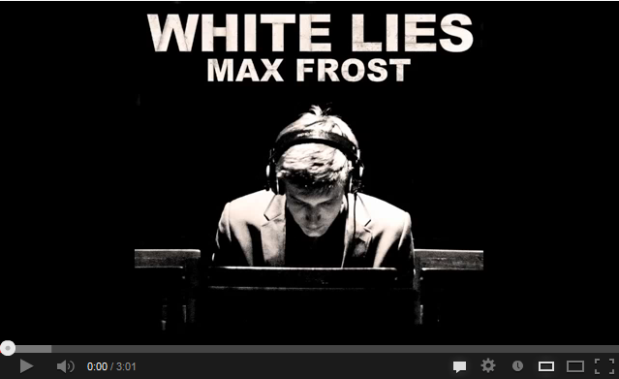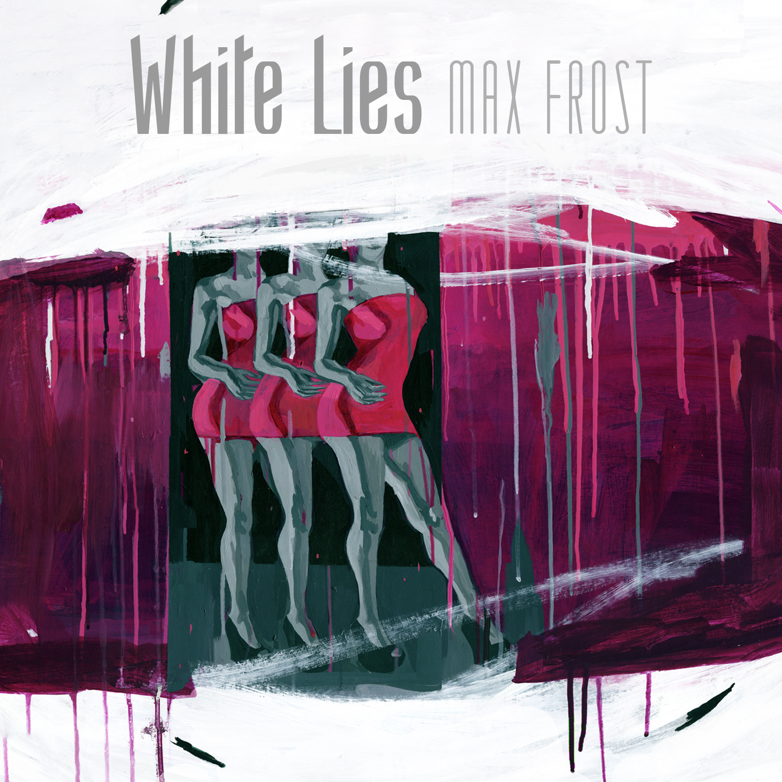
Atlantic Records has announced its signing of singer/songwriter, Max Frost. The Austin-based musician will release his much-anticipated debut EP, entitled simply “LOW HIGH LOW,” on October 8th.
“LOW HIGH LOW” is heralded by the genre-smashing single, “White Lies,” which arrives at all DSPs on September 17th. The track – which previously hit #1 on The Hype Machine’s “Most Popular Tracks on Blogs Now” chart in both April and May of this year – will be accompanied by a companion video clip, slated to follow the single’s digital release.
“White Lies” has already proven widely lauded, with Paste hailing it as “a jolt of energy” while naming it among “The Best Songs of 2013 So Far.” “A soul-pop gem with nimble vocal delivery, suspicious lyrics, and an irresistible groove,” said The Austin Chronicle, while My Old Kentucky Blog, further praised “White Lies” as “accessible, dancey…No need for multiple listens. This one will hit you immediately.” “The upbeat guitar mixed with the synthy electronic production come together to form a killer musical marriage,” declared Pigeons & Planes, adding, “If this is what the newcomer has to offer below the radar, it will be very exciting to see what he comes up with once he breaks.”
The multi-talented 21-year-old tunesmith will celebrate the release of “LOW HIGH LOW” with his biggest tour schedule to date. Frost will accompany his fellow Austinite, Warner Bros. recording artist Gary Clark Jr., on a major North American tour, kicking off September 26th at Los Angeles’ The Wiltern. For tour details and ticket information, please visit maxfrost.net/shows.
Frost has been an active presence on the ever-influential Austin scene since his high school days, performing in a variety of bands and collaborative projects at venues spanning Texas, Los Angeles, and Dublin. His knack for undeniably fresh beats and tight songwriting soon led to collaborations with such diverse artists as Austin icon Bob Schneider and hip-hop MC/producer Kydd.
In September 2012, Frost opted to leave the University of Texas - Austin to focus like a laser on his increasingly fruitful musical career. He began playing more and more live shows, winning over new fans nearly nightly with his electrifyingly idiosyncratic blend of soul, funk, hip-hop, pop, and electronica. The April 2013 release of “White Lies” proved his national breakthrough, earning him widespread notice in top music blogs and other major publications. What’s more, the track’s success catapulted another Frost track, “Nice and Slow” – also featured on the “LOW HIGH LOW” EP – to top 3 status on The Hype Machine blog rankings.
For more news and information, please visit maxfrost.net, twitter.com/maxfrostmusic (@maxfrostmusic), www.youtube.com/maxfrostguitar, www.facebook.com/Max-Frost, and www.atlanticrecords.com.

(TOUR ITINERARY ATTACHED)
MAX FROST ON TOUR
All dates w/ Gary Clark Jr. except *

SEPTEMBER
21 Utopia, TX Utopia Fest*
26 Los Angeles, CA The Wiltern Theatre
27 San Diego, CA House of Blues

OCTOBER
2 Oakland, CA Fox Theater
5 Austin, TX Austin City Limits Music Festival*
10 Salt Lake City, UT The Depot
11 Denver, CO Ogden Theater
12 Austin, TX Austin City Limits Music Festival*

NOVEMBER
11 Boston, MA Royale
12 Washington, DC 9:30 Club
16 New York, NY Terminal 5
20 Minneapolis, MI First Avenue
22 Indianapolis, IN The Vogue Theatre
23 Columbia, MO The Blue Note

Contact:
ATLANTIC RECORDS
Christina Kotsamanidis
212-707-2241
Christina.Kotsamanidis@atlanticrecords.com

Chelsey Northern
818-238-6832
Chelsey.Northern@atlanticrecords.com

