FOR IMMEDIATE RELEASE
APRIL 23, 2018

ATLANTIC RECORDS PREVIEWS “MEAN GIRLS ORIGINAL BROADWAY CAST RECORDING” WITH FIRST TRACK PREMIERE
“I’D RATHER BE ME” AVAILABLE NOW AND
JOINED BY NEW VIDEO STREAMING HERE

OFFICIAL DIGITAL ALBUM RELEASE DATE SET FOR FRIDAY, MAY 18TH
WITH PHYSICAL CD RELEASE TO FOLLOW ON FRIDAY, JUNE 15TH

MEAN GIRLS IN PERFORMANCES NOW AT BROADWAY’S AUGUST WILSON THEATRE

Atlantic Records is celebrating the upcoming release of “MEAN GIRLS ORIGINAL BROADWAY CAST RECORDING,” the official companion to the new musical comedy based on the iconic film, with the premiere of the show’s “I’d Rather Be Me,” performed by Barrett Wilbert Weed & the Original Broadway Cast of MEAN GIRLS. The anthemic track – accompanied by a new exclusive behind the scenes video of the in-studio recording, streaming HERE – is available now. Last week also saw Barrett Wilbert Weed celebrating the musical’s blockbuster success with a performance of “I’d Rather Be Me” on NBC’s The Tonight Show Starring Jimmy Fallon, streaming HERE. Additional instant grat tracks will be unveiled in the coming weeks. “MEAN GIRLS ORIGINAL BROADWAY CAST RECORDING” is available now for digital pre-orders and pre-saves HERE; the LP arrives digitally on Friday, May 18th with the physical CD’s set to arrive in stores nationwide on Friday, June 15th. For a full track listing, cover art, and additional details on the Cast Recording, please visit http://www.atlanticrecords.com/meangirls.

WATCH “I’D RATHER BE ME”
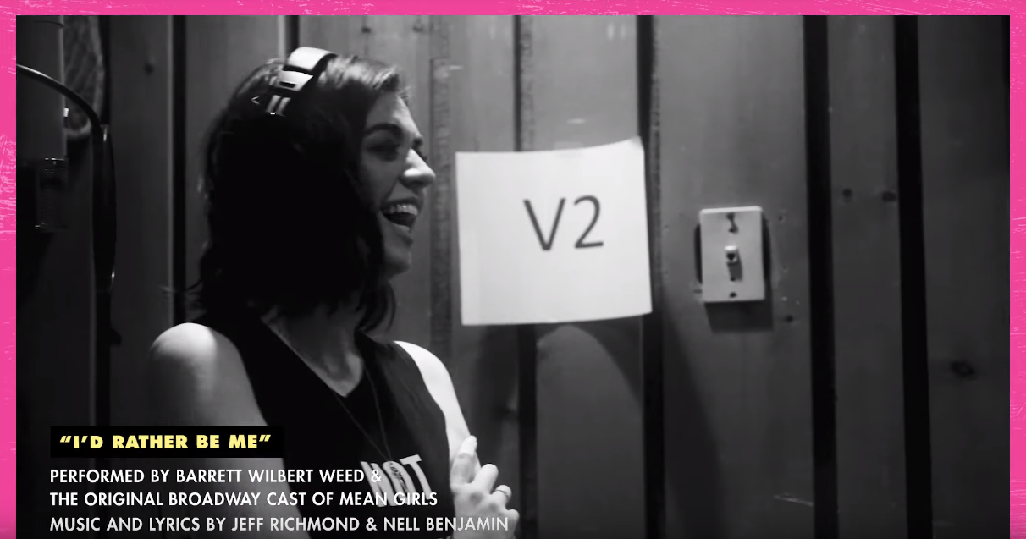

MEAN GIRLS garnered wide-ranging critical applause following its opening earlier this month. “The songs pack in their share of wit,” raved The Hollywood Reporter, "both in Benjamin's nimble lyrics and Richmond's buoyant tunes, which borrow with a wink from a variety of styles.” "Smart and splashy, with a clever book that’s unmistakably by Tina Fey,” added New York Magazine, “It delivers – approaching its material with immense energy and a wicked sense of humor." “Tina Fey’s catty book and Nell Benjamin’s saucy lyrics pump laughs into this smart, funny, musical-comedy version of the 2004 movie,” declared Variety while The New York Times professed, “Count me on Team Regina. Regina and her frenemies converse in dialogue by the peerless comic writer Tiny Fey, who has one of the most appealing satirical sensibilities on offer. Her wit is both caustic and polite, stinging and soothing at once. I was laughing even before the show started.” People added, “Fresh, Fun, Infectious…Jeff Richmond and Nell Benjamin’s songs keep the laughs coming. MEAN GIRLS is so good, it’ll make every day feel like October 3rd.”

“MEAN GIRLS ORIGINAL BROADWAY CAST RECORDING” continues Atlantic Records’ recent string of landmark Original Broadway Cast Recordings, including 2015’s GRAMMY® Award-winning, chart-topping milestone, “HAMILTON (ORIGINAL BROADWAY CAST RECORDING)” and this year’s GRAMMY® Award-winning, “DEAR EVAN HANSEN (ORIGINAL BROADWAY CAST RECORDING).”

ABOUT MEAN GIRLS:
Mean Girls, the new musical comedy produced by Lorne Michaels, Stuart Thompson, Sonia Friedman, and Paramount Pictures based on the hit film, is now in performances at Broadway’s August Wilson Theatre (245 West 52nd Street).

Mean Girls features a book by nine-time Emmy Award winner Tina Fey, based on her screenplay for the film, music by three-time Emmy Award winner Jeff Richmond, and lyrics by Tony Award nominee Nell Benjamin. Tony Award winner Casey Nicholaw directs and choreographs.

The Broadway cast is led by Erika Henningsen as Cady Heron, Taylor Louderman as Regina George, Ashley Park as Gretchen Wieners, Kate Rockwell as Karen Smith, Barrett Wilbert Weed as Janis Sarkisian, Grey Henson as Damian Hubbard, Kerry Butler as Mrs. Heron / Ms. Norbury / Mrs. George, Kyle Selig as Aaron Samuels, Cheech Manohar as Kevin Gnapoor, Rick Younger as Mr. Duvall. The cast also includes Stephanie Lynn Bissonnette, Tee Boyich, Collins Conley, Ben Cook, DeMarius R. Copes, Kevin Csolak, Devon Hadsell, Curtis Holland, Myles McHale, Chris Medlin, Brittany Nicholas, Becca Petersen, Nikhil Saboo, Jonalyn Saxer, Brendon Stimson, Riza Takahashi, Kamille Upshaw, Zurin Villanueva, Gianna Yanelli, and Iain Young.

Mean Girls’ creative team includes Scott Pask (Set Design), Gregg Barnes (Costume Design), Kenneth Posner (Lighting Design), Brian Ronan (Sound Design), Finn Ross & Adam Young (Video Design), Josh Marquette (Hair Design), Milagros Medina-Cerdeira (Make-Up Design), Mary-Mitchell Campbell (Music Director), John Clancy (Orchestrations), Glen Kelly (Dance and Incidental Music Arrangements), Mary-Mitchell Campbell, Jeff Richmond, and Natalie Tenenbaum (Vocal Arrangements), Howard Joines (Music Coordinator), and Telsey + Co / Bethany Knox, CSA (Casting).

The musical is produced by Lorne Michaels, Stuart Thompson, Sonia Friedman, Paramount Pictures, Marisa Sechrest, Ars Nova Entertainment, Berlind Productions, Steve Burke, Scott M. Delman, Roy Furman, Robert Greenblatt, Ruth Hendel, Jam Theatricals, The John Gore Organization, The Lowy Salpeter Company, James L. Nederlander, Christine Schwarzman, Universal Theatrical Group.

TICKET INFORMATION
Tickets are available through Ticketmaster.com, by calling (877) 250-2929, and in-person at the August Wilson Theatre Box Office (245 West 52nd Street; Monday – Saturday: 10am - 8pm). Book groups of 12 or more by calling 1-800-BROADWAY x2. Information on lottery and rush ticket policies can be found at www.MeanGirlsOnBroadway.com/Lottery.

MEANGIRLSONBROADWAY.COM
ATLANTICRECORDS

