MEEK MILL RECRUITS LIL UZI VERT FOR “BLUE NOTES 2”

WATCH OFFICIAL VIDEO
Directed by: Kid Art | Co-directed by Meek Mill

DOWNLOAD/STREAM
Produced by: Nick Papz and Xander

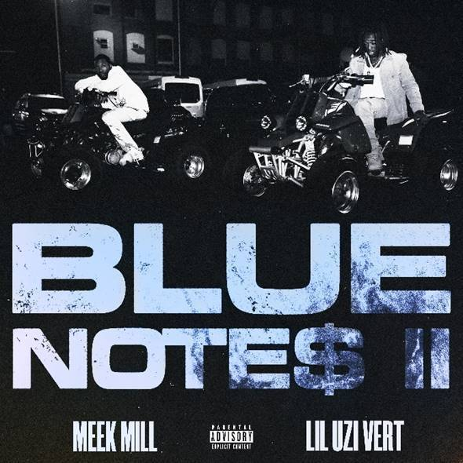
DOWNLOAD ARTWORK HERE

***

+ WATCH & LISTEN TO “SHARING LOCATIONS (FEAT. LIL BABY & LIL DURK)”
DOWNLOAD/STREAM | WATCH OFFICIAL VIDEO
Produced by: Nick Papz, Xander, KJ & Svdominik
Directed by: Meek Mill | Shot by: 20K Visuals & Carter’s Vision
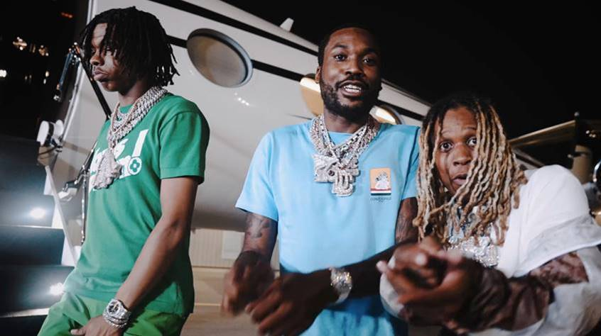

PRESS CONTACTS:
Jason Davis (Atlantic Records) – Jason.Davis@atlanticrecords.com
Jana Fleishman (Roc Nation) – JanaF@rocnation.com
Didier Morais (Berk Communications) – Didier@berkcommunications.com

# # #

