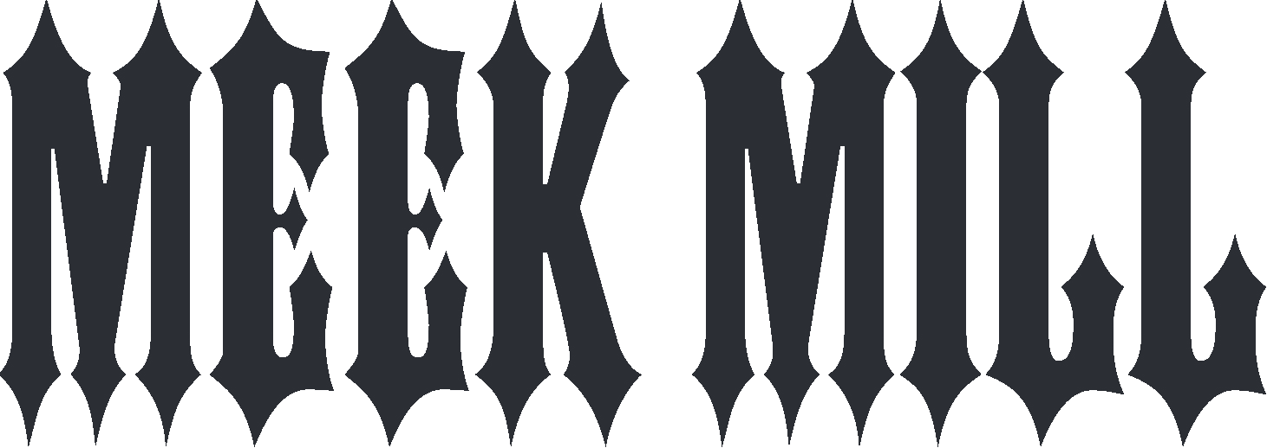

North Philadelphia’s Robert Rihmeek Williams, better known as Meek Mill, is no stranger to adversity and triumph. Hailed by Rolling Stone as “one of rap’s few voices for the everyman,” He is without question one of the most electrifying hip-hop talents in recent memory. Meek Mill first garnered attention and made waves by chronicling his hard-knock life on a series of stunning mixtapes before releasing his debut album, DREAMS & NIGHTMARES, in October 2012. The project instantly catapulted him into rap superstardom, thanks to his ability to create both high-energy street anthems and soul-bearing, emotionally relatable stories of overcoming struggle and adversity.

He followed up his debut album with his now platinum-certified sophomore album DREAMS WORTH MORE THAN MONEY in 2015, which topped Billboard’s “Top 200 Albums,” “Top R&B/Hip-Hop Albums” and “Top Rap Albums charts” for two consecutive weeks. He released WINS & LOSSES in 2017, which he followed up with his most recent release LEGENDS OF THE SUMMER. The 4-song project was heralded by “Stay Woke (feat. Miguel),” a powerful statement record chronicling his own experiences battling the injustices of the legal system.

For more information on Meek Mill, please visit www.meekmill.com or follow him on Twitter, Instagram, Facebook, YouTube.

