**Meek Mill Debuts Visual For “Expensive Pain”**

*New Music Video From GRAMMY-nominated Musician, Entrepreneur and Criminal Justice Reform Advocate Arrives Following The Release Of His Fifth Studio Album Available Now*

*Watch “Expensive Pain” Video* [*HERE*](https://nam04.safelinks.protection.outlook.com/?url=https%3A%2F%2Fwww.youtube.com%2Fwatch%3Fv%3Dry0q8BUhhZE&data=04%7C01%7CBrian.Sommer%40atlanticrecords.com%7Ca048329c844041595d4708d988352aee%7C8367939002ec4ba1ad3d69da3fdd637e%7C0%7C0%7C637690584193122818%7CUnknown%7CTWFpbGZsb3d8eyJWIjoiMC4wLjAwMDAiLCJQIjoiV2luMzIiLCJBTiI6Ik1haWwiLCJXVCI6Mn0%3D%7C1000&sdata=D4NGTeXGxDSXhBs4Ei126kWzli%2B52a1Sn6DkpB%2FnqUw%3D&reserved=0)

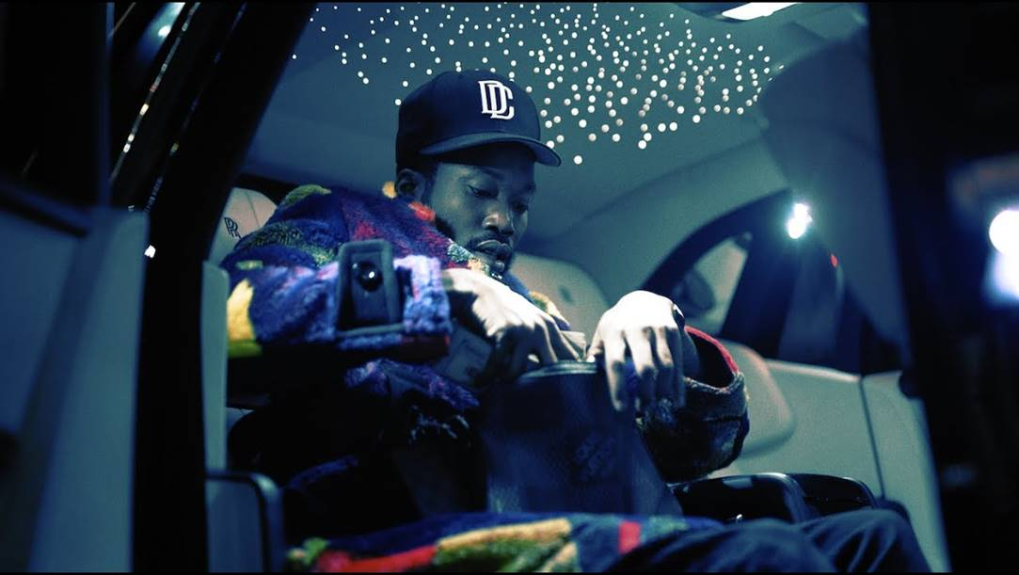

*Stream “Expensive Pain” Album*[*HERE*](https://nam04.safelinks.protection.outlook.com/?url=https%3A%2F%2Fmeekmill.lnk.to%2FExpensivePain&data=04%7C01%7CBrian.Sommer%40atlanticrecords.com%7Ca048329c844041595d4708d988352aee%7C8367939002ec4ba1ad3d69da3fdd637e%7C0%7C0%7C637690584193132819%7CUnknown%7CTWFpbGZsb3d8eyJWIjoiMC4wLjAwMDAiLCJQIjoiV2luMzIiLCJBTiI6Ik1haWwiLCJXVCI6Mn0%3D%7C1000&sdata=YSrdK2tSiFTrm8hVo3bqO9QjcIvqGHsQTvBNVrPozCA%3D&reserved=0)

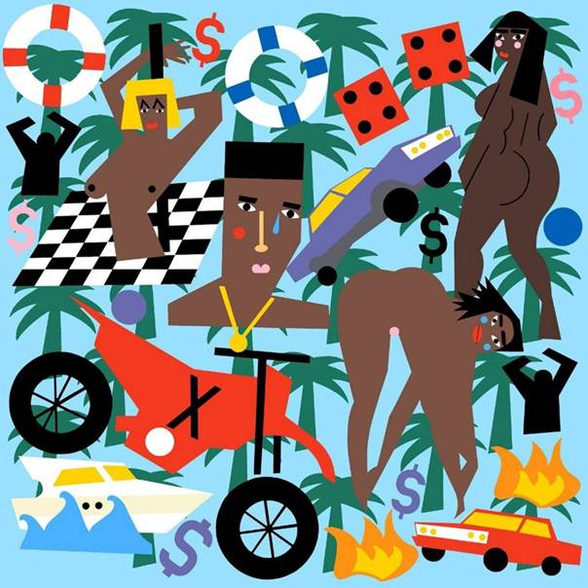

**Expensive Pain – Tracklist**

1. Intro (Hate On Me)
2. Outside (100 MPH)
3. On My Soul
4. Sharing Locations feat. Lil Baby and Lil Durk
5. Expensive Pain
6. Ride For You feat. Kehlani
7. Me (FWM) feat. A$AP Ferg
8. Hot feat. Moneybagg Yo
9. Love Train
10. Northside Southside feat. Giggs
11. We Slide feat. Young Thug
12. Tweaking feat. Vory
13. Love Money
14. Blue Notes 2 feat. Lil Uzi Vert
15. Angels (RIP Lil Snupe)
16. Cold Hearted III
17. Halo feat. Brent Faiyaz
18. Flamerz Flow (Bonus)

**About Meek Mill**   
Robert "Meek Mill" Williams is a Grammy-nominated recording artist, entrepreneur and criminal justice reform advocate that hails from Philadelphia, Pennsylvania. Mill evolved from Philadelphia's hottest underground rapper to one of the world's preeminent musical artists, having released a slew of smash studio albums and singles, including "Ima Boss," "Dreams and Nightmares (Intro)," "All Eyes on You," and "Going Bad," among many others.

He is also the co-chair of the REFORM Alliance, which launched in January 2019 and aims to advance criminal justice reform and eradicate outdated policies that perpetuate injustice in the United States. He partnered with JAY-Z, Michael Rubin, Robert Kraft, Robert F. Smith, Clara Wu Tsai, Laura Arnold, Michael Novogratz and Van Jones to launch the organization.

Additionally, Mill is a co-owner of sports apparel retailer Lids, the largest retail seller of hats and licensed sports product in North America. Mill is also the CEO of Dream Chasers, his music label imprint that he launched in 2012 and named after his mixtape series.

For more information on Meek Mill, please visit [www.meekmill.com](https://nam04.safelinks.protection.outlook.com/?url=https%3A%2F%2Fc212.net%2Fc%2Flink%2F%3Ft%3D0%26l%3Den%26o%3D3292311-1%26h%3D429705554%26u%3Dhttp%253A%252F%252Fwww.meekmill.com%252F%26a%3Dwww.meekmill.com&data=04%7C01%7CBrian.Sommer%40atlanticrecords.com%7Ca048329c844041595d4708d988352aee%7C8367939002ec4ba1ad3d69da3fdd637e%7C0%7C0%7C637690584193132819%7CUnknown%7CTWFpbGZsb3d8eyJWIjoiMC4wLjAwMDAiLCJQIjoiV2luMzIiLCJBTiI6Ik1haWwiLCJXVCI6Mn0%3D%7C1000&sdata=R9SyLp65%2FScwqsEoxTRoS3uLeL9ad5%2FZfs6gccDFkdk%3D&reserved=0) or follow him on [Twitter](https://nam04.safelinks.protection.outlook.com/?url=https%3A%2F%2Fc212.net%2Fc%2Flink%2F%3Ft%3D0%26l%3Den%26o%3D3292311-1%26h%3D1358279651%26u%3Dhttps%253A%252F%252Ftwitter.com%252Fmeekmill%26a%3DTwitter&data=04%7C01%7CBrian.Sommer%40atlanticrecords.com%7Ca048329c844041595d4708d988352aee%7C8367939002ec4ba1ad3d69da3fdd637e%7C0%7C0%7C637690584193142809%7CUnknown%7CTWFpbGZsb3d8eyJWIjoiMC4wLjAwMDAiLCJQIjoiV2luMzIiLCJBTiI6Ik1haWwiLCJXVCI6Mn0%3D%7C1000&sdata=3mjQVYTiUUyRu64sLqtjevVk2O1%2BoHXVx9orFngdLLo%3D&reserved=0), [Instagram](https://nam04.safelinks.protection.outlook.com/?url=https%3A%2F%2Fc212.net%2Fc%2Flink%2F%3Ft%3D0%26l%3Den%26o%3D3292311-1%26h%3D3513201185%26u%3Dhttps%253A%252F%252Fwww.instagram.com%252Fmeekmill%252F%26a%3DInstagram&data=04%7C01%7CBrian.Sommer%40atlanticrecords.com%7Ca048329c844041595d4708d988352aee%7C8367939002ec4ba1ad3d69da3fdd637e%7C0%7C0%7C637690584193142809%7CUnknown%7CTWFpbGZsb3d8eyJWIjoiMC4wLjAwMDAiLCJQIjoiV2luMzIiLCJBTiI6Ik1haWwiLCJXVCI6Mn0%3D%7C1000&sdata=ohV5ArvWnmspU3R0B7TiJL6giwQ%2FHLs%2FaUKQVN3GAVY%3D&reserved=0), [Facebook](https://nam04.safelinks.protection.outlook.com/?url=https%3A%2F%2Fc212.net%2Fc%2Flink%2F%3Ft%3D0%26l%3Den%26o%3D3292311-1%26h%3D1176659453%26u%3Dhttps%253A%252F%252Fwww.facebook.com%252FMeekMill%252F%26a%3DFacebook&data=04%7C01%7CBrian.Sommer%40atlanticrecords.com%7Ca048329c844041595d4708d988352aee%7C8367939002ec4ba1ad3d69da3fdd637e%7C0%7C0%7C637690584193152797%7CUnknown%7CTWFpbGZsb3d8eyJWIjoiMC4wLjAwMDAiLCJQIjoiV2luMzIiLCJBTiI6Ik1haWwiLCJXVCI6Mn0%3D%7C1000&sdata=NVzIrgqdQcu92xQ3sPKVtmc8K8iRCN6PvjjEgIoxRrY%3D&reserved=0) & [YouTube](https://nam04.safelinks.protection.outlook.com/?url=https%3A%2F%2Fc212.net%2Fc%2Flink%2F%3Ft%3D0%26l%3Den%26o%3D3292311-1%26h%3D1051858399%26u%3Dhttps%253A%252F%252Fwww.youtube.com%252Fuser%252FMeekMillTV%26a%3DYouTube&data=04%7C01%7CBrian.Sommer%40atlanticrecords.com%7Ca048329c844041595d4708d988352aee%7C8367939002ec4ba1ad3d69da3fdd637e%7C0%7C0%7C637690584193152797%7CUnknown%7CTWFpbGZsb3d8eyJWIjoiMC4wLjAwMDAiLCJQIjoiV2luMzIiLCJBTiI6Ik1haWwiLCJXVCI6Mn0%3D%7C1000&sdata=mNwudD8OQ2gQ719%2Fd5Rqs2oE3KjYB2uuijLlaNCvBE0%3D&reserved=0).

# # #