**MEEK MILL AND RODDY RICCH PEN A POWERFUL “LETTER TO NIPSEY"**

**NEW SONG FOLLOWS EMOTIONAL GRAMMY® AWARDS TRIBUTE TO THE LATE NIPSEY HUSSLE**

[**LISTEN TO “LETTER TO NIPSEY (FEAT. RODDY RICCH)” HERE**](https://meekmill.lnk.to/LetterToNipsey)

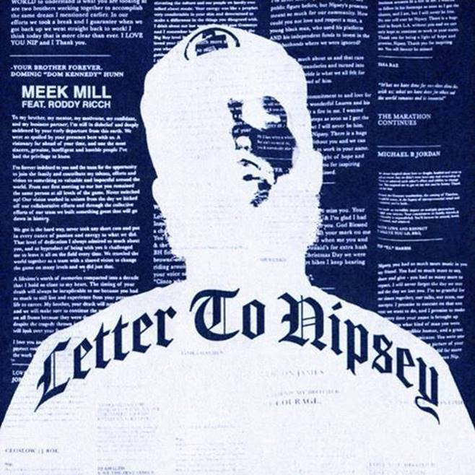

GRAMMY® nominated rapper and criminal justice reform advocate **Meek Mill** has teamed up with GRAMMY® winning rising rap superstar **Roddy Ricch** for a powerful collaboration titled [**“Letter to Nipsey,”**](https://meekmill.lnk.to/LetterToNipsey) an emotional song dedicated to their late collaborator and close friend, GRAMMY® winning artist **Nipsey Hussle**.

The new release follows the songs moving debut during a tribute to the late entrepreneur and rapper at the 62nd GRAMMY® Awards by Meek and Roddy in addition to **YG**, **DJ Khaled**, **John Legend** and **Kirk Franklin**.

All proceeds from sales and streams of **“Letter to Nipsey”** will benefit Nipsey’s family.

**PRESS CONTACTS:**

JASON DAVIS | [JASON.DAVIS@ATLANTICRECORDS.COM](mailto:JASON.DAVIS@ATLANTICRECORDS.COM)

JANA FLEISHMAN | [JANAF@ROCNATION.COM](mailto:JANAF@ROCNATION.COM)

DIDIER MORAIS | [DIDIER@BERKCOMMUNICATIONS.COM](mailto:DIDIER@BERKCOMMUNICATIONS.COM)

# # #