**MEEK MILL DROPS SURPRISE 4-SONG EP**

**QUARANTINE PACK**

[**Listen Now**](https://nam04.safelinks.protection.outlook.com/?url=https%3A%2F%2Fmeekmill.lnk.to%2FQuarantinePack&data=04%7C01%7CBrian.Sommer%40atlanticrecords.com%7Cad0dd71de5ca44839aa208d88d12db90%7C8367939002ec4ba1ad3d69da3fdd637e%7C0%7C0%7C637414459411432775%7CUnknown%7CTWFpbGZsb3d8eyJWIjoiMC4wLjAwMDAiLCJQIjoiV2luMzIiLCJBTiI6Ik1haWwiLCJXVCI6Mn0%3D%7C1000&sdata=zTPvaIvbq%2Bgpm94GaajX3%2FLq8fNItnLswAcy2hWVHX4%3D&reserved=0)

[**Download Artwork Here**](https://nam04.safelinks.protection.outlook.com/?url=http%3A%2F%2Fpress.atlanticrecords.com%2Fmeek-mill%2F&data=04%7C01%7CBrian.Sommer%40atlanticrecords.com%7Cad0dd71de5ca44839aa208d88d12db90%7C8367939002ec4ba1ad3d69da3fdd637e%7C0%7C0%7C637414459411422780%7CUnknown%7CTWFpbGZsb3d8eyJWIjoiMC4wLjAwMDAiLCJQIjoiV2luMzIiLCJBTiI6Ik1haWwiLCJXVCI6Mn0%3D%7C1000&sdata=%2FEyBEiR5n9XJluitUVt4s7DAN3YfnByJci%2F%2FJy%2B83kQ%3D&reserved=0)



**NEW EP ARRIVES ALONGSIDE VISUAL COMPANION FOR**

**“PAIN AWAY (FEAT. LIL DURK)”**

**Watch Here**

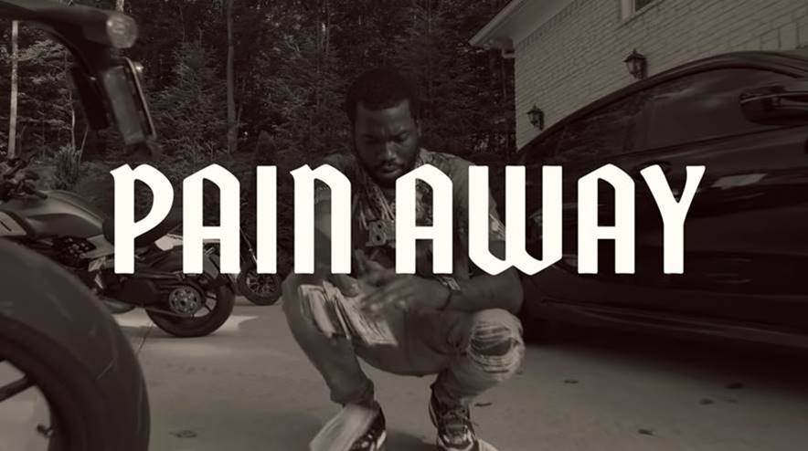

(Friday, November 20, 2020) Meek Mill surprised fans today with his **QUARANTINE PACK**. The drop was briefly teased in a tweet earlier this week and is available across all platforms.

TRACKLISTING:

1. Middle Of It ft. Vory

2. Pain Away ft. Lil Durk

3. GTA ft. 42Dugg

4. Think It’s A Game ft. Vory

Most recently seen in the critically acclaimed film, CHARM CITY KINGS, Meek Mill is a GRAMMY-nominated multi-platinum hip-hop artist, songwriter and entrepreneur that hails from Philadelphia, Pennsylvania. Meek evolved from Philadelphia’s hottest underground rapper to one of the world’s preeminent musical artists, having released a slew of smash studio albums and singles, including “Ima Boss,” “Dream and Nightmares (Intro),” “All Eyes on You” and “Whatever You Need,” among many others. His latest studio album, *CHAMPIONSHIPS*, debuted at No. 1 on Billboard’s “Top 200 Albums,” marking his second chart-topper following his 2015 album *DREAMS WORTH MORE THAN MONEY.* The album earned him a 2020 GRAMMY Award nomination “Best Rap Album*.”* In October 2012, Meek announced the launch of his own label imprint, Dream Chasers, named after his acclaimed mixtape series.

In addition to serving as the CEO of Dream Chasers, Mill is the co-chair of the REFORM alliance, which launched in January 2019 and aims to advance criminal justice reform and eradicate outdated policies that perpetuate injustice in the United States. Meek is committed to generating awareness around the problems of the criminal justice system – including excessive probations regulations, the disproportionate bail system and the lack of rehabilitation programs available – and highlighting how they disproportionately affect people of color.

**PRESS CONTACTS:**

Jason Davis (Atlantic Records) – [Jason.Davis@atlanticrecords.com](mailto:Jason.Davis@atlanticrecords.com)

Jana Fleishman (Roc Nation) – [JanaF@rocnation.com](mailto:JanaF@rocnation.com)