**MEEK MILL TEAMS UP WITH LIL BABY & LIL DURK ON “SHARING LOCATIONS”**

[**WATCH OFFICIAL VIDEO**](https://www.youtube.com/watch?v=p2oha3oS_ko)

*Directed By: Meek Mill*

*Shot by: 20K Visuals & Carter’s Vision*

[**DOWNLOAD/STREAM**](https://meekmill.lnk.to/SharingLocations)

*Produced by: Nick Papz, Xander, KJ & Svdominik*

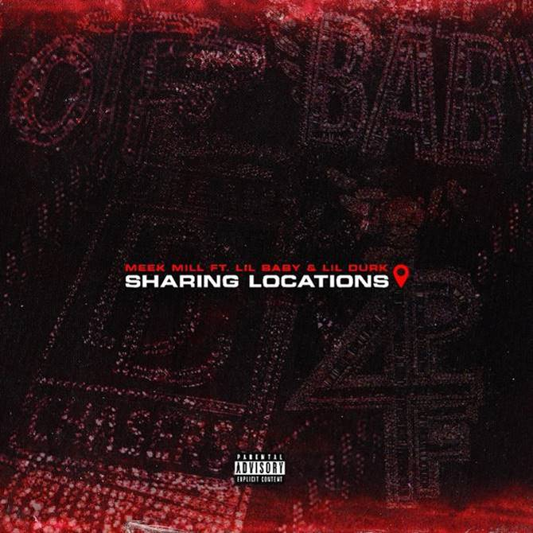

[DOWNLOAD ARTWORK HERE](https://nam04.safelinks.protection.outlook.com/?url=https%3A%2F%2Fpress.atlanticrecords.com%2Fmeek-mill%2F&data=04%7C01%7CBrian.Sommer%40atlanticrecords.com%7Cbfcff4a5fd5d4185f6f808d968d7256a%7C8367939002ec4ba1ad3d69da3fdd637e%7C0%7C0%7C637656095511521959%7CUnknown%7CTWFpbGZsb3d8eyJWIjoiMC4wLjAwMDAiLCJQIjoiV2luMzIiLCJBTiI6Ik1haWwiLCJXVCI6Mn0%3D%7C1000&sdata=Cu9BSt6a6Q9Sq0erg76niJYGja7vUQHb3038%2FJ6EJ4I%3D&reserved=0)

**PRESS CONTACTS:**

Jason Davis (Atlantic Records) – [Jason.Davis@atlanticrecords.com](mailto:Jason.Davis@atlanticrecords.com)

Jana Fleishman (Roc Nation) – [JanaF@rocnation.com](mailto:JanaF@rocnation.com)

Didier Morais (Berk Communications) – [Didier@berkcommunications.com](mailto:Didier@berkcommunications.com)

# # #