FOR IMMEDIATE RELEASE
JULY 29, 2019

MELANIE MARTINEZ ANNOUNCES “THE K-12 TOUR”

POP PHENOMENON CELEBRATES EAGERLY AWAITED NEW ALBUM
AND FULL-LENGTH COMPANION FEATURE FILM
WITH UNIQUE THEATRICAL PERFORMANCES AROUND THE WORLD

NORTH AMERICAN DATES GET UNDERWAY OCTOBER 13TH IN WASHINGTON, D.C.
EUROPEAN RUN BEGINS DECEMBER 2ND IN DUBLIN, IRELAND

U.S. TOUR TO BENEFIT THE TREVOR PROJECT

“K-12” ALBUM PRE-ORDERS AVAILABLE NOW
PRE-ORDERS PLACED VIA MELANIEMARTINEZMUSIC.COM
THROUGH MONDAY, AUGUST 5TH
RECEIVE PRESALE ACCESS TO UPCOMING HEADLINE DATES

WATCH OFFICIAL FILM TRAILER HERE

“K-12” ARRIVES AT ALL MUSIC RETAILERS AND STREAMING SERVICES
ON FRIDAY, SEPTEMBER 6TH



Atlantic recording artist Melanie Martinez has announced plans to present a unique theatrical performance on a major world tour. “The K-12 Tour” gets underway October 13th in Washington, D.C. at the All Things Go Fall Classic and then travels North America through late November; European dates follow, beginning December 2nd at Dublin, Ireland’s Olympia Theatre and then continues through mid-December. Support throughout the North American run comes from Lauren Ruth Ward; special guests for the European dates will be announced soon along with additional international dates. For complete details and additional information, please see melaniemartinezmusic.com.

“The K-12 Tour” celebrates the release of Martinez’s hugely anticipated new album and its accompanying full-length film. “K-12” arrives on Friday, September 6th; pre-orders are available now HERE, with all pre-orders placed via Martinez’s webstore through Monday, August 5th by 2 pm PT in the U.S. / 2pm in the UK receiving presale access to tickets for “The K-12 Tour.” Tickets go on sale to the general public starting Friday, August 9th at 10am (local) in North America/10am (GMT) in Europe.

Melanie Martinez has partnered with PLUS1 so that $1 from every ticket sold will go to support organizations bringing dignity, equity, and access to communities who need it. In the US specifically, the $1 per ticket sold will benefit The Trevor Project, and their work providing crisis intervention and suicide prevention services for LGBTQ youth. TheTrevorProject.org / www.plus1.org

“It’s been a bit since I’ve been on tour and I’m incredibly excited to bring the movie to life on stage,” says Martinez, “I’m putting all of my energy into making it not only visually stunning and pleasing to the senses but also a fun learning experience and a safe place to express yourself and be accepted for exactly who you are.”

“K-12” marks Martinez’s long anticipated follow-up to her RIAA platinum certified, 2015 debut album, “CRY BABY.” Produced by Michael Keenan with the exception of one song produced by Kinetics & One Love (who previously collaborated with Martinez on such hits as “Dollhouse” and “Carousel”), the album serves as a soundtrack companion to an eerily enchanting new musical film, written, directed, and starring Martinez. The official K-12 trailer is streaming now HERE and quickly received a stunning 2 million views in just 3 days of its premiere.

K-12 will have its official Los Angeles premiere on Tuesday, September 3rd, exclusively at Hollywood’s famed Arclight Cinerama Dome. An official New York City premiere will follow on Thursday, September 5th at the AMC Empire 25 in Times Square, with both premieres officially SOLD OUT within 24 hours. That same night will see K-12 shown as a one-night-only global event in theatres around the world. Presented by preeminent global theatrical distributor Abramorama, K-12 will play in 60+ theatres in the U.S. and many more internationally in over 27 countries including the United Kingdom, Australia, Canada, Spain, Mexico, Brazil, New Zealand, Ireland and Argentina, to name only a few. A complete list of participating theatres and tickets can be found now via www.k-12thefilm.com, with additional markets & theaters to be announced shortly.

Widely applauded for her remarkably creative live performances, Martinez will herald “K-12” and “The K-12 Tour” with a headline performance at Washington, DC’s upcoming All Things Go Fall Classic, set for Sunday, October 13th at DC’s historic Union Market. For live updates, please see melaniemartinezmusic.com.

Download Press Materials Here

# # #

ABOUT PLUS1
PLUS1 is an initiative that channels the collective energy of a concert to catalyze social change. By partnering with performing artists, PLUS1 raises and grants millions of dollars to high impact nonprofits addressing our most serious global challenges around Access, Equity, and Dignity. The work begins with a $1 per ticket add-on that makes fundraising simple and seamless. Beyond the dollar, PLUS1 supports artists as educators and advocates, fueling their passion, reach, impact. To date, PLUS1 has raised and granted over $7 million, and served as the connective tissue between over 100 artists, millions of their fans, and 100s of leading social justice organizations tackling global injustice.

MELANIE MARTINEZ
THE K-12 TOUR
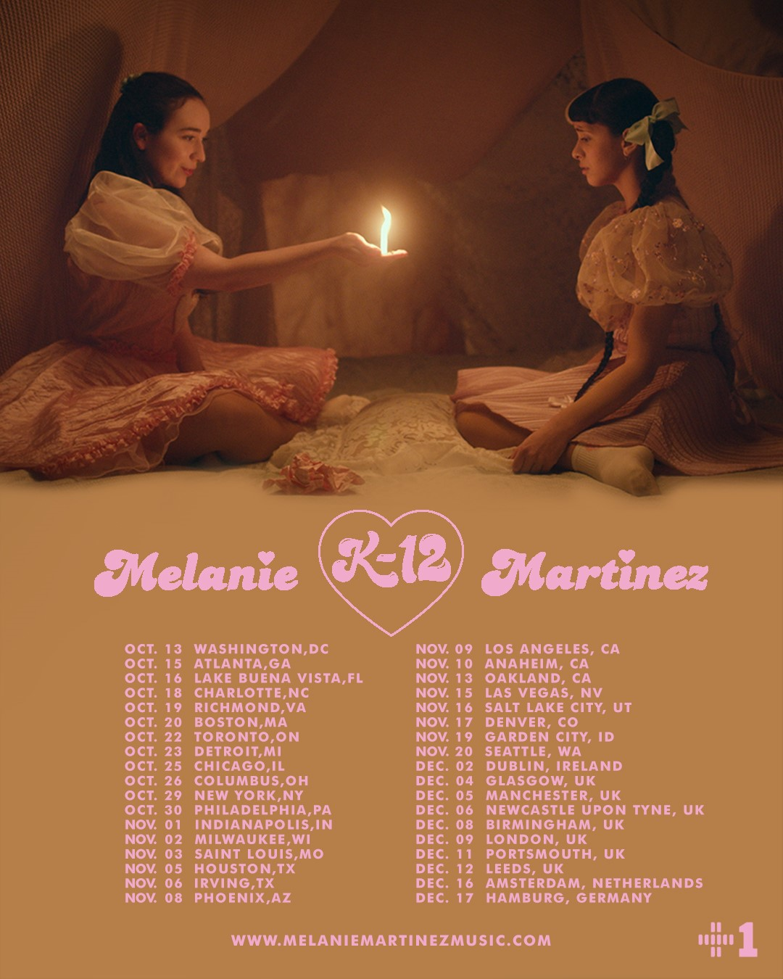

OCTOBER
13 Washington, DC All Things Go Fall Classic *
15 Atlanta, GA Coca-Cola Roxy
16 Lake Buena Vista, FL House of Blues Orlando
18 Charlotte, NC The Fillmore Charlotte
19 Richmond, VA The National
20 Boston, MA Orpheum Theatre
22 Toronto, ON Rebel
23 Detroit, MI The Fillmore Detroit
25 Chicago, IL Riviera Theatre
26 Columbus, OH Express Live!
29 New York, NY Manhattan Center Hammerstein Ballroom
30 Philadelphia, PA The Fillmore Philadelphia

NOVEMBER
1 Indianapolis, IN Murat Theatre
2 Milwaukee, WI The Eagles Ballroom
3 Saint Louis, MO The Pageant
5 Houston, TX Revention Music Center
6 Irving, TX The Pavilion at Toyota Music Factory
8 Phoenix, AZ The Van Buren
9 Los Angeles, CA Hollywood Palladium
10 Anaheim, CA House of Blues Anaheim
13 Oakland, CA Fox Theater
15 Las Vegas, NV The Pearl Concert Theater at Palms Casino Resort
16 Salt Lake City, UT The Union
17 Denver, CO Paramount Theatre
19 Garden City, ID The Revolution Center
20 Seattle, WA Paramount Theatre

DECEMBER
2 Dublin, IR Olympia Theatre
4 Glasgow, UK O2 Academy Glasgow
5 Manchester, UK O2 Apollo Manchester
6 Newcastle Upon Tyne, UK Newcastle City Hall
8 Birmingham, UK O2 Academy Birmingham
9 London, UK O2 Shepherd’s Bush Empire
11 Portsmouth, UK Guildhall
12 Leeds, UK O2 Academy Leeds
16 Amsterdam, NE Melkweg
17 Hamburg, DE Docks

* FESTIVAL PERFORMANCE
10/15-11/20 w/ Special Guest Lauren Ruth Ward

# # #

CONNECT WITH MELANIE MARTINEZ
OFFICIAL
INSTAGRAM
YOUTUBE
FACEBOOK
TWITTER

Contact Information:
Christina Kotsamanidis
212.707.2241
Christina.Kotsamanidis@atlanticrecords.com

