FOR IMMEDIATE RELEASE

SEPTEMBER 6, 2019

**ELECTRIC GUEST ANNOUNCE NEW ALBUM “KIN”**

**AND RELEASE SINGLE “MORE”**

**ACCLAIMED POP DUO’S EAGERLY AWAITED ATLANTIC RECORDS DEBUT LP *KIN***

**ARRIVES EVERYWHERE ON FRIDAY, OCTOBER 18TH; PRE-ORDER** [**HERE**](https://ElectricGuest.lnk.to/KINPR)

**LISTEN TO “MORE”** [**HERE**](https://ElectricGuest.lnk.to/MorePR) **+ WATCH VISUALIZER** [**HERE**](https://ElectricGuest.lnk.to/MorePR/youtube)

**“KIN” WORLD TOUR KICKS OFF OCTOBER 28TH IN SEATTLE, WA AND CONTINUES THROUGH NORTH AMERICA AND EUROPE**

**ALBUM RELEASE WEEK SHOW AT ROUGH TRADE NYC (OCTOBER 15TH) ALREADY SOLD OUT**

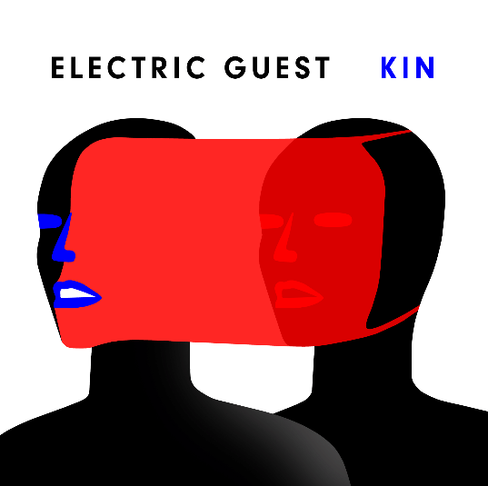

[**\*Download hi-res image here\***](https://www.dropbox.com/s/jft6o8uxl3to1nm/eg%20cover%20text%20LAYERED%20HD.pdf?dl=0)

Acclaimed pop duo Electric Guest have unveiled their brand new single, “More” off their highly-anticipated third album and Atlantic Records debut, *KIN*, which will be available everywhere Friday, October 18th. “More” is available now at all digital music retailers and streaming services. Listen [HERE](https://electricguest.lnk.to/MorePR). Watch Visualizer [HERE](https://electricguest.lnk.to/MorePR/youtube).

***“We wrote ‘More’ for anyone who feels like they’re searching for something different than what our culture is selling,”* says Electric Guest’s Asa Taccone. “*It was written with the hope that no matter how dire, despairing or seemingly impossible living can be, we are built for life & built to feed our best selves.”***

*KIN* is available for pre-order [HERE](https://electricguest.lnk.to/KINPR) and comes with digital downloads of “More” and the album’s first release, “Dollar.” The *KIN* album artwork officially unveiled today is the creation of Electric Guest’s longtime friend and collaborator [Elevator Teeth](https://www.instagram.com/elevatorteeth/).

KIN marks Electric Guest’s first LP in two years as well as the duo’s first new music since Taccone earned a 2019 GRAMMY® Award for co-writing and co-producing Portugal. The Man’s worldwide smash single, “[Feel It Still](https://bit.ly/2mYKUeQ).” Co-produced by Lars Stalfors (St. Vincent, HEALTH, Foster the People), the album sees Taccone and Compton pushing modern pop towards their own unique worldview, melding sunshine soul grooves and sugar candy hooks with ambitious production and a subversive lyrical power.

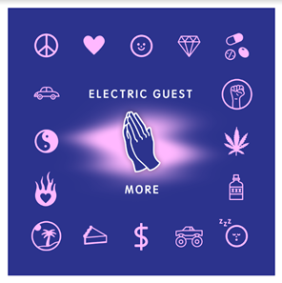

[**\*Download hi-res image here\***](https://drive.google.com/file/d/1YIf1HTEJZUmP3yOMtBNElzMswU-5-jQK/view)

In support of KIN, the duo will soon embark on their KIN WORLD TOUR, a massive global headline run, with special guests Wafia, Petrie, Joanna, and Soleima. The magnetic pair will bring their impressive, high-energy live show to cities throughout North America and Europe, kicking off at The Showbox in Seattle, WA on October 28th and continuing through to a finale show at The Crescent Ballroom in Phoenix, AZ on February 24th. During album release week, Electric Guest will play an already sold-out headline show at Brooklyn’s Rough Trade NYC on October 15th (full tour itinerary below).

For every ticket to the KIN WORLD TOUR sold, $1 will go to [Stand for Children](https://nam04.safelinks.protection.outlook.com/?url=http%3A%2F%2Fstand.org%2F&data=02%7C01%7CMegan.Rasmussen%40atlanticrecords.com%7C1c76f12000844a18b9b508d730a6da88%7C8367939002ec4ba1ad3d69da3fdd637e%7C0%7C0%7C637031365505408565&sdata=Ri47%2Fv7diUfVuKZneCs6hnzRpKUCDXOpIq012hfNg%2BY%3D&reserved=0), an organization focused on ensuring all students receive a high quality, relevant education, especially those whose boundless potential is overlooked and under-tapped because of their skin color, zip code, first language, or disability. Tickets will go on sale to the general public today at 10 AM (local time). For more ticket information, please visit [electricguestmusic.com](https://nam04.safelinks.protection.outlook.com/?url=https%3A%2F%2Felectricguestmusic.com%2FDollar%3Fref%3DTyped%2FBookmarked&data=02%7C01%7CMegan.Rasmussen%40atlanticrecords.com%7C1c76f12000844a18b9b508d730a6da88%7C8367939002ec4ba1ad3d69da3fdd637e%7C0%7C0%7C637031365505418558&sdata=6CbmqEpk%2BUlKm9ygw7X84OnLC8g66I3U2rZeqju%2F1V8%3D&reserved=0).

“More” follows KIN’S lead single “Dollar” which arrived earlier this summer. The vibey, electro-pop single, “Dollar,” was named by Apple Music’s Beats 1 as Zane Lowe’s World Record upon its July release, and is accompanied by a feel-good music [video](https://nam04.safelinks.protection.outlook.com/?url=https%3A%2F%2Felectricguest.lnk.to%2FWatchDollar&data=02%7C01%7CMegan.Rasmussen%40atlanticrecords.com%7C1c76f12000844a18b9b508d730a6da88%7C8367939002ec4ba1ad3d69da3fdd637e%7C0%7C0%7C637031365505428558&sdata=VyX5SeaC0eB1bjazypkFbT6uho8o5m%2Fhaf9BDOu8IKk%3D&reserved=0) – directed by The Lonely Island’s Jorma Taccone and co-starring a fully operational hovercraft DeLorean. The visual had its exclusive debut via [*Complex*](https://nam04.safelinks.protection.outlook.com/?url=https%3A%2F%2Fwww.complex.com%2Fmusic%2F2019%2F07%2Felectric-guest-dollar-video&data=02%7C01%7CMegan.Rasmussen%40atlanticrecords.com%7C1c76f12000844a18b9b508d730a6da88%7C8367939002ec4ba1ad3d69da3fdd637e%7C0%7C0%7C637031365505428558&sdata=%2BEWnXmRx7R%2Bw7D5s7jbqje86ibXUbWp1ryyzcRs%2BelU%3D&reserved=0), which wrote, “(‘Dollar’) is representative of the duo's goal of entering this latest era with a desire to make straight up, unapologetic pop…consciously avoiding making ‘a record that was angsty or artsy’ while balancing their pop ambitions with a bit of sentiment.” “Dollar” was recently joined by a pair of official remixes.

Reworked by both French rapper-producer 20syl, available [HERE](https://nam04.safelinks.protection.outlook.com/?url=https%3A%2F%2Felectricguest.lnk.to%2FDollar20Syl&data=02%7C01%7CMegan.Rasmussen%40atlanticrecords.com%7C1c76f12000844a18b9b508d730a6da88%7C8367939002ec4ba1ad3d69da3fdd637e%7C0%7C0%7C637031365505438545&sdata=DPDR7peKpj6J%2ByGU0KMNlA8uurtYbDY%2BeppLAHqtWqM%3D&reserved=0), and Norway-based indie electronic duo Lemaitre, available [HERE](https://nam04.safelinks.protection.outlook.com/?url=https%3A%2F%2Felectricguest.lnk.to%2FDollarLemaitrePR&data=02%7C01%7CMegan.Rasmussen%40atlanticrecords.com%7C1c76f12000844a18b9b508d730a6da88%7C8367939002ec4ba1ad3d69da3fdd637e%7C0%7C0%7C637031365505438545&sdata=F0xka4wwlhrVMWlWXHGDC78cGPus6PG4ai%2B7s4YZFQw%3D&reserved=0). “Dollar (Lemaitre Remix)” received raves upon its release, with [CULTR](https://nam04.safelinks.protection.outlook.com/?url=https%3A%2F%2Fwww.cultr.com%2Fnews%2Fremix-radar-016%2F&data=02%7C01%7CMegan.Rasmussen%40atlanticrecords.com%7C1c76f12000844a18b9b508d730a6da88%7C8367939002ec4ba1ad3d69da3fdd637e%7C0%7C0%7C637031365505438545&sdata=OvYpV8mEoAGFv0qlemoUWzMaq7M7mwRXTLksiVO0pqI%3D&reserved=0) declaring, “(Lemaitre) ups the funk and increases the tempo to transform Electric Guest’s ‘Dollar’ into a nu-disco record. The vibe from Lemaitre is perfect for late-night parties to close out the summer.”

Electric Guest’s contributions to the modern pop landscape don’t stop with “Feel It Still.” Taccone and Compton recently joined forces with Carly Rae Jepson to co-write and co-produce “[Feels Right (Feat. Electric Guest)](https://bit.ly/2lEqJXf),” the only feature on the pop star’s critically acclaimed new album DEDICATED. Both extremely collaborative creators, Taccone and Compton have recent credits on tracks for artists including Cold War Kids, Amine, and Melvv.

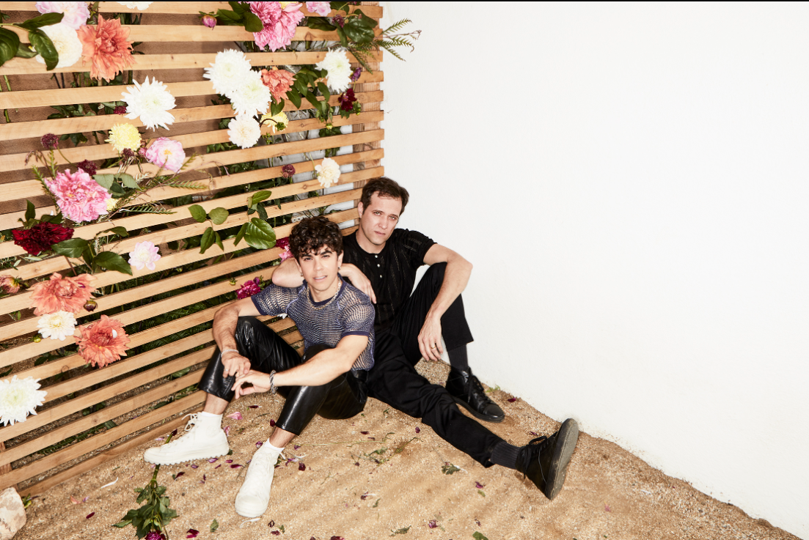

[**\*Download hi-res image here\***](http://press.atlanticrecords.com/wp-content/uploads/2019/07/Electric-Guest-Press-Photo-2-Credit-Jimmy-Fontaine.jpg)

**CONNECT WITH ELECTRIC GUEST:**

[OFFICIAL](https://nam04.safelinks.protection.outlook.com/?url=https%3A%2F%2Felectricguestmusic.com%2F&data=02%7C01%7CMegan.Rasmussen%40atlanticrecords.com%7C1c76f12000844a18b9b508d730a6da88%7C8367939002ec4ba1ad3d69da3fdd637e%7C0%7C0%7C637031365505448542&sdata=5hU1T4F9wK83gdR86tUnt4s3BY2kKu0nMsni0usEUh8%3D&reserved=0) I [FACEBOOK](https://nam04.safelinks.protection.outlook.com/?url=https%3A%2F%2Fwww.facebook.com%2Felectricguest&data=02%7C01%7CMegan.Rasmussen%40atlanticrecords.com%7C1c76f12000844a18b9b508d730a6da88%7C8367939002ec4ba1ad3d69da3fdd637e%7C0%7C0%7C637031365505458534&sdata=%2FdJkqGU3qVNzGDBLFsW1SHtkGnnsPk6bgnkFqUh9M3A%3D&reserved=0) I [TWITTER](https://nam04.safelinks.protection.outlook.com/?url=https%3A%2F%2Ftwitter.com%2FElectricGuest&data=02%7C01%7CMegan.Rasmussen%40atlanticrecords.com%7C1c76f12000844a18b9b508d730a6da88%7C8367939002ec4ba1ad3d69da3fdd637e%7C0%7C0%7C637031365505458534&sdata=P5cFDf0pHuJUlUXA8SeT8TOvTV70aDdV36lEsaCQ4hg%3D&reserved=0) I [INSTAGRAM](https://nam04.safelinks.protection.outlook.com/?url=https%3A%2F%2Fwww.instagram.com%2Felectricguest%2F&data=02%7C01%7CMegan.Rasmussen%40atlanticrecords.com%7C1c76f12000844a18b9b508d730a6da88%7C8367939002ec4ba1ad3d69da3fdd637e%7C0%7C0%7C637031365505468532&sdata=BF%2B2JV6%2BpwVGh8N5nF0Ztyc2QrWmi7RkIf1E%2BW329NE%3D&reserved=0) I [YOUTUBE](https://nam04.safelinks.protection.outlook.com/?url=https%3A%2F%2Fwww.youtube.com%2Fchannel%2FUCNZivkOQXGa0hnm6Z1bdYkQ&data=02%7C01%7CMegan.Rasmussen%40atlanticrecords.com%7C1c76f12000844a18b9b508d730a6da88%7C8367939002ec4ba1ad3d69da3fdd637e%7C0%7C0%7C637031365505468532&sdata=2Lr%2FJJ4bY8zsxqaLM9HDuizpd95owp9GWg2yr7u4%2BPM%3D&reserved=0)

**CONTACT:**

[CHELSEY.NORTHERN@ATLANTICRECORDS.COM](mailto:CHELSEY.NORTHERN@ATLANTICRECORDS.COM) (NATIONAL)

[LIBBY.KOBER@ATLANTICRECORDS.COM](mailto:LIBBY.KOBER@ATLANTICRECORDS.COM) (TOUR/ONLINE)

**ELECTRIC GUEST KIN WORLD TOUR**

With Special Guests Wafia ^ / Petrie * / Joanna > / Soleima #

**October**

15 – Brooklyn, NY – Rough Trade NYC (SOLD OUT)

28 – Seattle, WA - The Showbox ^

29 – Vancouver, BC – Imperial ^

30 – Portland, OR – Wonder Ballroom ^

**November**

1 – San Francisco, CA – Regency Ballroom ^

2 – Los Angeles, CA – The Regent ^

3 – San Diego, CA – The Irenic ^

18 – Antwerp, Belgium – Trix *

19 – Reims, France – La Cartonnerie Club >

20 – Nimes, France – Le Paloma >

21 – Bordeaux, France – Rock School Barbey >

23 – Paris, France – Café De La Danse >

24 – Amsterdam, Netherlands – Bitterzoet

26 – Hamburg, Germany – Molotow *

27 – Berlin, Germany – Musik & Frieden – Blue Room *

29 – Erlangen, Germany – PULS Festival 2019 (Indoor)

30 – Munich, Germany – PULS Festival 2019 (Indoor)

**December**

2 – London, UK – Village Underground *

3 – Manchester, UK – The Deaf Institute *

4 – Glasgow, UK – King Tuts *

5 – Leeds, UK – Belgrave Music Hall *

**January**

28 – Las Vegas, NV – The Bunkhouse Saloon #

29 – Albuquerque, NM – Launchpad #

31 – Austin, TX – The Mohawk #

**February**

Feb 1 – Houston, TX – White Oak Music Hall Downstairs #

Feb 2 – Dallas, TX – Trees #

Feb 4 – Nashville, TN – Exit / In #

Feb 5 – Charlotte, NC – Visulite Theatre #

Feb 7 – Washington, DC – 9:30 Club #

Feb 8 – Philadelphia, PA – Union Transfer #

Feb 10 – Cambridge, MA – The Sinclair #

Feb 11 – New York, NY – Webster Hall #

Feb 14 – Toronto, ON – The Mod Club #

Feb 16 – Columbus, OH – The Basement #

Feb 17 – Chicago, IL – Metro #

Feb 18 – Minneapolis, MN – Fine Line #

Feb 19 – Lawrence, KS – Granada Theater #

Feb 21 – Denver, CO – The Summit #

Feb 22 – Salt Lake City, UT – Urban Lounge #

Feb 24 – Phoenix, AZ – The Crescent Ballroom #

# # #