**SNOW THA PRODUCT**

**RELEASES NEW SINGLE AND VIDEO FOR “MYSELF” FT. DRAM**

**HEADLINE “VIBE HIGHER” TOUR BEGINS IN JUNE**

[**WATCH “MYSELF” HERE**](https://www.youtube.com/watch?v=sXngJa-lpH8&feature=youtu.be)



Atlantic recording artist Snow Tha Product returns to release her newest single, “Myself” featuring DRAM. The single is also accompanied by a companion video, which premiered last night via Paper Mag. “Myself” comes on the heels of Snow Tha Product’s first release of 2018, “Help a B*tch Out” featuring O.T. Genasis. This summer will see Snow Tha Product head out on her headliner “Vibe Higher” tour with dates beginning June 1st – tickets on sale now. In 2017, Snow made her official acting debut in the second season of USA Network's highly-rated TV series *Queen of The South*, portraying the character of Lil' Traviesa. Last year, she also won an MTV VMA for ‘Best Fight Against the System’ video for “Immigrants (We Get the Job Done)” from The Hamilton Mixtape.

**Buy/Stream “Myself” ft. DRAM Here:**

[**https://atlantic.lnk.to/Myself**](https://atlantic.lnk.to/Myself)

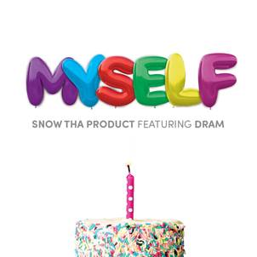

**SNOW THA PRODUCT**

**“VIBE HIGHER” TOUR**

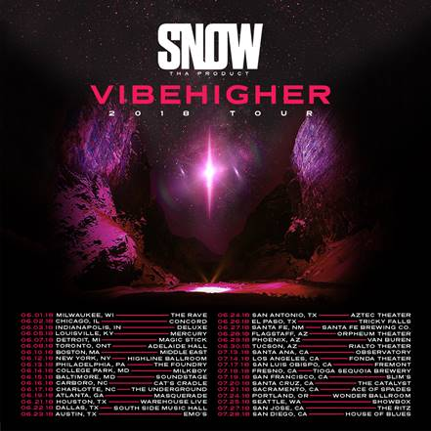

FOR MORE INFORMATION:

[SITE](http://www.snowthaproduct.com/VibeHigherTour?ref=https://www.google.com/)

[FACEBOOK](https://www.facebook.com/SnowThaProduct)

[TWITTER](https://twitter.com/snowthaproduct)

[INSTAGRAM](https://www.instagram.com/snowthaproduct/)

[YOUTUBE](https://www.youtube.com/snowthaproduct)