NEW MUSIC FROM YOUR FAV BAND
NASTY CHERRY

THIRD SINGLE “LIVE FOREVER” + SELF-MADE VIDEO DROPS TODAY

TRACK CO-WRITTEN WITH CHARLI XCX + PRODUCED BY JUSTIN RAISEN

DEBUT EP ARRIVES THIS FALL

STREAM THE VIDEO: https://youtu.be/EhvB4EDLqUU
LISTEN TO THE SONG: https://lnk.to/NC-LiveForever

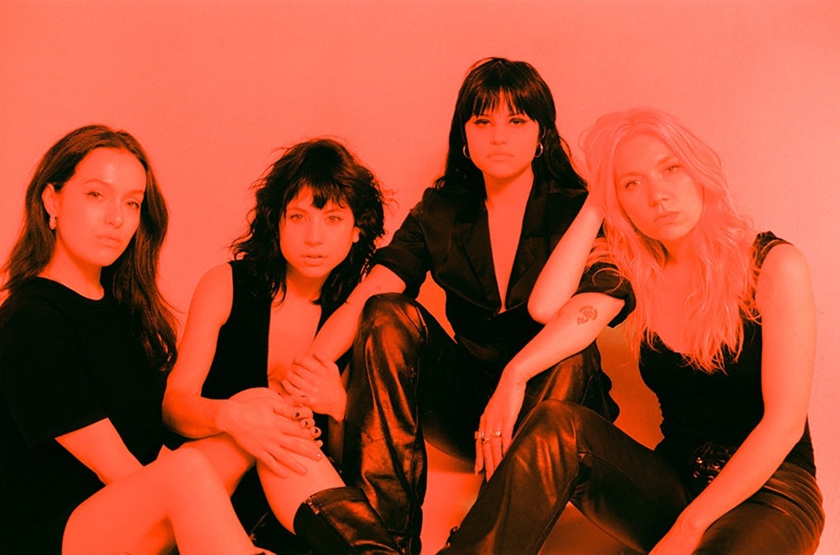
(Photo credit: Tsarina Merrin - @tsarinamerrin)

“'Live Forever’ features a buzzy Eighties new wave riff with splashes of Nineties dream pop in the vocals and chorus.” -ROLLING STONE

Femme fatales Nasty Cherry premiere their third single “Live Forever” on Rolling Stone who named the band a “best new artist of the year” alongside their self-produced music video made during a recent Los Angeles writing trip; offering a true look into the playful personalities behind Charli XCX’s favorite new act signed to her label Vroom Vroom Recordings – WATCH HERE!

In their own words ‘Live Forever,’ is a song about being “unconfined, unrefined and self-assured” so naturally, "the video shows a less filtered side of the band…” says Nasty Cherry band-mate Georgia Somary who also directed the video, edited by Matt Copson. “I wanted all of us to be seen as we are. We just went to a theme park for my birthday, ate a ton of fried pickles and filmed most of it there on our phones, as well as in sessions, and at Gabriette’s apartment over two days."

Nasty Cherry co-wrote ‘Live Forever’ with Charli XCX and producer Justin Raisen (Sky Ferreira, Angel Olsen, Kim Gordon); the dream team behind the band’s first single ‘WIN’ (watch here)! As with the earlier releases, including their latest, “What Do You Like In Me” (watch here), ‘Live Forever’ came together in a day with a very quick and organic writing process involving lots of woodblocks and guitars and birth control.

After selling out their debut live show as a band at The Moroccan Lounge in Los Angeles, and their first show in New York at Baby’s All Right, Nasty Cherry will head to Washington, DC to play their first festival – All Things Go Fall Classic -- https://www.allthingsgofallclassic.com/artist/nasty-cherry/, but the girls will first head oversees to headline NME’s “Girls To The Front” club night in London on September 23rd at Shacklewell Arms.

The next first for Nasty Cherry is their debut EP, arriving this fall---stay tuned for more!

##

“The vibe is ’90s angst rock welded to a Sia-esque chorus, and it is indeed a winner.”
-THE NEW YORK TIMES

“Sassy Eighties-MTV girl pop guided by Charli XCX’s rebel spirit"
-ROLLING STONE

“…the track is a potent introduction to the band's vision, a kick-drum slow burner laced with powder keg determination.”
-THE FADER

“…a promising kick-off for a group that seems looking to take the girl group concept in a punkier, darker direction — while still having plenty of fun.”
-TIME

"Win" is as sticky a song as you'll find this year, with a chorus that'll live with you long after the track stops playing. More Nasty Cherry soon, please.”
-GQ

“From the very ’80s matrimonial white dresses that they’ve worn on stage to their matching red hot photoshoot ensembles, which are as glamorous as rock ’n’ roll can get, Nasty Cherry might just resurrect that bygone era when coordinated girl groups ruled the charts.”
-VOGUE

“Without a doubt, Nasty Cherry will always be cooler than we could ever hope to be.”
-PAPER

“I stan four witchy queens.”
-NYLON

““…LA band serving girl power with a bitchy attitude.””
-FLAUNT

“… one of those pop tracks that’s genius in its simplicity.”
-VICE’s NOISEY

“…shadowy ’80s post-punk riffs with a huge anthemic pop chorus…”
-STEREOGUM

##

The band caused a social stir when Charli first hinted at Nasty Cherry’s existence, racking up nearly 10K followers overnight, but the girls have otherwise kept a pretty shadowy profile. Made up of two Brits (@georgiasomary, @debbiedrums), and two Americans (@gabriette, @chloechaidez), Nasty Cherry is hinged by Los Angeles with purpose to write and play their own music—which is romantic and bitchy at the same time—like if Robert Smith was created by Andy Warhol in the Factory, or The Strokes, if they all had vaginas. Someone should remake ‘The Craft’ just so Nasty Cherry can make the soundtrack.

In Nasty Cherry’s spare time you might see lead singer Gabz modeling for the recent cover of Galore or sitting front row at YSL in Paris; you might see bassist Georgia flying planes, loading 18th century muskets or decorating sets for the Star Wars movies; you might hear drummer Debbie recording radio episodes with Charli at the Beats 1 studio or you might catch guitarist Chloe gate crashing the red carpet or jumping off a speaker, performing with her second band KITTEN.

Follow on Instagram/Twitter: @nastycherryband

Press tools: http://press.atlanticrecords.com/nasty-cherry

For more information or US press inquiries please contact:

Jordan Danielle Frazes - jordan@frazescreative.com

