FOR IMMEDIATE RELEASE
JANUARY 29, 2021 (1p EST)

NASTY CHERRY UNVEIL FIRST NEW TRACK OF 2021 “LUCKY”

NEW EP SET FOR SPRING RELEASE

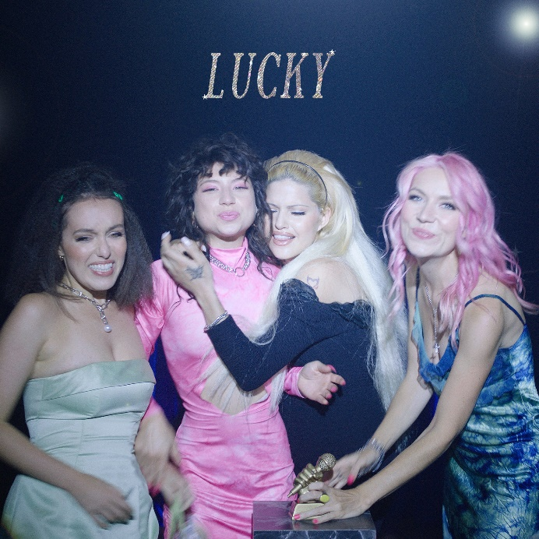

WATCH: https://lnk.to/NC-Lucky-video
STREAM: https://lnk.to/NC-lucky

Following weeks of teasing across their social accounts, Nasty Cherry return with their first new song of 2021. “Lucky,” released today, is the first offering from their upcoming EP, set for release this spring via Vroom Vroom Recordings.

Written by the band alongside the track’s producer, Yves Rothman (L Devine, Conan Grey), “Lucky” is built around understated synths, escalating drum beats and rich vocal melodies, highlighting the importance of friendship and unity. The song arrives accompanied by a Kristen Jan Wong-directed video, which sees the band playing the roles of different audience members and winners at an award show, each being celebrated for their own induvial traits.

Nasty Cherry explain: “’Lucky’ is a song we wrote for each other during the pandemic where the 6 weeks we got to spend together felt incredibly precious and introspective. It's a reflective, sweet and spiky little song.”

Proving more than just hype, 2020 saw the release of the band’s sophomore EP, Season 2, and found them joining forces with the likes of Dylan Brady (100 gecs) on self-love anthem “I Am King,” British screenwriter Drew Pearce for the cinematic “Better Run” video and animator Du Blonde for “Shoulda Known Better.” A thoroughly modern band who have let their fans in to their world from the very beginning and allowed them to evolve in real time, Nasty Cherry have established a network of esteemed collaborators well in advance of a debut album to firmly cement themselves as alt-pop frontrunners.

Check out recently released live performances of “Shoulda Known Better” and “Better Run.”

Nasty Cherry is: Gabi Bechtel (singer), Chloe Chaidez (guitarist), Georgia Somary (bassist) and Debbie Knox-Hewson (drummer).

ABOUT NASTY CHERRY:
Following a social media frenzy set in motion by founder and mentor, Charli XCX, Nasty Cherry made their typically unconventional debut in 2019. The half UK / half US band emerged with a Netflix series, I’m With The Band: Nasty Cherry, an unfiltered, intimate, 6-part docuseries following the highs and lows of forming and breaking a thoroughly modern band. Lauded by the likes of Rolling Stone, The FADER, TIME, Vogue, The Face and many more, their debut EP Season 1 was released to critical acclaim and brought to life across sold out headline shows in the UK and US. To date, the band have garnered over 13 million global streams.

CONNECT:
Twitter | Facebook | YouTube | Instagram | Press Assets

CONTACT:
Ted Sullivan | Ted.Sullivan@atlanticrecords.com

