NASTY CHERRY
RELEASE NEW SINGLE
‘MUSIC WITH YOUR DAD’

TRACK PRODUCED BY JUSTIN RAISEN OFF DEBUT EP ARRIVES THIS NOVEMBER

LISTEN: https://lnk.to/MusicWithYourDad

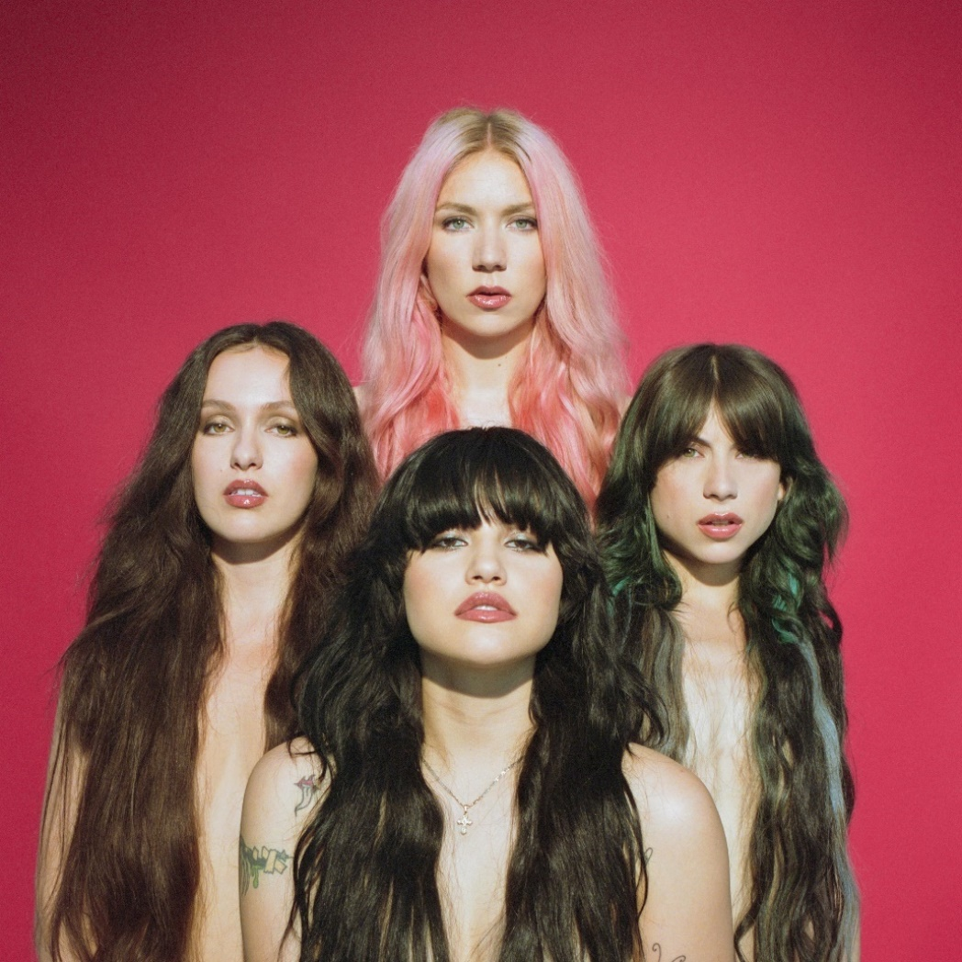

[Charli] XCX-ellent four-piece Nasty Cherry release their fourth single ‘Music With Your Dad’ on Charli XCX’s Vroom Vroom Recordings off their debut EP arriving in November alongside some other cool things in the works… LISTEN HERE!

The track, written by the band and produced by Justin Raisen (Angel Olson, Sky Ferreira), who have already proven themselves to be a killer combo on the band’s previous singles ‘WIN’ & ‘Live Forever’, perfectly encapsulates what Nasty Cherry are all about. Written in the space of a day shortly after the band first met, the song is equal parts hooky, fun, silly and in-your-face sassy. This song is simultaneously unlike any other song you’ll hear this week/month/year, while also being just what you’d expect from a band that has caught the attention of everyone from Rolling Stone to New York Times.

After selling out their debut live show at Los Angeles’ The Moroccan Lounge, and their first show in New York at Baby’s All Right, the girls played their first ever UK show last month headlining NME’s “Girls To The Front.” New York fans, say tuned for more….!

##

“The vibe is ’90s angst rock welded to a Sia-esque chorus, and it is indeed a winner.”
-THE NEW YORK TIMES

“Sassy Eighties-MTV girl pop guided by Charli XCX’s rebel spirit"
-ROLLING STONE

“…the track is a potent introduction to the band's vision, a kick-drum slow burner laced with powder keg determination.”
-THE FADER

“…a promising kick-off for a group that seems looking to take the girl group concept in a punkier, darker direction — while still having plenty of fun.”
-TIME

"Win" is as sticky a song as you'll find this year, with a chorus that'll live with you long after the track stops playing. More Nasty Cherry soon, please.”
-GQ

“From the very ’80s matrimonial white dresses that they’ve worn on stage to their matching red hot photoshoot ensembles, which are as glamorous as rock ’n’ roll can get, Nasty Cherry might just resurrect that bygone era when coordinated girl groups ruled the charts.”
-VOGUE

“Without a doubt, Nasty Cherry will always be cooler than we could ever hope to be.”
-PAPER

“I stan four witchy queens.”
-NYLON

““…LA band serving girl power with a bitchy attitude.””
-FLAUNT

“… one of those pop tracks that’s genius in its simplicity.”
-VICE’s NOISEY

“…shadowy ’80s post-punk riffs with a huge anthemic pop chorus…”
-STEREOGUM

##

The band caused a social stir when Charli first hinted at Nasty Cherry’s existence, racking up nearly 10K followers overnight, but the girls have otherwise kept a pretty shadowy profile. Made up of two Brits (@georgiasomary, @debbiedrums), and two Americans (@gabriette, @chloechaidez), Nasty Cherry is hinged by Los Angeles with purpose to write and play their own music—which is romantic and bitchy at the same time—like if Robert Smith was created by Andy Warhol in the Factory, or The Strokes, if they all had vaginas. Someone should remake ‘The Craft’ just so Nasty Cherry can make the soundtrack.

In Nasty Cherry’s spare time you might see lead singer Gabs modeling for the recent cover of Galore or sitting front row at YSL in Paris; you might see bassist Georgia flying planes, loading 18th century muskets or decorating sets for the Star Wars movies; you might hear drummer Debbie recording radio episodes with Charli at the Beats 1 studio or you might catch guitarist Chloe gate crashing the red carpet or jumping off a speaker, performing with her second band KITTEN.

CONNECT WITH NASTY CHERRY:

Official Instagram
Twitter
YouTube

PRESS TOOLS:

http://press.atlanticrecords.com/nasty-cherry

PUBLICIST:

Jordan Danielle Frazes
FRAZES CREATIVE
jordan@frazescreative.com

