FOR IMMEDIATE RELEASE
APRIL 24, 2020

NASTY CHERRY UNVEIL FIRST NEW TRACK OF 2020 "SHOULDA KNOWN BETTER”

OFFICIAL VIDEO ANIMATED BY DU BLONDE – WATCH HERE

NEW EP COMING THIS SUMMER

DOWNLOAD HIGH-RES IMAGES

WATCH/STREAM “SHOULDA KNOWN BETTER”: https://lnk.to/shouldaknownbetter

Hotly-tipped foursome, Nasty Cherry, return with their first new song of 2020. “Shoulda Known Better," released today, is lifted from their new EP, set for release via Charli XCX’s Vroom Vroom Recordings this summer. The song arrives accompanied by an official video, animated by fellow musician and multi-disciplinary artist, Du Blonde, WATCH HERE.

Written by the band alongside production duo Noise Club, "Shoulda Known Better” is a modern slice of pop-rock, served Nasty Cherry style. "‘Shoulda Known Better’ is a song about making dumb decisions despite knowing better” they explain, “we wrote it in LA a couple of months ago, at a time we all felt we were falling for the same shit over and over. The vibe of ‘Shoulda Known Better’ is the angel and devil on your shoulder, simultaneously shout-singing at you, and you’re kind of enjoying it.”

Comprised of singer Gabi Bechtel, guitarist Chloe Chaidez, bassist Georgia Somary and drummer Debbie Knox-Hewson, Nasty Cherry made their typically unconventional debut last year. Following a social media frenzy set in motion by founder and mentor, Charli XCX, the half UK / half US band emerged with a Netflix series, ‘I’m With The Band: Nasty Cherry’, an unfiltered, intimate, 6-part docuseries following the highs and lows of forming and breaking a thoroughly modern band. Lauded by the likes of NME, Rolling Stone, The FADER, TIME, Vogue, The Face and many more, their debut EP ‘Season 1’ was released last November to critical acclaim and brought to life across sold out headline shows in both the UK and US.

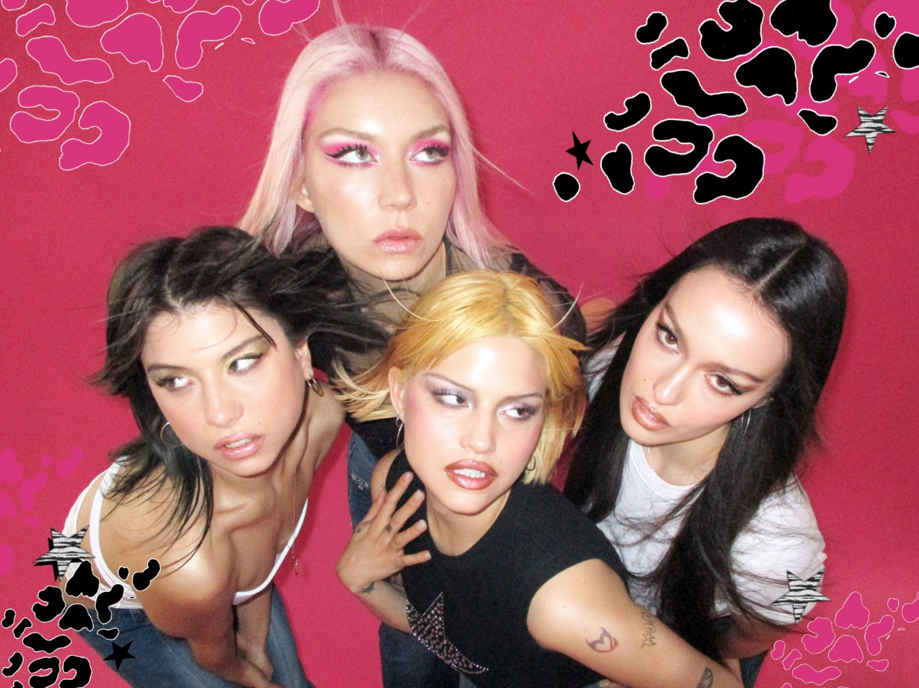
DOWNLOAD HIGH-RES IMAGES

CONNECT:
Twitter | Facebook | YouTube | Instagram | Press Assets

CONTACT:
Ted Sullivan | Ted.Sullivan@atlanticrecords.com

