FOR IMMEDIATE RELEASE
APRIL 2, 2021

‘NASTY CHERRY: THE MOVIE’ OUT NOW

BRAND NEW EP FEATURING “LUCKY,” “HER BODY” AND “WHAT’S THE DEAL”

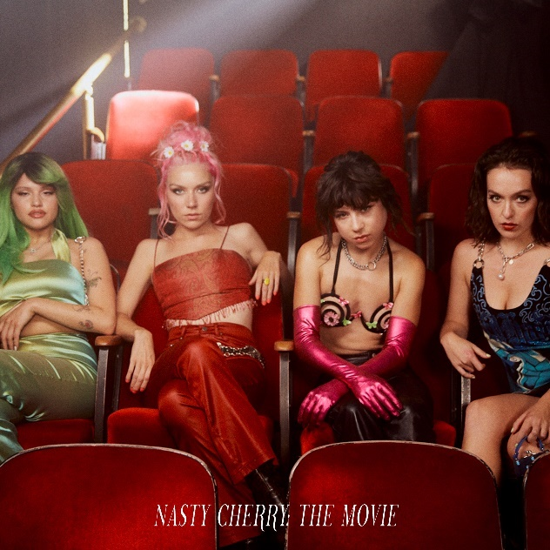

STREAM NASTY CHERRY: THE MOVIE: https://lnk.to/TheMovie-EP

Nasty Cherry have released their brand-new EP, Nasty Cherry: The Movie, featuring recently released tracks, “Lucky,” Charli XCX co-write, “Her Body,” and “What’s The Deal.” Listen HERE.

Created over a short period of time last summer, when drummer Debbie was able to safely join her bandmates in LA, Nasty Cherry: The Movie was written entirely by the band, alongside producer, Yves Rothman. Confidently understated, the EP is the third body of work from the much loved alt-pop foursome, who have been effortlessly experimenting with their sound since launching in 2019.

Of the title, Nasty Cherry explain: “We wanted to make a ‘Stray Cat Rock: Delinquent Girl Boss’ / Russ Meyer style full length feature film to come out with the EP. We got so hyped with Yves about it and we genuinely started planning it and got two weeks into finding crew and writing it. Unfortunately, we are visionaries who turned it into a 5 million dollar action caper idea and sadly no one else thought it was that good. We didn’t change the EP name, because it’s got huge energy and we really hope you’ll listen to it and imagine each song as a different act in a film.”

THE MOVIE EP TRACKLIST
- Six Six Six
- What’s The Deal
- Her Body
- All In My Head
- Lucky

Nasty Cherry is: Gabi Bechtel (singer), Chloe Chaidez (guitarist), Georgia Somary (bassist) and Debbie Knox-Hewson (drummer).

ABOUT NASTY CHERRY:
Following a social media frenzy set in motion by founder and mentor, Charli XCX, Nasty Cherry made their typically unconventional debut in 2019. The half UK / half US band emerged with a Netflix series, I’m With The Band: Nasty Cherry, an unfiltered, intimate, 6-part docuseries following the highs and lows of forming and breaking a thoroughly modern band. Lauded by the likes of Rolling Stone, The FADER, PAPER, Vogue, The Face and many more, their debut Season 1 and Season 2 EPs were released to critical acclaim and brought to life across sold out headline shows in the UK and US. To date, the band have garnered over 14 million global streams.

CONNECT:
Twitter | Facebook | YouTube | Instagram | Press Assets

CONTACT:
Ted Sullivan | Ted.Sullivan@atlanticrecords.com

