FOUR GIRLS, ONE CHARLI XCX BAND:
NASTY CHERRY
RELEASES SOPHOMORE SINGLE
‘WHAT DO YOU LIKE IN ME?’
+ MUSIC VIDEO ALSO ARRIVES TODAY
AHEAD OF DEBUT NEW YORK SHOW
@ BABY’S ALL RIGHT IN BROOKLYN ON JUNE 18th

MUSIC VIDEO: https://youtu.be/pUhFA1xVRPc
BUY/STREAM: https://lnk.to/whatdoyoulikeinme
TICKETS: https://www.eventbrite.com/e/nasty-cherry-tickets-60153894919

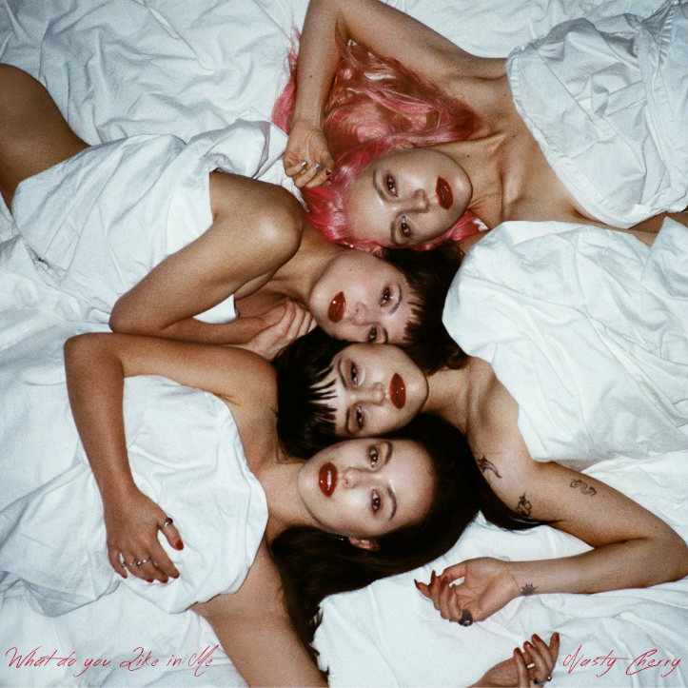

“Without a doubt, Nasty Cherry will always be cooler than we could ever hope to be.” -PAPER

The internet buzzed but the only one who really knew Nasty Cherry was Charli XCX. Now, the female-fronted, Los Angeles-based all-girl band delivers their sophomore single, “What Do You Like In Me?” released today on Charli XCX’s label imprint Vroom Vroom Recordings--alongside the official music video produced and codirected by lead-singer Gabbriette and creative Indiana Piorek. Quirky, off beat, silly and sexy, the video perfectly demonstrates what Nasty Cherry embodies – WATCH HERE!

“The song is personal to all of us...” Gabbriette shares, “Indiana and I wanted to create a world that felt familiar and timeless and let the song speak for itself. We used all of our own clothes and “props” from our homes and friends to help out...it was a wonderful collaboration that I’m so happy was born.”

“What Do You Like In Me?” came together in one day in Los Angeles, written with sonically cosmic French production trio Planet 1999. The track shows a more mellow tone from the band with hazy synths and nonchalant chords, whilst lead singer Gabi muses over the demands and drains of relationships online and offline.

Nasty Cherry *pun-tended* won with their debut single ‘WIN’, born with praise from tastemakers – see highlights below – as well as Top 10 stream playlist placements globally; for the track co-written with the genre defining, culture inspiring, multi-platinum selling singer/songwriter Charli XCX, and produced by Justin Raisen (Sky Ferreira, Angel Olsen, Kim Gordon).

Hinged by the city of Los Angeles, the city where Nasty Cherry writes together and plays music – comprised of two Brits (@georgiasomary, @debbiedrums) and two Americans (@gabbriette, @chloechaidez). Their sound is romantic and bitchy at the same time, like if Robert Smith was created by Andy Warhol in the Factory, or The Strokes, if they all had vaginas. Someone should remake ‘The Craft’ just so Nasty Cherry can make the soundtrack.

Off the heels of a sold-out debut show at The Moroccan Lounge in Los Angeles, the band will be play their first New York showcase at Baby’s All Right on Tuesday, June 18th, with few tickets still available via: https://www.eventbrite.com/e/nasty-cherry-tickets-60153894919.

Follow on Instagram/Twitter: @nastycherryband

Press site: http://press.atlanticrecords.com/nasty-cherry/

“The vibe is ’90s angst rock welded to a Sia-esque chorus, and it is indeed a winner.”
-THE NEW YORK TIMES

“…the track is a potent introduction to the band's vision, a kick-drum slow burner laced with powder keg determination.”
-THE FADER

“…a promising kick-off for a group that seems looking to take the girl group concept in a punkier, darker direction — while still having plenty of fun.”
-TIME

"Win" is as sticky a song as you'll find this year, with a chorus that'll live with you long after the track stops playing. More Nasty Cherry soon, please.”
-GQ

“From the very ’80s matrimonial white dresses that they’ve worn on stage to their matching red hot photoshoot ensembles, which are as glamorous as rock ’n’ roll can get, Nasty Cherry might just resurrect that bygone era when coordinated girl groups ruled the charts.”
-VOGUE

“We have ourselves a winner…” “…the song… paints an empowered self-assured portrait of a band you can't help but gaze upon with admiration.”
-PAPER

““…LA band serving girl power with a bitchy attitude.””
-FLAUNT

“It’s one of those pop tracks that’s genius in its simplicity.”
-VICE’s NOISEY

“…shadowy ’80s post-punk riffs with a huge anthemic pop chorus…”
-STEREOGUM

###

For more info please contact: Jordan Danielle Frazes - Jordan.Frazes@atlanticrecords.com

