**WHO THE F*CK ARE NASTY CHERRY?**

**NEW SONG ‘WIN’ ARRIVES TODAY!**

**LISTEN/SHARE:** <https://youtu.be/uX9T9ZYMtvg>

**BUY/STREAM**: <https://lnk.to/NC-Win>

**DEBUT HEADLINE SHOW AT THE MOROCCAN LOUNGE (LA) ON FRI MARCH 15:**

Tickets on-sale here: [https://www.ticketfly.com/event/1826986-nasty-cherry-los-angeles/](https://protect-us.mimecast.com/s/O61vCQW57QHR5g7wsPnWPn)

[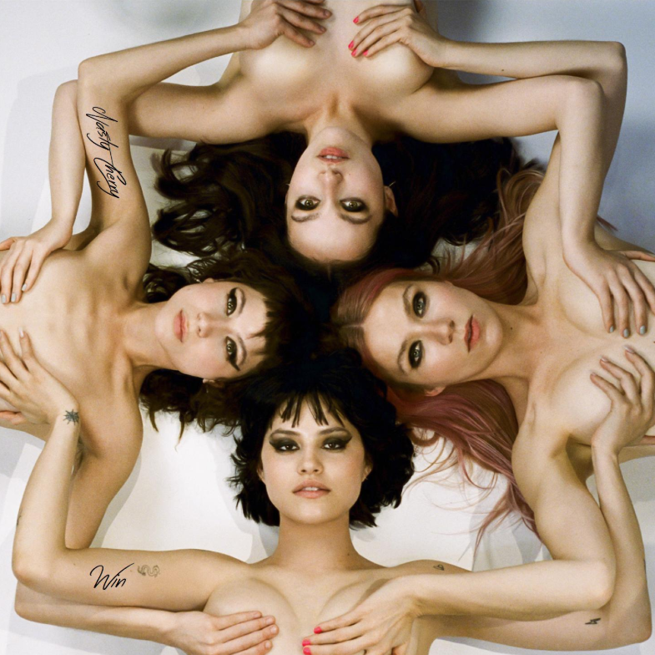](http://press.atlanticrecords.com/nasty-cherry/)

*“Win,” with its driving central riff and Gabby’s so-over-it lyrics, is a hell of an introduction to the band.*

*It’s one of those pop tracks that’s genius in its simplicity.”*

**-NOISEY**

The internet is buzzing — first [PAPER](https://protect-us.mimecast.com/s/qu26CR651RhOAoN3iPEiFF) asked, then [Halsey got curious](https://protect-us.mimecast.com/s/VDShCVO0QYuZDmMpIJJR32)… but the only one who knows is **Charli XCX**. The all-female band is the brainchild of the genre defining, culture inspiring, multi-platinum selling singer/songwriter, who has officially just signed **Nasty Cherry** to her **Vroom Vroom Recordings** label imprint.

The girls can throw out a few more smiles… or smirks… but you should listen to the music for yourself, their debut song **‘WIN’** arrives today – [LISTEN HERE](https://lnk.to/NC-Win)– co-written with **Charli XCX** and produced by **Justin Raisen** (Sky Ferreira, Angel Olsen, Kim Gordon). The girls are also playing their first headline show in Los Angeles at the Moroccan Lounge on Friday March 15th – [TICKETS HERE](https://protect-us.mimecast.com/s/O61vCQW57QHR5g7wsPnWPn) – or send me a cheeky note to request one!

The band caused a social stir when Charli first hinted at **Nasty Cherry**’s existence, racking up nearly 10K followers in one evening overnight, but the girls have otherwise kept a pretty shadowy profile. Made up of two Brits ([@georgiasomary](https://protect-us.mimecast.com/s/Bbc5CW6jqZh4AZ0nHmC2YB), [@debbiedrums](https://protect-us.mimecast.com/s/FYsyCXDk51c9xjmLS9VJZ3)), and two Americans ([@gabriette](https://protect-us.mimecast.com/s/dF2_CYEl52h9zm5yS3KbLZ), [@chloechaidez](https://protect-us.mimecast.com/s/7QR_CZ6m03hj3AzWHNQSn7)), Nasty Cherry is hinged by **Los Angeles** with purpose to write and play their own music—which is romantic and bitchy at the same time—like if Robert Smith was created by Andy Warhol in the Factory, or The Strokes, if they all had vaginas. Someone should remake ‘The Craft’ just so **Nasty Cherry** can make the soundtrack.

In Nasty Cherry’s spare time you might see lead singer **Gabz** modelingfor [the recent cover of Galore](https://protect-us.mimecast.com/s/RkMBC1wB42fZ7x8QImsu5z) or sitting front row at YSL in Paris; you might see bassist **Georgia** flying planes, loading 18th century muskets or decorating sets for the Star Wars movies; you might hear drummer **Debbie** recording radio episodes with Charli at the Beats 1 studio or you might catch guitarist **Chloe** gate crashing the red carpet or jumping off a speaker, performing with her second band KITTEN.

Follow on Instagram/Twitter: [@nastycherryband](https://protect-us.mimecast.com/s/EMS2C2k1W3cmNW7DSv6Tev)

Press site: <http://press.atlanticrecords.com/nasty-cherry/>

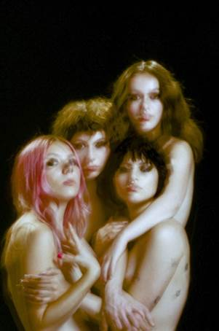

(Photo credit: Tsarina Merrin - @tsarinamerrin, [Download Hi-Res](http://press.atlanticrecords.com/wp-content/uploads/2019/03/Nasty-Cherry_-credit-@tsarinamerrin-.jpg))

###

For more info please contact: **Jordan Danielle Frazes** - [Jordan.Frazes@atlanticrecords.com](mailto:Jordan.Frazes@atlanticrecords.com)