GIRL BAND NASTY CHERRY RELEASES OFFICIAL VIDEO FOR DEBUT SINGLE “WIN” CO-DIRECTED BY CHARLI XCX!

FOLLOWING SOLD OUT DEBUT LIVE SHOW AT LA’S THE MOROCCAN LOUNGE

WATCH/SHARE: https://ad.gt/nastycherry-win
BUY/STREAM: https://lnk.to/NC-Win

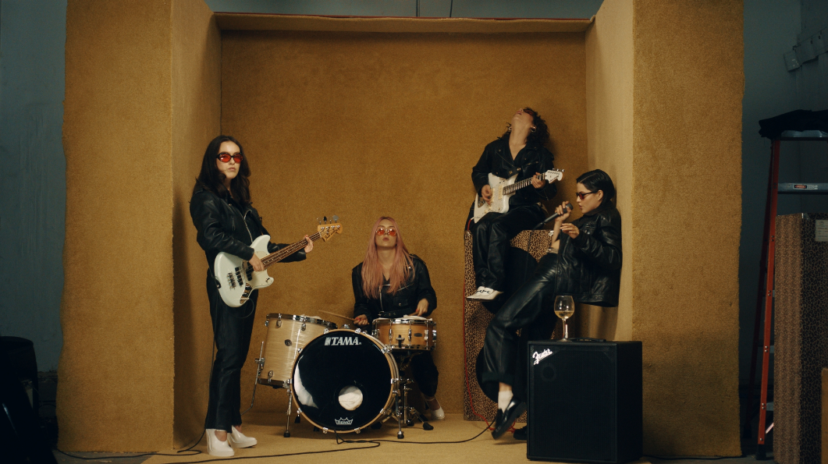
(Approved music video screen shot)

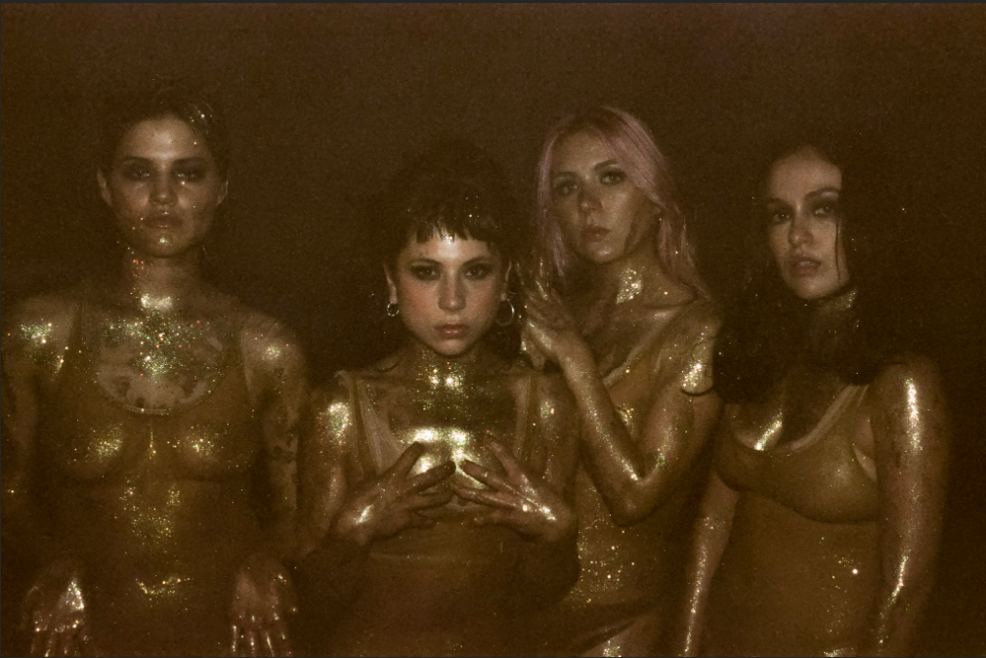
(Photo credit: Tsarina Merrin - @tsarinamerrin, Download Hi-Res)

“From the very ’80s matrimonial white dresses that they’ve worn on stage to their matching red hot photoshoot ensembles, which are as glamorous as rock ’n’ roll can get, Nasty Cherry might just resurrect that bygone era when coordinated girl groups ruled the charts. ” -VOGUE

Last month Charli XCX announced the signing of female-fronted, all-girl band signing Nasty Cherry to her label Vroom Vroom Recording. The genre defining, culture inspiring, multi-platinum selling singer/songwriter co-penned their debut single “WIN” produced by Justin Raisen (Sky Ferreira, Angel Olsen, Kim Gordon); and today the Brit reveals her latest video co-directing work, alongside Kristen Jan Wong, for Nasty Cherry’s debut. The official visual sees the band performing “WIN” in unusual ensembles, shot in one day in Los Angeles, highlighting all the true weirdness that makes up the dynamic nature of Nasty Cherry – reminiscent of both the 80’s, and the 90’s – culminating in a gold-glitter dance party. Watch the shimmering video HERE – which arrives off the heels of the girl’s highly anticipated single release which earned praise from tastemakers and journalists, and led to a sold-out debut live show at The Morroccan Lounge in Los Angeles, a few days following the song release – enclosed are some press highlights!

The two Brits (@georgiasomary, @debbiedrums), and two Americans (@gabriette, @chloechaidez) caused a social stir when Charli XCX first hinted at Nasty Cherry’s existence, racking up nearly 10K followers (now almost double) in one evening overnight, but the girls have otherwise kept a pretty shadowy profile. Nasty Cherry is romantic and bitchy at the same time—like if Robert Smith was created by Andy Warhol in the Factory, or The Strokes, if they all had vaginas. Someone should remake ‘The Craft’ just so Nasty Cherry can make the soundtrack. In Nasty Cherry’s spare time you might see lead singer Gabz modeling for the recent cover of Galore or sitting front row at YSL in Paris; you might see bassist Georgia flying planes, loading 18th century muskets or decorating sets for the Star Wars movies; you might hear drummer Debbie recording radio episodes with Charli at the Beats 1 studio or you might catch guitarist Chloe gate crashing the red carpet or jumping off a speaker, performing with the band KITTEN.

“WIN” follows Charli’s directing vision since her iconic “Boys” music video release, and later David Guetta’s “Dirty Sexy Money” which she’s also vocally featured and a songwriter, ALMA “Phases” and RAYE “I, You, US”. Charli XCX said about the video, “When Kristen and I thought about the “WIN” video for Nasty Cherry we were very inspired by the female form, block color, Dario Argento’s Suspiria and the four members of the band themselves. Gabriette is a trained dancer (as well as all the other stuff she does), Chloe’s been performing in bands since she was like 10, Debbie eats, sleeps and breathes drumming, and Georgia had a pretty amazing career as a set decorator before the band began. I wanted to create a space for them where they could all shine, all be themselves and all perform to the maximum. I love these women, I love their strength and I love this song and video. I’m so happy to be involved with their creative vision.”

“The vibe is ’90s angst rock welded to a Sia-esque chorus, and it is indeed a winner.”
-THE NEW YORK TIMES

“…the track is a potent introduction to the band's vision, a kick-drum slow burner laced with powder keg determination.”
-THE FADER

“…a promising kick-off for a group that seems looking to take the girl group concept in a punkier, darker direction — while still having plenty of fun.”
-TIME

"Win" is as sticky a song as you'll find this year, with a chorus that'll live with you long after the track stops playing. More Nasty Cherry soon, please.”
-GQ

“It’s one of those pop tracks that’s genius in its simplicity.”
-VICE’s NOISEY

“We have ourselves a winner in the debut track from Nasty Cherry…”
“…the song forgoes the male bravado and entitlement that might make "Win" come off as arrogant, and instead paints an empowered self-assured portrait of a band you can't help but gaze upon with admiration.”
-PAPER

“…(Charli XCX) really knows how to co-write a track.”
-NYLON

““…LA band serving girl power with a bitchy attitude.””
-FLAUNT

“The song successfully merges shadowy ’80s post-punk riffs with a huge anthemic pop chorus…”
-STEREOGUM

Follow on Instagram/Twitter: @nastycherryband
Press site: http://press.atlanticrecords.com/nasty-cherry/

###

For more info please contact: Jordan Danielle Frazes - Jordan.Frazes@atlanticrecords.com

